WEB-BASED PIGGERY MANAGEMENT SYSTEM WITH

MOBILE-BASED QR CODE SCANNER FOR RVM HOG FARM IN LAMBA, BANGA SOUTH COTABATO

A Capstone Project Proposal

Presented to the Faculty of the

Information and Communications Technology Program

STI College Koronadal

In Partial Fulfilment

of the Requirements for the Degree

Bachelor of Science in Information Technology

Royd P. Catalunes

April Jude D. Provido

Pea Marie D. Tumilap

June 2022

# APPROVAL SHEET

This capstone project proposal titled: Web-based Piggery Management System with Mobile-based QR Code Scanner for RVM Hog Farm in Lamba, Banga South Cotabato prepared and submitted by Royd P. Catalunes, April Jude D. Provido and Pea Marie D. Tumilap in partial fulfillment of the requirements for the degree of Bachelor of Science in Information Technology, has been examined and is recommended for acceptance and approval.

Regine Jesa J. Palara, MIT

Capstone Project Adviser

Accepted and approved by the Capstone Project Review Panel

in partial fulfillment of the requirements for the degree of

Bachelor of Science in Information Technology

|  |  |
| --- | --- |
| Mark C. Tres Reyes, MIT | Cliff M. Capileño, MIT |
| Panel Member | Panel Member |

Engr. Jessie M. Gayosa, MPA, MIT

Lead Panelist

Noted:

|  |  |
| --- | --- |
| Engr. Leila B. Guerrero, PhD. | Engr. Leila B. Guerrero, PhD. |
| Capstone Project Coordinator | Program Head |

June 2022

# Table of Contents

|  |  |  |
| --- | --- | --- |
|  | | Page |
| Title Page | | i |
| Approval Sheet | | ii |
| Table of Contents | | iii |
| List of Figures | | iv |
| List of Tables | | vi |
| Introduction | | 1 |
|  | Project Context | 1 |
|  | Purpose and Description of the Project | 5 |
|  | Objectives of the Study | 6 |
|  | Scope and Limitations of the Study | 8 |
| Review of Related Literature/Systems | | 11 |
|  | Review of Related Literature | 11 |
|  | Related Studies and/or Systems  Synthesis | 19  23 |
| Technical Background | | 26 |
|  | Overview of Current Technologies to be Used in the System | 26 |
|  | Calendar of Activities | 33 |
|  | Resources | 46 |
| Appendix | | 47 |
|  | Resource Persons | 47 |
|  | References | 48 |
|  | Personal Technical Vitae | 51 |
|  | |  |

List of Figures

Page

Figure 1: Class Scheduling System 19

Figure 2: Smart Student Attendance Using 20

Code Teacher Module

Figure 3: Inventory Management System 21

Creating Product Module

Figure 4: Peopleware Diagram 30

Figure 5: Network Diagram 32

Figure 6: Agile Methodology 33 Figure 7: Pig Breeding Process 47

Figure 8: Pig Vaccination and Deworming Process 48

Figure 9: Veterinarian Diagnose Process 48

Figure 10: Inventory Process 49

Figure 11: Context Diagram of the Current System 50

Figure 12: Logical Data Flow Diagram of the Current System 51

Figure 13: Context Diagram of the Proposed System 52

Figure 14: Physical Data Flow Diagram of the Proposed System 54

(Level 0)

Figure 15: Physical Data Flow Diagram of the Proposed System 55

(Level 1 2.0)

Figure 16: Physical Data Flow Diagram of the Proposed System 55

(Level 1 3.0)

Figure 17: Physical Data Flow Diagram of the Proposed System 56

(Level 1 4.0)

Figure 18: Physical Data Flow Diagram of the Proposed System 56

(Level 1 5.0)

Figure 19: Physical Data Flow Diagram of the Proposed System 57

(Level 1 6.0)

Figure 20: Physical Data Flow Diagram of the Proposed System 57

(Level 1 7.0)

Figure 21: Physical Data Flow Diagram of the Proposed System 58

(Level 1 8.0)

Figure 22: Physical Data Flow Diagram of the Proposed System 58

(Level 1 9.0)

Figure 23: Physical Data Flow Diagram of the Proposed System 59

(Level 1 10.0)

Figure 24: Physical Data Flow Diagram of the Proposed System 59

(Level 1 11.0)

Figure 25: Physical Data Flow Diagram of the Proposed System 60

(Level 1 12.0)

Figure 26: Conceptual Framework 91

Figure 27: System Architecture of Web-Based Piggery 93

Management System

Figure 28: Use Case Diagram involving the Owner, Worker and 95

Veterinarian of Piggery Management System of User

Management Module

Figure 29: Activity Diagram of Enter Username and Password of 96

Login Module Use Case

Figure 30: Activity Diagram of Create User Account of User 97

Module Use Case

Figure 31: Activity Diagram of Search and View User Account 98

of User Module Use Case

Figure 32: Activity Diagram of Search and Update User Account 100

of User Module Use Case

Figure 33: Activity Diagram of Remove User Account of User 101

Module Use Case

Figure 34: Activity Diagram of Logout User Account of User 102

Module Use Case

Figure 35: Use Case Diagram involving the Owner, Worker, and 103

Veterinarian of Piggery Management System of Dashboard Module

Figure 36: Activity Diagram of View Dashboard Interface of 103

Dashboard Module Use Case

Figure 37: Use Case Diagram involving the Worker of Piggery 104

Management System of Cage Management Module

Figure 38: Activity Diagram of Create Cage of Cage Management 105

Module Use Case

Figure 39: Activity Diagram of Search and View Cage of Cage 106

Management Module Use Case

Figure 40: Activity Diagram of Search and Update Cage of Cage 107

Management Module Use Case

Figure 41: Activity Diagram of Search and Remove Cage of 108

Cage Management Module Use Case

Figure 42: Use Case Diagram involving the Worker of Piggery 109

Management System of Pig Management Module

Figure 43: Activity Diagram of Create Pig of Pig Management 110

Module Use Case

Figure 44: Activity Diagram of Search and View Pig of Pig 111

Management Module Use Case

Figure 45: Activity Diagram of Search and Update Pig of Pig 112

Management Module Use Case

Figure 46: Activity Diagram of Search and Remove Pig of Pig 113

Management Module Use Case

Figure 47: Use Case Diagram involving Worker of Piggery 114

Management System of Batch Management Module

Figure 48: Activity Diagram of Create Batch of Batch 115

Management Module Use Case

Figure 49: Activity Diagram of Search and View Batch of 116

Batch Management Module Use Case

Figure 50: Activity Diagram of Search and Update Batch of 117

Batch Management Module Use Case

Figure 51: Activity Diagram of Search and Remove Batch 118

of Batch Management Module Use Case

Figure 52: Use Case Diagram involving Worker of Piggery 119

Management System of Breed Management Module

Figure 53: Activity Diagram of Create Breed of Breed 120

Management Module Use Case

Figure 54: Activity Diagram of Search and View Breed of 121

Breed Management Module Use Case

Figure 55: Activity Diagram of Search and Update Breed of 122

Breed Management Module Use Case

List of Tables

Page

Table 1: Related Systems Summary Table 23

Table 2: Hardware Requirements for Running the Web 29

Application

**Table 3: Hardware Requirements for Installing 29**

**and Running the Mobile Application**

**Table 4: Software Requirements for Web Application 30**

**Table 5: Software Requirements for Mobile Application 30**

**Table 6: Hardware Requirements for Developing and 47**

**Testing the Web application**

**Table 7: Hardware Requirement for Testing Mobile 47**

**Application**

**Table 8: Event Decomposition of the User Management Module 78**

**Table 9: Event Decomposition of the Piggery Management 85**

**System Dashboard Module**

**Table 10: Event Decomposition of the Piggery Management 86**

**System Cage Management Module**

**Table 11: Event Decomposition of the Piggery Management 91**

**System Pig Management Module**

**Table 12: Event Decomposition of Batch Management Module 96**

**Table 13: Event Decomposition of Breed Management Module 101**

**Table 14: Event Decomposition of Inventory Management 106**

**Module**

**Table 15: Event Decomposition of Purchase Request Module 111**

**Table 16: Event Decomposition of Operation Management 118**

**Module**

**Table 17: Event Decomposition of**

# Introduction

## Project Context

The world is now changing so fast and thanks to the help of technology. Technology has now become a vital part of our life and it enables us to do things faster, better, and become more efficiently.

An important part of farming is piggery management, which has a big impact on things like increasing piggery productivity, pig health and welfare, environmental sustainability, compliance with laws and regulations, and efficient data management. Farmers may ensure that their pigs are growing, healthy, and producing at their full potential for a variety of uses by keeping livestock in piggeries. To perform that, the farmers should manage the hog farm well. This allows the hog farm to manage by the farmers to make the farm organized and increase productivity.

The method of raising and breeding pigs as livestock is valued for the meat and fat they can provide for human use. The increase in food consumption of people brings an enormous impact on the piggery farm as the demand for livestock becomes bigger (Netinant, P., Niratsoke, A., & Rukhiran, M., 2021).

The piggery farm of RVM Hog Farm experienced the pen and paper process of recording the information of pigs and inventory to record all the activities that the farm does. For the farm to grow, they usually rely on the pen and paper process of recording the information of pigs and inventory this way they can manage the farm.

RVM Hog Farm is one of the existing farms in South Cotabato, established in the year 2019. It is located at Barangay Lamba, Banga, South Cotabato. The RVM hog farm has forty (40) sows, two (2) boars, two hundred thirteen (213) fattening pigs, and fifty-six (56) piglets. The RVM is capable of housing seventy-five (75) sows and has thirty (30) cages with a maximum capacity of ten (10) pigs each. They also had two (2) isolation cages for the sick pigs that needed to be observed and diagnosed.

The process at RVM hog farm begins the process when the sow and the boar breed. Workers will record the details of sow and boar before and after breeding. The purpose of recording the breeding date is to determine the sow’s due date and track the race of the piglets that will become the next sow on the farm. Pigs have a gestation period of one hundred twelve to one-twenty (112-120) days, and farrowing occurs approximately one hundred fourteen (114) days after breeding. It is termed abortion if a pig farrows before the 109th day of pregnancy. During pregnancy, workers will feed the sow gestation feed for one hundred days before feeding a lactating feed.

The veterinarian will travel to Banga from Tacurong City to check the sow physically, examine the sow, and check the pig logbook; the veterinarian is also the one who is responsible for monitoring the health of the pigs on the farm. The veterinarian also gives the worker a schedule. This schedule includes the date of vaccination and deworming of the sow during pregnancy days. For example, during the ninety (90) days of pregnancy, the worker gives the first dose of iron vitamin to the sow and records it in a pig logbook to avoid administering it again until the second dose during one hundred ten (110) days of pregnancy. When the piglets are born, they are injected with several vitamins to ensure their health. All the vitamins that are injected into the piglets are scheduled and recorded in the pig logbook. When they reach the age of one month, they are taken from their mothers to become fattening pigs on the farm. At ten (10) days after being separated from the sow, the pigs are dewormed to ensure that they are healthy. This process is also recorded in the logbook. The pigs are fed until they achieve an average kilogram of eighty (80) and are ready to be sold in the market, the selected female pigs who will become the next sow are left behind.

Pigs that are left behind will be fed and nursed by giving vitamins, vaccinations, deworming, and a variety of feeds. According to one of the workers, they record the number of vaccinations, deworming medicines, and feeds given to the pigs. The purpose of recording this information is for the workers and veterinarian to track the information of the pig’s vaccination and deworming to ensure that all the pigs in the batch have been given vaccination and deworming. As for the feed, they use this to track how much feed is being consumed and to know on what date the pig needs to change its feed. In inventory, the worker requests items from the owner to buy hog farm stocks. The worker gives a list of items that do not include prices to the owner that need to be replenished. Thus, the owner buys these items.

The RVM Hog Farm encountered the following issues:

1. Poor monitoring of stock in the inventory. As RVM operate its farm they do not keep track of its inventory level, and as a result, they are not able to reorder products on time. This lack of inventory management leads to delays in the operation of the farm like the administration of medicine and vitamin pigs, as the farm may run out of stock before reordering. The understocking can cause a lot of problems, and delay of operation of the farm which can cause the delayed growth of the pigs, which can ultimately impact the farm's profitability.
2. Loss of record. RVM uses logbooks to keep track of essential information about the pig, such as the administration of medicine and vitamins to the pigs. However, due to the busy schedule of the worker, they sometimes place the logbook anywhere causing it to be lost. When logbooks are lost, it can cause problems for the farm, workers, and veterinarians. Without this information, they may encounter difficulties administering the appropriate care to the pigs. In addition, if a logbook is lost, it means that the permanent record of the pig is also lost, and it cannot be retrieved. This can cause further issues for the farm, as the history of the pig's health and treatment is an important factor in maintaining their overall wellbeing.
3. Unorganized recording of information. Workers are recording multiple pigs’ information together, which is leading to confusion among other workers when they try to read the logbook. Additionally, when updating the records, workers are crossing out or rewriting information, which led the logbook to become messy and difficult to read. When information is not organized properly, it is easy to miss important details, which can lead to incomplete and inaccurate records it can cause problems for the farm, including double administration of vitamins and medicines, as well as causing a problem with the given schedule of administration of vitamins and medicines the farm which can have negative impacts on the health and growth of the pigs.

Therefore, the proponents proposed a Web-Based Piggery Management System with Mobile-Based QR Code Scanner as a solution to the scenarios and issues presented above that would help the RVM hog farm to track the records of pig information and the inventory of vitamins, vaccines, feeds, medicines, and dewormer and to make their operations more efficient to maximize the hog production. Also, it would help the data integrity of each pig’s information as it is organized and stored in a database. Furthermore, the proposed system can generate an inventory report that would make the hog farm owner decide whether to buy new stock on time or not. Thus, helping him to budget his money. Moreover, the worker can do their feeding, vitamins, vaccine, and deworming operation without delays as the items needed for the operation are checked and refilled if needed. Thus, the proponents also want to point out the importance of implementing a mobile-based QR code scanner as this would help the worker check pig information faster with the use of the mobile phone. However, the data entry, data retrieval, data consistency, and data accuracy allow the RVM Hog Farm to work efficiently through its operations as the proposed system would allow data entry and the ability to record pig information and inventory of the hog farm.

## Purpose and Description of the Project

The purpose of this project was to develop a web-based piggery management system with a mobile-based QR code scanner that records the pig information and monitors the item in the inventory.

The following are the proposed functions of a web-based piggery management system:

1. Manages inventory of vitamins, and medicines in the hog farm.
2. Create a schedule for the operation of the hog farm such as vaccination and deworming.
3. Records and monitors the information of each pig such as birth date, vaccine and deworming date, and food given.
4. Generate a report for the following:
5. Inventory (daily, weekly, and monthly)
6. Deworming
7. Feeding
8. Vaccination
9. Scans QR Code and retrieves information about each pig such as birth date, vaccine and deworming date, and food given.

The web-based piggery management system proposed a function to make the records of pig information precisely and monitor the items in inventory appropriately for the Piggery Management System of RVM Hog Farm in Lamba, Banga South Cotabato, and gave a compelling benefit to the farm, it provided the farm with precise information and monitor the inventory properly. The system also provided a generated report regarding the operation of the farm.

The proposed project will offer benefits and significance, particularly to the following:

1. **RVM hog farm owner.** The proposed system benefited the RVM hog farm owner by being able to monitor the farm even if he is away. It provides the owner the information about the exact amount of income and expenses of the farm. Not only that the owner can see all the information about the pig, but the owner can also view the inventory of the farm when needed.
2. **Workers.** The proposed system benefited the worker by lessening their work and at the same time they can use the system to check the information of the pigs. It will also be much easier for them to trace the origin of the pig using this system.
3. **Veterinarian.** The proposed system benefited the veterinarian and hog farm because the veterinarian can check every piece of information in the system and give advice to the owner and workers on what to do. The veterinarian can also access the system and see the information about the hog farm, check the hog farm daily using the system, and saved a lot of time and money.
4. **Future Researchers.** This study enabled other researchers to use this system as their guide in making the same system. It is also a tremendous help for them to understand how the system works and the benefits it will bring to the farm.

Therefore, the proposed system is implemented, it improved the daily processes of the hog farm, offering a more efficient way to make the record of the pig information accurately and monitor the inventory properly. The system addressed the pen and paper process of the hog farm, particularly in recording the pig information and monitoring the inventory. It also points out that the data security of the system is only for authorized personnel to be allowed to access. Furthermore, for the backup and restore of the system, piggery hog farm did not have to worry about losing data because the data records by the system have backup copies that were stored in a database and can retrieve if there are primary data failures.

## Objectives of the Study

The following are the general and specific objectives of the study:

General Objective

The general objective of the study was to develop a web-based piggery management system with a mobile-based QR code scanner to record pig information and monitor the inventory for the RVM Hog Farm

Specific Objectives

This study aimed to achieve the following specific objectives:

1. To develop the following front-end modules:
2. **User Management -** A module that provides allows the owner to modify or create user accounts that the worker and veterinarian will be using.
3. **Dashboard** – A module that provides the owner, worker, and veterinarian to view the overview of piggery statistics of RVM Hog Farm.
4. **Pig Record Management** - A module that provides the worker and veterinarian to view records and modify the information of the pigs. It also includes cage, breed, and batch management of pigs.
   1. **Cage Management** - To manage the record of cages which includes creating, updating, and removing cage records.
   2. **Breed Management**- To manage the record of pig breeds which includes creating, updating, and removing breed records.
   3. **Batch Management**-To manage the record of pig batch includes view, creating, updating, and removing the batch record.
5. **Inventory Management** – A module that provides the worker to manage the hog farm inventory. This includes viewing, creating, updating, and removing the Inventory records.
   1. **Stock Card Management** – A module that manages stocks in hog farm inventory items. This includes viewing, creating, updating, restocking, and removing reorder requests.
6. **Scheduling Management** – A module that provides the owner to manage the schedule and allows the worker and veterinarian to view, confirm, reschedule, or remove a scheduled operation. This includes the pig plan management.
   1. **Pig Plan Management**- A module that provides the owner to manage pig plans that include viewing, creating, updating, and removing a plan.
7. **Operation Management** – A module that provides the worker with record operations such as feeding, medicine administration, and vaccination. It is also providing the veterinarian to manage the operations which include viewing, updating, and removing the operation details.
8. To generate the following reports for the owner:
9. **Inventory Report** – provides the owner to print an inventory report of the deducted and added items in inventory. The data includes the name of the item, the amount it got deducted the date and time.
10. **Deworming Report** – provides the owner to print deworming operation reports such as the number of pigs that are given deworming, deworm date, and deworm name.
11. **Feeding Report** – provides the owner to print feeding operation including the feeds name, date and time, and the number of pigs that are given feeds.
12. **Vaccination Report** – provides the owner to print vaccination operations including the vaccine name, age of vaccination, date of vaccination, and the number of pigs given a vaccine.
13. **Reorder Report** – provides the owner to print and reorder the list by date.
14. To develop a mobile application with the following modules:
    1. **Login** – provides the user to login its username and password. By using the authentication to make sure that the authorized person uses the android application such as the worker, owner, or veterinarian.
15. **Dashboard** – provides the user to view the hog farm statistics in the table.
16. **QR Scan** – provides the user to scan QR code tag of a pig. However, the user can retrieve information of a pig based on the scanned tag and display it in android app.

## Scope and Limitations of the Study

This study was only focused on the development of a web-based piggery management system with mobile based QR code scanner for RVM Hog Farm. This project was set to be done within the second semester of the school year 2021-2022 up to the first semester of the school year 2022-2023. The target users of the system were the owner, authorized workers, and veterinarian. The proposed system used web and mobile applications to computerize and automate the record and monitor the pigs in RVM Hog Farm.

The following is the scope of the study:

1. For the web-application:
2. **Login** - This module provides the users to access the web-based application by entering a username and password into the system. It uses login credentials of the owner, workers, and veterinarian accounts and only authenticated users are allowed to access.
3. **Dashboard** – This module provides the user to view the statistics of the hog farm such as the total number of pigs, the total number or boar, the total number of sow and inventory statistics like how many sacks of feeds, medicines, vitamins, and other farm supply left.
4. **User Management** – This module provides the owner to create an account for worker, veterinarian, and co-owner. This module also provides the owner to view, update, and delete created accounts.
5. **Pig Record Management** – This module provides the workers and veterinarian to manage pig information that includes adding, modifying, and viewing pig information. Other than that, Pig Management Module users should be able to create a QR code to be used as a QR code tag for pigs. Also, this module includes the following sub modules:
   1. **Cage Management** - This module provides the worker to create a cage detail of the pig that includes viewing, updating, and removing a cage details.
   2. **Breed Management**- This module provides the worker to create a breed detail of the pig that includes viewing, updating, and removing breed details.
   3. **Batch Management**-This module provides the worker to create a batch detail of the pig that includes viewing, updating, and removing batch detail.
6. **Inventory Management** – This module provides the worker to manage inventory of the hog farm supplies including vaccine, vitamins, dewormers, feeds and other items that are used in hog farm. This module provides a measurement that is used by the product (e.g., pcs, gram, or kilogram). Also, this module would include the following sub modules:
   1. **Stock Card Management**- A module provides the worker to manage stock in hog farm and provides a list of items that are below the critical level of 5 quantity and send it to the owner via SMS Notification. This also includes restocking the inventory, update, view and remove reordering details.
7. **Scheduling Management** - This module provides the owner, veterinarian, and worker to view the current schedule that was created for the pig. The worker also confirms, reschedule, or remove a schedule. The worker should be notified for incoming operation 1 day before the actual scheduled operation. This module would include the following sub-modules:
   1. **Pig Plan Management**- This module provides the worker to create a plan for the pigs that includes item that is going to be used in an operation. Days the plan should get carried out and the objective of that day.
8. **Operation Management** – This module provides the worker to create an operation detail. This module should record the operations such as feeding, medicine administration and vaccination. This also includes viewing, updating, and removing the operation details.
9. **Reports** – A module that the owner and worker can generate the following reports that can be printed:
10. **Inventory Report** - This module allows the owner and worker to print inventory reports on a daily, monthly, and yearly basis.
11. **Deworming Report** - This module allows the owner and worker to print deworming operation report by date.
12. **Feeding Report** – This module allows the owner and worker to print feeding operation report by date.
13. **Vaccination Report** - This module allows the owner and worker to print vaccination operation report by date.
14. **Reorder Report** - This module allows the owner and worker to print reorder list by date.
15. **Back-up and restore** – This module provide the owner to manage the data stored in the database. It allows the owner to produce backup copies of data and restore them to recover data if there is a primary data failure.
16. For the mobile application it contains the following modules:
17. **Login** – This module provides the user to authenticates and makes sure that the authorized personnel use the android application such as the worker, owner, or veterinarian.
18. **Dashboard** – Dashboard module should display hog farm statistics in the table.
19. **QR Scan** – This module should be able to scan QR Code tag of pig, Thus, retrieving information base on the scanned tag and display it in android app.

The following are the limitations of the study: First, the proposed sub module called reorder management would not involve money as it will only create a list that will be reordered. Furthermore, Inventory Management do not track product expiration.

# review of related literature/systems

This section presents relevant literature related to the study of the Web-based Piggery Management System and the use of Mobile Application for QR code scanning. This part explores the accounts of works that have been published by scholars and researchers, electronically which tackles payroll management, timekeeping, and web-based application that will establish the known facets of the study.

## Review of Related Literature

Pig Breed Information System

Pig Breed Information System is a system that will collect information and monitor the appearance and performance of pigs. This system will be used to help the hog farm owner to manage their business by monitoring the situation of the pigs, easy to gather data, and easy to view the overview of the operations on the farm. This system was developed to solve the problems in monitoring the health of the pigs, to have an uncomplicated situation in recording of the pigs, and to make the work of the workers convenient. For the workers to make the recording easy and to have a fast transaction during the operation in the farm (Reginio, R. & Robles, J., 2021).

On hog farm, the pig breed information works by having a database that can manage and keep track the performance and appearance of the pigs. This database enables the workers to store breed information such as recording pig situation and their health, manage, archive, and analyze the data. Workers, Owner, and Veterinarian can use mobile applications in tracking, collecting, and managing the information about the pigs for them to monitor the pigs easy (Jung, S., Lee, T., Gasic, K., Campbell, T., Yu, J., Humann, J., Ru, S., Garza, D., Hough, H., & Main, D., 2021).

Breeding is the genetic principle in agriculture because it helps farmers to improve the desirable quality of a pig. it is very essential when it comes to the animal production and for small and starting up a pig farm business because it plays an important role in the daily lives of the farmers which it helps to improve the capability of an animal to have a trait that increase the population and productions of an animals and can create a benefit to those farmers that has a business, to the customers, and especially in our surroundings. Therefore, having genetics helps improve the breeding of animals, it can produce a product and with a high standard when it comes to the pig’s meat (Hady, A. & Lammers, P., 2015).

There are methods that the farm need in processing which is the pen mating where the boar run with females, hand mating where supervised natural mating, and AI. Pen mating is commonly found in smaller operation which the best pen when it comes in breeding, next the hand mating which the female or sow is usually mated two to three times during estrus, and lastly, the third method which is the AI, it detects the heating process of the pigs which it executes twice or once per day and some AI need to be modified based on a particular farm’s availability of labor, building design, or herd genetics (Knox, R., 2021).

### Theoretical Considerations

**Theory of Database/Normalization**

Database normalization is done to reduce redundancy where it affects performance when retrieving or updating information in database. Normalization uses 3 phases where table is processed into normal form and any higher normal form cannot be processed without being processed from previous normal form (Hillyer, M., 2015). To achieve normalization, first put it in 1NF or first normal form. Next, identify the field in database where it has 2 information. To fix this it needs to separate this information into 2 rows where the piece of information will have their own respective rows. After that proceed to the second normal form or 2NF. 2NF eliminate the repeating data in column. Thus, reducing the amount of time the server request to find data with the repeating information in one column. To achieve this, identify a table first with repeating information in column. Next, create another table and add join in the repeating data into one single row then add identified like ID in the row to identify the information when inserting to another table for reference. In the previous table add column that can describe the table with ID (ex. StudentID). In third normal form or 3NF the column is separated into multiple table that groups the information base on its relativity (ex. StudentID, StudentFirstName, StudentLastName) and using a foreign key to access this information. Foreign keys are used as reference in another table which the main table (ex. StudentDetail) will contain an identification which has attribute of primary key and can be used in another table to be the reference key.

**Theory of Cloud Computing**

Cloud computing works as a decentralized storage of information where you can share this information through a network. It is also a network-based computing where the client can access it across the globe. There are two sections in how cloud computing works. First is the front end. It is where the user communicates with the server or computer. The front end also allows the user to access the data stored in cloud computing. Each cloud computing provider has a different layout for the front end of cloud computing. Secondly, we have the back end. It consists of programs that are being used to run cloud computing. This includes the operating system. Cloud computing also solve the problem on storge limitation wherein it is an unlimited online storage which can be used to store information for free (Dar, A. & Ravindran, D., 2018). Also, a network plays a big role in cloud computing as it carries data from one data center to a user's computer. Without a network, cloud computing will not work.

**Theory of QR Code**

A QR Code also known as a Quick Response Code is a graphic that can store information using black and white squares, it can also display information once it is scanned. The idea behind the QR code is to create an image that can be scanned using any device that has a QR Code reader or scanner to retrieve information stored within it. This is typically used to store long-character URLs, images, or video links. A QR code enables you to scan and copy the data it stores. Other than that, it also uses for business they put QR code in their product that allows the customer to directly scan the product to see the information and price of the product, which is beneficial to the customer, and it can save a lot of time. QR code has many uses it only depend on how you apply it (Hossain, S., Zhou, X., & Rahman, F., 2018). With a QR code, you can store information and automatically scan it to retrieve information. With the help of a library like XZing, this can be used to automatically decode QR Code and run it through the system to process and retrieve information related to it. Creating QR Codes is easy with the use of a library. An example would be QRCode.js, which is a JavaScript library that can generate QR Codes in web base format. QR Code is being decoded with the help of the square blocks that are oriented when scanned by the reader. This enables the scanner to scan it in any orientation. These blocks consist of format version, error checking version and decoding mask which is encoded in QR Code. Error checking allows the QR Code to be scanned even if 30% of it is scratched or damaged.

**Theory of Web Programming**

Web programming or web development refers to the process of developing webpages that can be deployed in the web with the help of cloud computing solutions. Web applications are growing and evolving so the number of times that the requirements on quality performance of the web application are increasing too (Odeh, A., 2019). Client coding is the UI or the web interface of the web while the server side is the data manipulation of the web page where it accesses database and server-side operations like comparison of data and delivery of data. Web programming can be used with several programming languages. However, the proponent will use PHP as choosing programming language. Hypertext Preprocessor, or PHP, is an open-source programming language that is used to create web-based applications or websites. It can be embedded into HTML. PHP uses a combination of characters (<?php?>) to go into and leave PHP mode. PHP is also known as being a server-side scripting language, where the server processes and renders data into the website instead of rendering it on the client side, which gives the code that is executed (Siame, A., & Kunda, D., 2017). Web programming works when a client and server are connected. Clients refer to web user which devices are connected to the internet via Wi-Fi or mobile networks (ethernet for desktop users). While servers are computers that serve webpages. This typically is run via cloud computer which is connected to the internet. Webpages are downloaded onto the client computer which in turn will be rendered by the web browser. Other than client and server you will need to have an internet connection which allow you to send packets of data which contains information like your IP address, TCP/IP a protocol that transmit your data into on the internet this protocol defines how data is being transmitted into the network. DNS or known to be a Domain Name System is a library or collection of addresses where each domain of website is being kept. Domain is the name of a website that you enter your web browser when you are going to the website. This matches the IP address of the server, and the domain will forward the connection to that server. And other things are website components which are composed of Code and assets like image, music, videos, and other multimedia format. By Web development it can help individuals to find their job and it leads an individual regarding to be a web developer (Wheeler, R., 2021).

**History of Development of the Piggery Production System**

The traditional system in piggery production system uses a manual process of managing the piggery. The process uses a pen and record book in recording of every information, monitoring the health of the pigs, their performance in the farm, capturing necessary events or operations on the farm, and financial records. The information that is being process is complicated and it is prone to loss of data because there are workers forgot to record some information about the pigs or even when they are in operation. That is why workers or farmers need to capture every detail when they do the operation to monitor or track the pigs if this pig is already given a vitamin, food, deworming etc. (Evin, A., Dopney, K., Cucchi, T., 2017).

Managing the pig breeding system is hard to understand and complicated because of its manual process but because of the individuals that has an innovative mind, they prefer to innovate the existing system of the breeding system which can help the farmers and workers in managing farm when it comes in breeding. They make a new, easy, and convenient system that makes the farm comfortable to use. The new system builds an Expert Management Information System that is a decision support system that helps to solve problems in farm by allowing data and model manipulation to makes the workers feel free to work. The system uses a graphical user interface (GUI) a user-friendly which workers will be comfortable to use and enables the workers to retrieve, update, and enable the system to update the user about warnings or malicious actions. The system also contains a DBMS database that contains data about the pigs such as the recording of the vitamins, deworming, birthdate, food intake and many more. An expert shell system a computer application that provide problem-solving help for specific problems that a user might need to access to solve, for example, a utility software difficulty in operation. This system helps the workers to add tables to make the report accurate (Maliappis, M., Yialouris, C., Deligeorgis, S., & Sideridis, A., 2014).

**Research Methods**

**Agile**

It is necessary to identify the research method for the proponents to know the phasing and time range of the system. It also allows them to monitor if the requirements have met the expected output. Unlike the waterfall model, the agile model enables parallel testing and development. The agile model allows the customer and developer to interact with one another. It is also a set of practices that promote continuous development and testing across a project's software development lifecycle (Janani, 2021). Before using the Agile model, the following six phases must be considered: requirements; design, development, and coding; integration and testing; implementation and deployment; and review. Each individual phase has a different process, like the requirement wherein the product owner first must have the initial documentation that has the description of the project. Next is the design, wherein the developers discuss the tools and requirements they need. The development and coding phase is the most time-consuming phase of the agile model. It is the development phase wherein the developer transforms the documentation into actual software. The integration and testing phase is where the developer tests and debugs the software to ensure that it is functioning well. The implementation and development in this phase allow the customer to use the software for demonstration. And finally, the review phase, where the owner and developer discuss and review the requirements of the software if they are achieved, at the same time they discuss new ideas for correcting the issues they encounter in the process, which can lead to another agile software development lifecycle, either with a fresh iteration or by moving on to the next stage. The agile model is likely to be used in projects where some details aren't known from the start because of its adaptability, iteration, continuous delivery, and short time periods. The agile model is flexible, wherein it is adaptable to changing development environments. However, the agile method also lacks documentation. This is due to the project's ever-changing scope in terms of requirements and problem definition.

**Waterfall**

The waterfall model is a liner-sequential process used in software development methodologies wherein it’s like a waterfall that continues to move downward through its phases. The waterfall phase must be finished before the next one can begin, and the stages do not overlap (Sharma, 2021). The waterfall model is divided into different phases, like agile, which has six phases. The waterfall also had six phases composed of requirements, system design, implementation, integration and testing, deployment of the system, and maintenance. Each of these phases has a corresponding function. The first is the requirement phase, wherein this phase focuses on the specification of the product. It also involves the purpose, function, and what is needed to be designed. The details from the first phases are used for the system design study in the second phase of system design. The implementation phase is where the development of smaller units of the system is happening. Next is the integration and testing, wherein all the units from the implementation are integrated into a system that needs constant software testing. The system deployment is completed in this phase. The system is now ready to be released into the market. And finally, the maintenance, which involves modifications of the system due to the feedback of the customer to improve the performance of the system. The waterfall model is used when the needs are well defined, obvious, and unlikely to change in the future. The waterfall model is best when it comes to a release date, wherein each step of development has a specific deadline, and the product can be guided through the various phases of the development process one by one. However, the waterfall model doesn’t interact with customers in the development phase, which sometimes leads to customer dissatisfaction. Its phases need to be completed before they can proceed to the next phase, and the waterfall model only works best for smaller projects with well-defined needs.

**Spiral**

The spiral model is a risk-driven software development process model. The spiral model is a combination of both the waterfall model and the iterative model (Martin, 2022). The spiral model is used for large projects when they want to minimize the risk. It also requires a high level of risk assessment skills. The spiral also has many loops. The spiral has four phases, such as: planning, risk analysis, engineering, and evaluation. In planning, the goal of this phase is to determine the objective and requirements. The risk analysis is where all the risk analysis is done, and the plan is being finalized. For the engineering phase, this is where the design and prototype of the system are started, which involves testing and coding. And finally, the evaluation of the software, wherein the system is evaluated by the customer. The spiral model also enables gradual releases and refinement of a product through each phase of the spiral, as well as the ability to build prototypes at each phase. The spiral model works best when it comes to risk management, wherein the spiral model continues to loop until it eliminates all the risk. However, the spiral model is not suitable for small projects because it is expensive and, at the same time, it requires a lot of time in development because of its repeated process.

## Related Studies and/or Systems

**Local**

**Traditional Piggery to Automation Farm System**

Pigs are considered one of the most economically important animals in Thailand, with an increasing demand for pork exports to many countries. Despite the COVID-19 pandemic causing severe health problems worldwide, the demand for pork has remained relatively stable in most areas. However, farmers have faced numerous challenges managing their farms due to a shortage of local and foreign laborers, as well as the need to adhere to social distancing measures. In response, recent developments in IoT technology have led to the rapid design and development of automated systems that can sense, monitor, control, and manage farm tasks automatically. This paper proposes an automated piggery system designed to monitor and manage daily farmer tasks.

The system was evaluated for a week in a physical piggery and was found to be capable of automatically performing the basic daily work schedules of farmers on a traditional piggery. The system monitors various time periods to check food quantity and temperature controls, as well as water supply and fan operation. The software testing included a precision timing module, data display, and the accuracy of IoT particle sensors. While the primary evaluation of the automated piggery system showed promising results, further research is required before its actual deployment in a piggery setting. This research highlights the potential benefits of utilizing IoT technology in agriculture and the growing trend towards automation in the pig farming industry (Nitenant, P., Niratsoke, A., & Rukhiran, M., 2021).

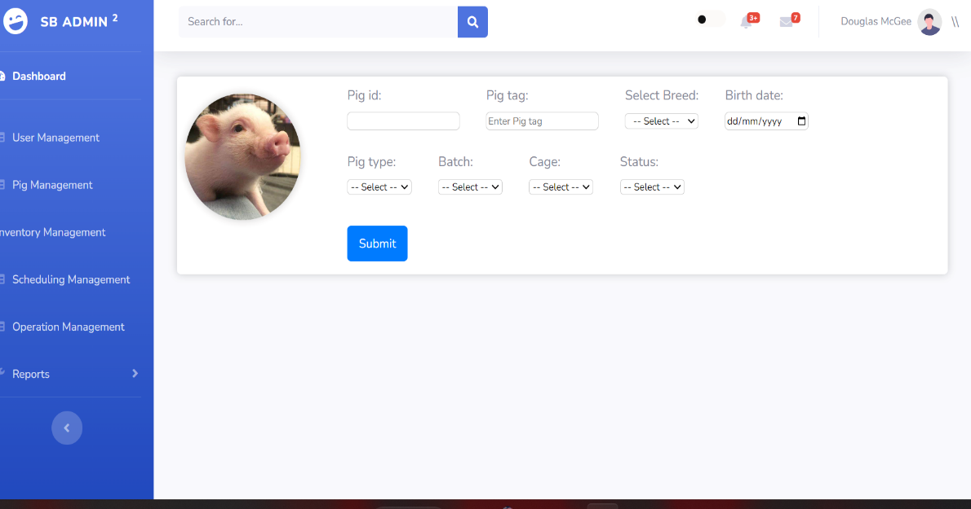

Figure 1: Traditional Piggery to Automation Farm System

Foreign

Smart Student Attendance System Using QR Code

Smart Student Attendance System Using QR Code plays a key role in recording the attendance of students wherein they need to scan the displayed QR code of their teacher. When the student is done scanning the QR code, it will automatically mark the student's attendance as present. At the same time, the system can also be used to check how many absences the student has had in one month. It can also view and edit the attendance of the student, calculate monthly attendance, and send notification to the student (Arpankumar, P., Ansel, J., Shubham, S., & Rohini, N., 2019). The researchers use web and android applications as their platform. The researchers use Java for their programming language, and they also use it to create QR code algorithms. They use PHP for the design and framework of the system, an API to generate QR codes in the system and MYSQL for their database. They use this for storing data and for database backup. In addition, this study conducted by (Arpankumar et al. 2019) suggested that the Smart Student Attendance System Using QR Code is helpful for both students and teachers. It will be easy for them to record and track their absences. Also, it will only take less than a minute for any student, as well as for the whole class, to complete their attendance, and it can save a lot of paper.

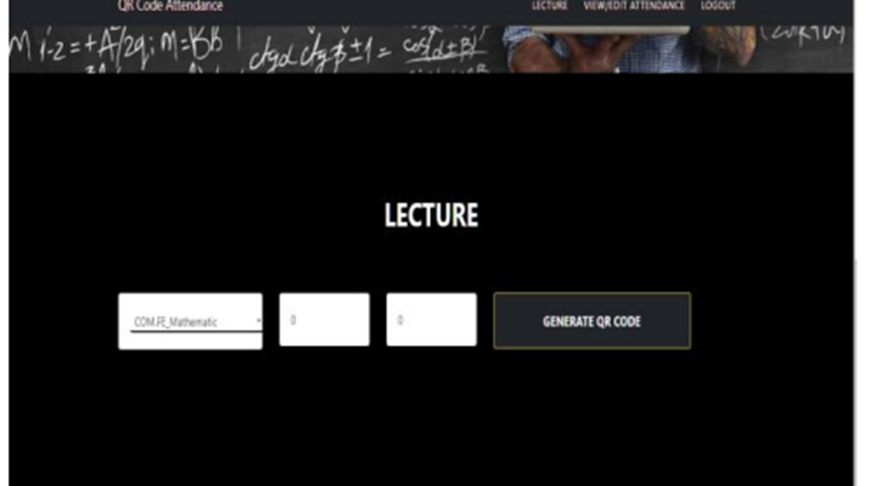

Figure 2: Smart Student Attendance System Using QR Code Teacher Module Inventory Management System

Inventory Management System

Inventory Management System was submitted at Nobel College, Pokhara University. The proposed system can be used for storing the details of the inventory, stock maintenance, updating the inventory based on the sales details, and generating sales and inventory reports daily or weekly (Maharjan, A., 2016). The Inventory Management System uses Microsoft SQL Server for the database. They also used.NET Framework 4.5 to create a platform, Microsoft Visual Studio to create console and graphical user interfaces, and Java as a programming language. The researcher uses agile methodology in developing the system, wherein by using the phase of agile, they continue to add suggestions that should make the system much 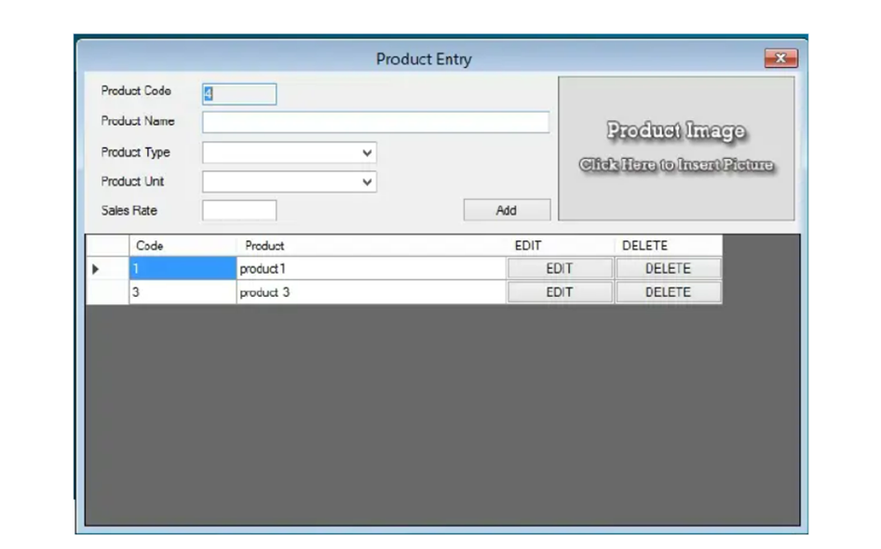better.

Figure 3: Inventory Management System Creating Product Module

|  |  |  |  |  |
| --- | --- | --- | --- | --- |
|  | Related Studies/Systems | |  |  |
| Components | Class Scheduling System | Smart Student Attendance System Using QR Code | | Inventory Management System |
| Development Environment | Web-based | Web-based and Android Mobile | | Web-based |
| Technology | Windows 10 | QR code | | Visual Studio |
| Programming Language | PHP | Java | | Java |
| Database | XAMPP,  MySQL | MySQL | | Microsoft SQL Server |
| Methodology | Rapid Application Development (RAD) | None | | Agile |
| Reports Generated | Schedule report | Present and Absences of the student | | Generate Sales and inventory Report |
| Security | User authentication | User authentication | | User authentication |
| System Features | It can assign schedule, view, and edit. | It can check how many absences you have. | | It can provide details about stock balance and balance of transaction. |
|  | It has a search button. | It can also edit the attendance, calculate monthly absences, and send a notification to the student. | | It can add items to the inventory. |
|  | It is capable of import and export. |  | | The application also contains general organization profile. |

Table 1: Related Systems Summary Table

## Synthesis

The review of related literature and studies discussed the importance and the use of technology in the field of piggery management system. The review of related literature described and discussed the theories and technologies that could be used to develop a system that will help the hog farm to have a fast transaction in managing the piggery farm and discussing on how to eliminate the human error that the workers in the farm experienced (Reginio & Robles, 2021). Thus, discussing the process of the breed information system uses a database which the workers can store, manage, analyze, and archive data. Also, it that can help them easy to monitor and manage the performance and the health of the pig in the farm by Jung et al. (2021). The importance on how the workers control the information if they do an operation in the farm and the importance of having a healthy pig when it comes in business or enterprise, and the process on how the farmers and workers manage the animals in terms of breeding (Hady & Lammers, 2015). As Knox (2021) said, breeding has a method that the farm need. This process are the pen mating, hand mating, and an AI which can help the farm to make the process easy. This process uses a Database normalization to lessen the repetition of data in database that causes the performance in retrieving and updating the information in the database by Hiller (2015). Cloud computing is an essential technology in today's world as it allows users to access information anywhere in the world. Cloud computing uses infrastructure like data centers to run virtual servers and access data centers. These servers are built around the world, which offers fast load times depending on client internet service. As mentioned by (Dar & Ravindran, 2018), Cloud computing is cost effective as multiple users buy monthly service and they pay for the power they use which means, it is performance driven. The more the client user uses, the higher the cost, but the lower the client user uses, the lower the cost. A QR code, on the other hand, is a graphic that consists of black and white squares. As Hossain et al. (2018) mentioned, it can store long characters like URLS, images or video links. This feature is helpful with advertising and using unique identification as it could store a lot of information that can be processed by a system that integrates QR Code. Also, QR has error correction where even if 30% of the QR Code is damaged, it can still be scanned.

Furthermore, QR Code can be detected with its sides and scanned in any orientation, which is useful when used in an environment where the QR Code can be rotated. As Odeh (2019) mentioned, Web programming is essential for creating web pages. It has a lot of languages that can be used to do web programming. However, one of those languages, PHP, an open-source server-side scripting language, can be used to render web pages using server-side, which makes server-side data and code safe by (Siame & Kunda, 2017). It requires an internet connection to do so. Other than that, it requires data to pass in a network protocol called TCP/IP, which determines how the data is sent to the server. However, Wheeler (2021) said, before you can connect to a website, you must know which IP address is the server, so DNS keeps track of this IP and assigns a name to it. There are also systems that develop manually which in terms of recording the information or the data about pigs, workers are responsible in listing all the pig information such as in every operation that the farm doing, and they should capture the important events that the farm do because having a human error makes the information and report inaccurate or they can loss the record book. Also, about monitoring the health of the pigs, workers must check it regularly so that the farm owners should not worry about its pig by Evin et al. (2017). However, there is also an existing system from the past years which needs more improvement, although, it can make the work of the workers in the farm easy, but it is not totally convenient or enough to use for the current generation by Maliappis et al. (1972). The define methods can help the proponent in deciding the correct method they will used in their study. Upon the 3 methods which is the agile method which define by Janani (2021), the waterfall method which used by Sharma (2021). And spiral method of Martin (2022). These methodologies give idea to the proponent on what is the best method for their proposed system. The proponents choose agile model to develop the system because of its evolutionary wherein programmers and developers can create a system and improved it in every process. Also, because they Agile method is a step-by-step process it also can accept feedback or suggestions from clients or customers. The review of related studies showed that both local and foreign are focused on resolving the problems especially in recording of information and monitoring, which will make the recording of information and monitoring much easier. The related systems can also give idea to the proponents on what technologies will be helpful in developing a system.

The related system mentioned by Labuanan et al. (2021), the College of Computing Studies, Information and Communication Technology (CCSICT) developed a Class Scheduling System that uses HTML, XAMPP, MySQL, PHP, CSS3, Bootstrap, JQuery in developing a web application and RAD in developing a system prototype. As Arpankumar et al. (2019) said, they use mobile and QR code technology for making the recording of attendance much easier, they use MySQL for the database of the system. The system can also generate monthly reports on the absence of the students, the related system is also like the proposed system wherein the proposed system had also a mobile based QR code technology that will be used for displaying the information of the pigs. In developing the inventory system, Maharjan (2016) show that inventory purposed and capabilities which it can store items and recording items which the proponent can use as a reference in developing the inventory module of the proposed system. It also uses web-based technology that can be used by the proponent in the proposed system, the web-based technology can be accessed anywhere and anytime by the user provided they had internet connection which can give a huge advantage in the proposed system especially for the owner of the RVM hog farm that always travel. The related system also uses technologies that the proponent can also use or consider when developing the proposed system like the MySQL wherein almost all the related system uses as their database, the proposed system will also use MySQL as a database when developing a system. MySQL will play a big role in storing the data of the system which all information of the farm will be stored with. The related system shows how the technologies like CSS and PHP is used in the related system, the proponent will be using same technologies for the design and development of the proposed system. Furthermore, the proposed system is not a repetition of any system, the proposed system is designed and developed for the sake of the RVM hog farm. The proposed system is built using the following technologies: cloud computing, web programming languages like PHP and frameworks such as tailwind CSS and jQuery, android studio, XZing Library, MySQL for the database, MCamera X library, Chart.js and QRCode.js Library. That are the technologies that the proponent will be using while developing the proposed system.

## TECHNICAL BACKGROUND

## This chapter describes the technical background of the study considering the overview of the current technologies to be used in the system. This section also describes the hardware, software, peopleware, and network requirement of the proposed system.

## Overview of Current Technologies to be Used in the System

In developing the proposed system, the proponent will use certain technologies to achieve the goal the proponent needs. The proponent will use cloud computing, web programming languages like JavaScript and frameworks such as tailwind CSS and NextJs, android studio, XZing Library, Camera X library, Chart.js, Twilio SMS API and QRCode.js Library.

NextJs is a JavaScript framework that provide server-side rendering (SSR) or client-side rendering. NextJs enables the proponent to use a strong type programming language on top of JavaScript called typescript to enable advance error catching and types in variables. NextJs which is supported by Vercel can be easily deployed on Vercel. Other than that, it supports API routing out of that box which we can implement authentication easily with Json Web Token. NextJs will require Node Js a development environment for JavaScript which provide packages via Node Package Manager (NPM) which the proponents can use to create and implement the required proposed function of the system.Chart.js would be used to server as chart generator for dashboard module.

Cloud computing is a choice for hosting web servers. The proponent will use Digital Ocean VPS for this proposed system with installed software like NodeJs for webserver to run the web-based system and act as API end point for the mobile application to access data like their login information or pigs’ information. and MYSQL Database service which is for storing information that is needed for system like login information, pig information and inventory information.

Android application will use Java programming language with Android Studio IDE which is the current latest IDE version. This Android application can authenticate and Scan QR Code to retrieve pig information. This provides mobility so that the worker does not need to carry computer devices while doing pig information checking.

XZing QR Code Library or called Zebra Crossing is an open-source image processing library that can process 1D/2D barcode image that is implemented in JAVA and ported to other language like C# and many more. This will be used to read or scan QR Code to retrieve the unique identifier of a pig.

Camera X library is a Jetpack library that is built to help make camera app development easy. It provides easy to API that works across most of android devices which start from android 5.0 or API Level 21. This will make android camera access easy and fast for the proponent to work efficiently in the proposed system.

QRCode.js was developed by David shimjs, A JavaScript library for making QR Code using html 5 canvas and table tag in DOM. This library will be used to create QR Code with unique identifier and can be save and printed when needed. Twilio SMS API is an Application Program Interface for sending text message automatically. Twilio is a company that provide services such as SMS API, Programmable Voice call and many more. Thus, Twilio provide plans for services with monthly payment .SMS API would be used in sending SMS Notification for the scheduling management.

With the mentioned development tools and technologies, this gives proponent a power to create a web-based piggery accounting and management system with mobile based QR code scanner that can improve the management of RVM hog farm. Other than that, it provides better data retrieval, security consistency and accuracy on current situation in RVM hog farm.

**Hardware**

The minimum hardware requirements for running the web application are listed in the table below:

|  |  |
| --- | --- |
| **HARDWARE** | **REQUIREMENTS** |
| MONITOR | 19” LCD screen Resolution:1366x768 |
| PROCESSOR/CPU | 1.8GHz or faster Intel or AMD processor |
| HARD DISK SPACE | 250GB Hard Disk Drive (HDD) or 256GB Solid State Drive (SSD) |

**Table 2: Hardware Requirements for Running the Web Application**

The minimum hardware requirements for installing and running the mobile application are listed in the table below:

|  |  |
| --- | --- |
| **HARDWARE** | **REQUIREMENTS** |
| PROCESSOR | 1.3GHz Quad-Core |
| MEMORY (RAM) | 4GB RAM or higher |
| MEMORY (ROM) | 8GB ROM or higher |
| STORAGE | 32GB or better |
| DISPLAY | At least 6.5“Display or higher |

**Table 3: Hardware Requirements for Installing and Running the Mobile Application**

**Software**

The minimum software requirements for running the web application are listed in the table below:

|  |  |
| --- | --- |
| **SOFTWARE** | **REQUIREMENTS** |
| OPERATING SYSTEM (OS) | Any operation system that supports web browser |
| BROWSER | Google Chrome/Mozilla Firefox |

**Table 4: Software Requirements for web application**

The minimum software requirements for installing and running the mobile application are listed in the following tables below:

|  |  |
| --- | --- |
| **SOFTWARE** | **REQUIREMENTS** |
| OPERATING SYSTEM (OS) | Lollipop version 5.0 - 5.1.1 or higher versions |

**Table 5: Software Requirements for mobile application**

Peopleware

The following are the people involved and their responsibilities in developing the project:

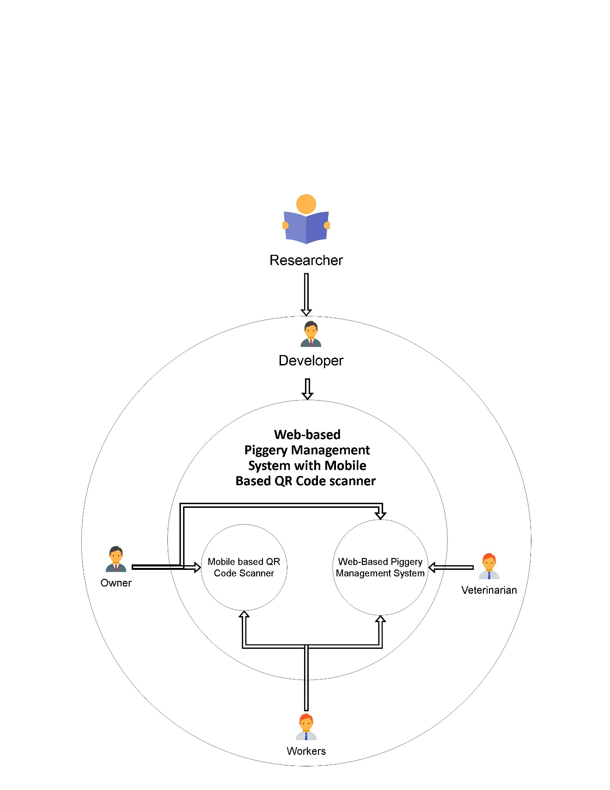

Figure #

**Researcher** - The researcher creates plans that would meet the requirements of the proposed systems. The researcher collects data from books, journals, other existing research, and other documents that can relate to the proposed system.

**Developer** – Developer’s task is to create a program that is in line to the required modules of the proposed system; and identify the possibilities of new program feature to be modified and making these modifications to in line with the proposed system. Developer will also ensure that the program is feasible and has quality assurance procedure. Developer will also be in charge on testing, deployment of tools and processes that are required to run the application.

**Owner** - Owner of RVM Hog farm has access to the mobile based QR code scanner and the web-based accounting and management system which enable him to manage the web-based system better. Other than that mobile app access gives him power to monitor each pig information if the owner is in the hog farm.

**Veterinarian** – Veterinarian needs to see information of the pig. Giving access to the web-based System allow them to view information’s that the veterinarian needs.

**Figure 4: Peopleware Diagram**

**Researcher** - The researcher creates plans that would meet the requirements of the proposed systems. The researcher collects data from books, journals, other existing research, and other documents that can relate to the proposed system.

**Developer** – Developer’s task is to create a program that is in line to the required modules of the proposed system; and identify the possibilities of new program feature to be modified and making these modifications to in line with the proposed system. Developer will also ensure that the program is feasible and has quality assurance procedure. Developer will also be in charge on testing, deployment of tools and processes that are required to run the application.

**Owner** - Owner of RVM Hog farm has access to the mobile based QR code scanner and the web-based accounting and management system which enable him to manage the web-based system better. Other than that mobile app access gives him power to monitor each pig information if the owner is in the hog farm.

**Veterinarian** – Veterinarian needs to see information of the pig. Giving access to the web-based System allow them to view information’s that the veterinarian needs.

**Worker** - Worker has access to both web based and mobile system as they need to enter data into system. Other than that, they need to view pig information and that is achievable using the android application.

**Network**

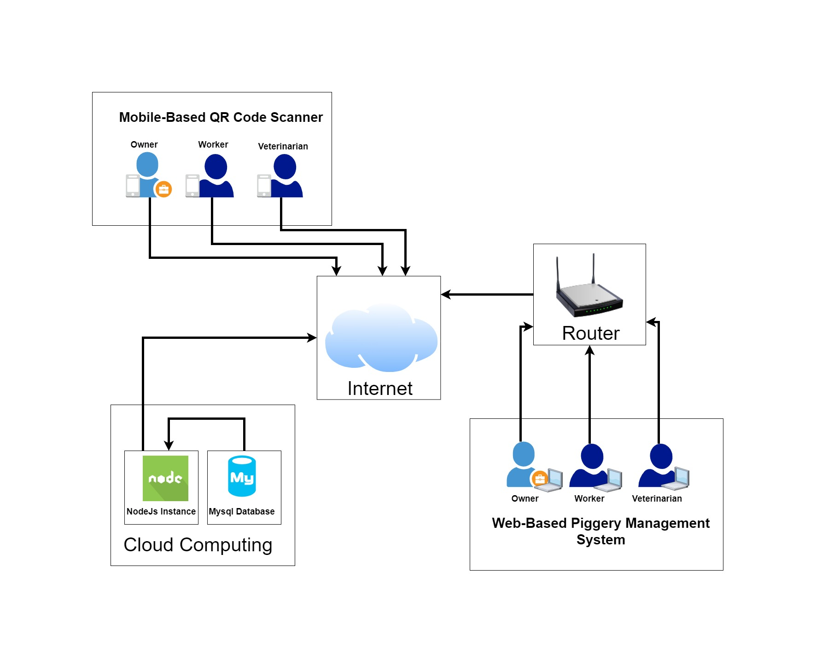

**Figure 5: Network Diagram**

The diagram above shows how the network of proposed system. Web-based system is deployed in one of digital ocean cloud computing using a VPS or called droplet. This allows owner, workers, and veterinarian to view piggery status and information anywhere and anytime. They would need to have internet connection to access the web-based system and they can be in the farm using Wi-Fi or ethernet or mobile data. The data on android application can be retrieved using the API. In this way, everything can be easily retrieved using http request.

## Calendar of Activities

**Methodology**

The proponents will use agile model as it offers team productivity. With agile, task is divided into chunk where each chunk will have to deliver specific requirement. Agile model is a combination of iterative which means it changes can be done easily and incremental which means adding something slowly.

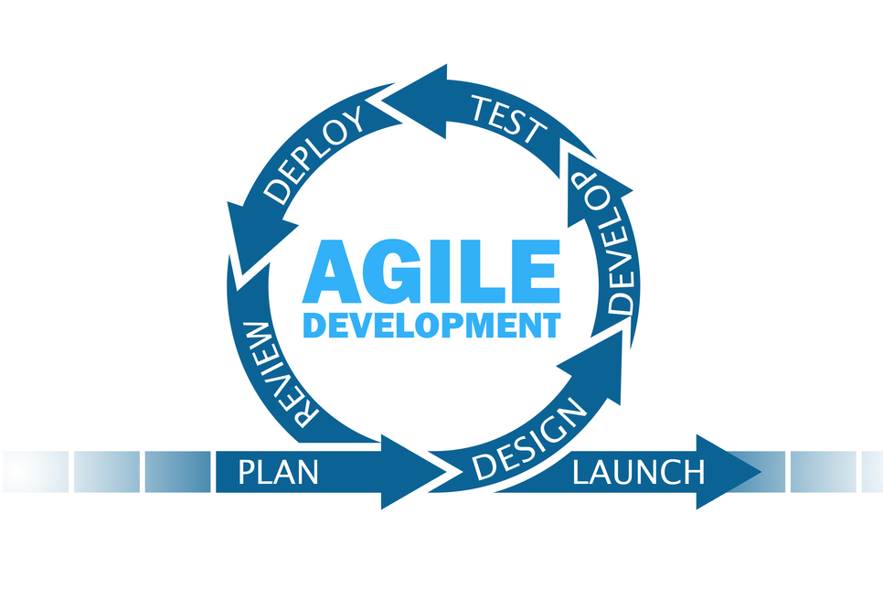

Figure 6: Agile Methodology

**Activity Name:** Project Planning and Initiation

**Objectives of the Activity:**

1. To identify the company/agency that is suitable for the proposed system.
2. To create a questionnaire that can gather data and process of the identified company/agency.
3. To create a request letter to interview the identified company/agency.

**Description:**

The proponent brainstormed an idea for a system that will be proposed to a company/agency. After deciding on the system, the proponent will find a company/agency to propose the chosen idea of the proposed system. If the proponents identified the company/agency, then they will create a letter to request permission from the manager /owner of the agency for permission to conduct an interview. Thus, if permitted then the proponent will create a questionnaire to ask for details about the problems and process of the identified company/agency. Furthermore, the proponent will gather data that can be analyzed to create the modules of the proposed system.

**Persons Involved:** Proponents, stakeholders.

**Resources:** Request Letter, Questionnaire, Laptop, and Microsoft

**Timeline:** Week 3-18

**Activity Name:** Requirements Analysis

**Objectives of the Activity:**

1. To determine the current technical process of RVM Hog farm.
2. To create data flow diagram of the current system using Gane and Sarson Model.
3. To create a dataflow diagram of the proposed system using Gane and Sarson Model.
4. To determine the implementation of proposed system with the use of physical diagram.

**Description:**

The proponent would create diagram that would see if the current and proposed system will have difference. The proponent would like to see that the proposed system will have better process than the current system. The proponent would create data flow diagram that would visualize how the current process of RVM hog farm work. This would include Level 0, Logical Data Flow Diagram Level 1. Furthermore, the proponent would create data flow diagram of the proposed system that would visualize how the proposed system process would work. This includes a Level 0 Physical data flow diagram of the proposed system and Level 1 physical data flow diagram of the proposed system.

**Persons Involved:** Proponents and Developers

**Resources:** Laptop, Lucid Chart, Microsoft Word, Browser, Diagram.net, Internet Connection

**Timeline:** Week 19-20

**Activity Name:** Requirements Documentation

**Objectives of the Activity:**

1. To create functional requirements and non-functional requirement

**Description:**

The proponent would create a storyboard which would show how the User Interface of the proposed system works. Thus, creating this story board would allow the proponent to visualize and layout the look of the proposed system. Furthermore, the proponent would create functional requirements for the proposed system where it would describe how the proposed system will behave. Thus, giving the proponent plans for the proposed system when Iterations start.

**Persons Involved:** Proponents and Developers

**Resources:** Lucid Chart, Laptop, Diagram.net, Internet Connection, Browser, Microsoft Word

**Timeline:** Week 21

**Activity Name:** Design of Conceptual Framework and System Architecture

**Objectives of the Activity:**

1. To design system architecture that follows Three-Tier Architecture Model
2. To design Conceptual Framework that follow Input-Process-Output Model

**Description:**

The proponents would create System Architecture design that follows Three-Tier Architecture Model which would consist of application, presentation, and data tier. This would give the proponent an idea of how the proposed system works based on the designed System Architecture. Furthermore, the proponent would create conceptual framework that follow Input-Process-Output model to determine how the input data will be processed and outputted by the proposed system.

**Persons Involved:** Proponents and Developers

**Resources:** Laptop, Lucid Chart, Browser, Internet Connection, Diagram.net

**Timeline:** Week 22-23

**Activity Name:** Object Modeling

**Objectives of the Activity:**

1. To create an Event Decomposition, Use Case Diagram and Activity Diagram of the proposed system.

**Description:**

The proponent would create an Even Decomposition with Use Case diagram to determine which use case each event will do. Thus, the proponent would determine which stakeholders are involved in each event. Furthermore, the proponent would create activity diagram which would determine the flow of activity in the proposed system.

**Persons Involved:** Proponents, stakeholders.

**Resources:** Laptop, Lucid Chart, Browser, Internet Connection, Diagram.net

**Timeline:** Week 24-25

**Activity Name:** Database Design

**Objectives of the Activity:**

1. To create Conceptual Database Model
2. To create Normalization
3. To create Logical Database Model
4. To create Physical Database Model
5. To create Data Dictionary

**Description:**

The proponent will create a Conceptual Database Model to determine how to organize the view of database and it`s relationship. This only includes entities, attributes, and the relationship of each table. Also, the proponent would create Normalization of the design Database Model thus making the database model efficient. The proponent would only use 1NF, 2NF, and 3NF in Normalization as it would be efficient enough to optimize the database model. The proponent would also create Logical Database Model which would add more detail to the Conceptual Database Model and to create a foundation for the Physical Database Model which would offer database abstraction and would add database schema Physical Database Model would help the proponent visualize how the database structure would look like in Database Management Software (DBMS) by adding indexes, foreign keys, primary keys, and other DBMS features.

**Persons Involved:** Proponents and Developers

**Resources:** Lucid Chart, Diagram.net, Microsoft World, Laptop, Internet, Browser

**Timeline:** Week 26-27

**Activity Name:** Software Development Iteration 1 – Development of <module name>

**Objectives of the Activity:**

1. To design, code and test Pig Management Module

**Description:**

The proponent would start to develop Pig Management Module. The proponent would Code the proposed module base on the scope presented. This would include a batch and cage management. Furthermore, design and event would follow the created story board and models.

**Persons Involved:** Proponents and Developers

**Resources:** XAMPP, Visual Studio Code, Laptop, Internet, Browser, LucidChart.io and Diagram.net

**Timeline:** Week 28

**Activity Name:** Software Development Iteration 2 – Development of Inventory Management

**Objectives of the Activity:**

1. To design, code and test Inventory Management

**Description:**

The proponent would start to develop Inventory Management Module. The proponent would Code the proposed module base on the scope presented. This module would follow the created story board which would help the developers to visualize how the module would look like and the series of event it would occur.

**Persons Involved:** Proponents and Developers

**Resources:** XAMPP, Visual Studio Code, Laptop, Internet, Browser, LucidChart.io and Diagram.net

**Timeline:** Week 29

**Activity Name:** Software Development Iteration 3 – Development of Scheduling Management

**Objectives of the Activity:**

1. To design, code and test Scheduling Management

**Description:**

The proponent would start to develop Scheduling Management Module. The proponent would Code the proposed module base on the scope presented. This module would follow the created story board which would help the developers to visualize how the module would look like and the series of event it would occur. Furthermore, the proponent would start to implement the SMS Notification to the module.

**Persons Involved:** Proponents and Developers

**Resources:** XAMPP, Visual Studio Code, Laptop, Internet, Browser, LucidChart.io and Diagram.net

**Timeline:** Week 30

**Activity Name:** Software Development Iteration 4– Development of Record Management

**Objectives of the Activity:**

1. To design, code and test Inventory Management

**Description:**

The proponent would start to design, code and testing Record Management Module. The proponent would Code the proposed module base on the scope presented. This module would follow the created story board which would help the developers to visualize how the module would look like and the series of event it would occur.

**Persons Involved:** Proponents and Developers

**Resources:** XAMPP, Visual Studio Code, Laptop, Internet, Browser, LucidChart.io and Diagram.net

**Timeline:** Week 31

**Activity Name:** Software Development Iteration 5– Development of Dashboard

**Objectives of the Activity:**

1. To design, code and test Dashboard

**Description:**

The proponent would start to design, code and testing Dashboard Module. The proponent would Code the proposed module base on the scope presented. This module would follow the created story board which would help the developers to visualize how the module would look like and the series of event it would occur.

**Persons Involved:** Proponents and Developers

**Resources:** XAMPP, Visual Studio Code, Laptop, Internet, Browser, LucidChart.io and Diagram.net

**Timeline:** Week 32

**Activity Name:** Software Development Iteration 6– Development of User Management

**Objectives of the Activity:**

1. To design, code and test User Management

**Description:**

The proponent would start to design, code and testing User Management Module. The proponent would Code the proposed module base on the scope presented. This module would follow the created story board which would help the developers to visualize how the module would look like and the series of event it would occur.

**Persons Involved:** Proponents and Developers

**Resources:** XAMPP, Visual Studio Code, Laptop, Internet, Browser, LucidChart.io and Diagram.net

**Timeline:** Week 33

**Activity Name:** Software Development Iteration 7– Development of Back-up and restore.

**Objectives of the Activity:**

1. To design, code and test Backup and restore

**Description:**

The proponent would start to design, code and testing Back-up and Restore Module. The proponent would Code the proposed module base on the scope presented. This module would follow the created story board which would help the developers to visualize how the module would look like and the series of event it would occur.

**Persons Involved:** Proponents and Developers

**Resources:** XAMPP, Visual Studio Code, Laptop, Internet, Browser, LucidChart.io and Diagram.net

**Timeline:** Week 34

**Activity Name:** Software Development Iteration 8– Development of Reports Module

**Objectives of the Activity:**

1. To design, code and test Reports Module

**Description:**

The proponent would start to design, code and testing Reports Module. The proponent would Code the proposed module base on the scope presented. This module would follow the created story board which would help the developers to visualize how the module would look like and the series of event it would occur. This would include Inventory, Deworming, Feeding, Vaccination and Expenses report.

**Persons Involved:** Proponents and Developers

**Resources:** XAMPP, Visual Studio Code, Laptop, Internet, Browser, LucidChart.io and Diagram.net

**Timeline:** Week 34

**Activity Name:** Software Development Iteration 9– Development of QR Scan Module

**Objectives of the Activity:**

1. To design, code, and test QR Scan Module

**Description:**

The proponent would start to design, code and testing QR Scan Module. The proponent would Code the proposed module base on the scope presented. This module would follow the created story board which would help the developers to visualize how the module would look like and the series of event it would occur.

**Persons Involved:** Proponents and Developers

**Resources:** XAMPP, Android Studio, Mobile Phone, Laptop, Internet, Browser, LucidChart.io and Diagram.net

**Timeline:** Week 35

**Activity Name:** Software Development Iteration 10– Development of Dashboard Module

**Objectives of the Activity:**

1. To design, code and test Dashboard

**Description:**

The proponent would start to design, code, and testing Dashboard Module. The proponent would Code the proposed module base on the scope presented. This module would follow the created story board which would help the developers to visualize how the module would look like and the series of event it would occur.

**Persons Involved:** Proponents and Developers

**Resources:** XAMPP, Android Studio, Mobile Phone, Laptop, Internet, Browser, LucidChart.io and Diagram.net

**Timeline:** Week 35

**Activity Name:** Software Development Iteration 11– Development of Login Module for Web Application

**Objectives of the Activity:**

1. To design, code and test Login Module

**Description:**

The proponent would start to design, code and testing Login Module. The proponent would Code the proposed module base on the scope presented. This module would follow the created story board which would help the developers to visualize how the module would look like and the series of event it would occur.

**Persons Involved:** Proponents and Developers

**Resources:** XAMPP, Visual Studio Code, Laptop, Internet, Browser, LucidChart.io and Diagram.net

**Timeline:** Week 36

**Activity Name:** Software Development Iteration 11– Development of Login Module for Mobile Application

**Objectives of the Activity:**

1. To design, code and test Login Module

**Description:**

The proponent would start to design, code and testing Login Module. The proponent would Code the proposed module base on the scope presented. This module would follow the created story board which would help the developers to visualize how the module would look like and the series of event it would occur.

**Persons Involved:** Proponents and Developers

**Resources:** XAMPP, Android Studio, Laptop, Mobile Phone, Internet, Browser, LucidChart.io and Diagram.net

**Timeline:** Week 36

**Activity Name:** Alpha Testing

**Objectives of the Activity:**

1. To test the proposed System with the help of IT Professionals

**Description:**

The proponent would test the Proposed System with the help of IT Professionals and would gather feedback if the Developed System aligned with the proposed system.

**Persons Involved:** Proponents, IT Professionals, and Developers

**Resources:** XAMPP, Visual Studio Code, Laptop, Internet, Browser, LucidChart.io and Diagram.net, Android Studio, and Mobile Phone.

**Timeline:** Week 37-38

Gantt chart would visualize how the calendar of activity look like when formatted per weeks. Furthermore, Gantt chart would show clear visualization of the sequence of event will work.

**Gantt Chart of Activities**

|  |  |  |  |  |  |  |  |  |  |  |  |  |  |  |  |  |  |  |  |  |  |  |  |  |  |  |  |  |  |  |  |  |  |  |  |  |  |  |  |  |
| --- | --- | --- | --- | --- | --- | --- | --- | --- | --- | --- | --- | --- | --- | --- | --- | --- | --- | --- | --- | --- | --- | --- | --- | --- | --- | --- | --- | --- | --- | --- | --- | --- | --- | --- | --- | --- | --- | --- | --- | --- |
| MONTH | FEBRUARY | | | | MARCH | | | | APRIL | | | | MAY | | | | JUNE | | | | JULY | | | | AUGUST | | | | SEPTEMBER | | | | OCTOBER | | | | NOVEMBER | | | |
| ACTIVITY |
| Planning & Initiation |  |  |  |  |  |  |  |  |  |  |  |  |  |  |  |  |  |  |  |  |  |  |  |  |  |  |  |  |  |  |  |  |  |  |  |  |  |  |  |  |
| Requirements Analysis |  |  |  |  |  |  |  |  |  |  |  |  |  |  |  |  |  |  |  |  |  |  |  |  |  |  |  |  |  |  |  |  |  |  |  |  |  |  |  |  |
| Requirements  Documentation |  |  |  |  |  |  |  |  |  |  |  |  |  |  |  |  |  |  |  |  |  |  |  |  |  |  |  |  |  |  |  |  |  |  |  |  |  |  |  |  |
| Design of Conceptual  Framework and System  Architecture |  |  |  |  |  |  |  |  |  |  |  |  |  |  |  |  |  |  |  |  |  |  |  |  |  |  |  |  |  |  |  |  |  |  |  |  |  |  |  |  |
| Object Modeling |  |  |  |  |  |  |  |  |  |  |  |  |  |  |  |  |  |  |  |  |  |  |  |  |  |  |  |  |  |  |  |  |  |  |  |  |  |  |  |  |
| Database Design |  |  |  |  |  |  |  |  |  |  |  |  |  |  |  |  |  |  |  |  |  |  |  |  |  |  |  |  |  |  |  |  |  |  |  |  |  |  |  |  |
| System Development |  |  |  |  |  |  |  |  |  |  |  |  |  |  |  |  |  |  |  |  |  |  |  |  |  |  |  |  |  |  |  |  |  |  |  |  |  |  |  |  |
| *\*Back-end Modules*  *Development* |  |  |  |  |  |  |  |  |  |  |  |  |  |  |  |  |  |  |  |  |  |  |  |  |  |  |  |  |  |  |  |  |  |  |  |  |  |  |  |  |
| Iteration 1 – Pig Management |  |  |  |  |  |  |  |  |  |  |  |  |  |  |  |  |  |  |  |  |  |  |  |  |  |  |  |  |  |  |  |  |  |  |  |  |  |  |  |  |
| Design |  |  |  |  |  |  |  |  |  |  |  |  |  |  |  |  |  |  |  |  |  |  |  |  |  |  |  |  |  |  |  |  |  |  |  |  |  |  |  |  |
| Coding |  |  |  |  |  |  |  |  |  |  |  |  |  |  |  |  |  |  |  |  |  |  |  |  |  |  |  |  |  |  |  |  |  |  |  |  |  |  |  |  |
| Unit Testing |  |  |  |  |  |  |  |  |  |  |  |  |  |  |  |  |  |  |  |  |  |  |  |  |  |  |  |  |  |  |  |  |  |  |  |  |  |  |  |  |
| Iteration 2 – Inventory Management |  |  |  |  |  |  |  |  |  |  |  |  |  |  |  |  |  |  |  |  |  |  |  |  |  |  |  |  |  |  |  |  |  |  |  |  |  |  |  |  |
| Design |  |  |  |  |  |  |  |  |  |  |  |  |  |  |  |  |  |  |  |  |  |  |  |  |  |  |  |  |  |  |  |  |  |  |  |  |  |  |  |  |
| Coding |  |  |  |  |  |  |  |  |  |  |  |  |  |  |  |  |  |  |  |  |  |  |  |  |  |  |  |  |  |  |  |  |  |  |  |  |  |  |  |  |
| Unit Testing |  |  |  |  |  |  |  |  |  |  |  |  |  |  |  |  |  |  |  |  |  |  |  |  |  |  |  |  |  |  |  |  |  |  |  |  |  |  |  |  |
| Iteration 2 – Scheduling Management |  |  |  |  |  |  |  |  |  |  |  |  |  |  |  |  |  |  |  |  |  |  |  |  |  |  |  |  |  |  |  |  |  |  |  |  |  |  |  |  |
| Design |  |  |  |  |  |  |  |  |  |  |  |  |  |  |  |  |  |  |  |  |  |  |  |  |  |  |  |  |  |  |  |  |  |  |  |  |  |  |  |  |
| Coding |  |  |  |  |  |  |  |  |  |  |  |  |  |  |  |  |  |  |  |  |  |  |  |  |  |  |  |  |  |  |  |  |  |  |  |  |  |  |  |  |
| Unit Testing |  |  |  |  |  |  |  |  |  |  |  |  |  |  |  |  |  |  |  |  |  |  |  |  |  |  |  |  |  |  |  |  |  |  |  |  |  |  |  |  |
| MONTH | FEBRUARY | | | | MARCH | | | | APRIL | | | | MAY | | | | JUNE | | | | JULY | | | | AUGUST | | | | SEPTEMBER | | | | OCTOBER | | | | NOVEMBER | | | |
| ACTIVITY |
| Iteration 1 – Record Management |  |  |  |  |  |  |  |  |  |  |  |  |  |  |  |  |  |  |  |  |  |  |  |  |  |  |  |  |  |  |  |  |  |  |  |  |  |  |  |  |
| Design |  |  |  |  |  |  |  |  |  |  |  |  |  |  |  |  |  |  |  |  |  |  |  |  |  |  |  |  |  |  |  |  |  |  |  |  |  |  |  |  |
| Coding |  |  |  |  |  |  |  |  |  |  |  |  |  |  |  |  |  |  |  |  |  |  |  |  |  |  |  |  |  |  |  |  |  |  |  |  |  |  |  |  |
| Unit Testing |  |  |  |  |  |  |  |  |  |  |  |  |  |  |  |  |  |  |  |  |  |  |  |  |  |  |  |  |  |  |  |  |  |  |  |  |  |  |  |  |
| Iteration 1 – Dashboard |  |  |  |  |  |  |  |  |  |  |  |  |  |  |  |  |  |  |  |  |  |  |  |  |  |  |  |  |  |  |  |  |  |  |  |  |  |  |  |  |
| Design |  |  |  |  |  |  |  |  |  |  |  |  |  |  |  |  |  |  |  |  |  |  |  |  |  |  |  |  |  |  |  |  |  |  |  |  |  |  |  |  |
| Coding |  |  |  |  |  |  |  |  |  |  |  |  |  |  |  |  |  |  |  |  |  |  |  |  |  |  |  |  |  |  |  |  |  |  |  |  |  |  |  |  |
| Unit Testing |  |  |  |  |  |  |  |  |  |  |  |  |  |  |  |  |  |  |  |  |  |  |  |  |  |  |  |  |  |  |  |  |  |  |  |  |  |  |  |  |
| Iteration 1 – User Management |  |  |  |  |  |  |  |  |  |  |  |  |  |  |  |  |  |  |  |  |  |  |  |  |  |  |  |  |  |  |  |  |  |  |  |  |  |  |  |  |
| Design |  |  |  |  |  |  |  |  |  |  |  |  |  |  |  |  |  |  |  |  |  |  |  |  |  |  |  |  |  |  |  |  |  |  |  |  |  |  |  |  |
| Coding |  |  |  |  |  |  |  |  |  |  |  |  |  |  |  |  |  |  |  |  |  |  |  |  |  |  |  |  |  |  |  |  |  |  |  |  |  |  |  |  |
| Unit Testing |  |  |  |  |  |  |  |  |  |  |  |  |  |  |  |  |  |  |  |  |  |  |  |  |  |  |  |  |  |  |  |  |  |  |  |  |  |  |  |  |
| Iteration 2 – Backup and Restore |  |  |  |  |  |  |  |  |  |  |  |  |  |  |  |  |  |  |  |  |  |  |  |  |  |  |  |  |  |  |  |  |  |  |  |  |  |  |  |  |
| Design |  |  |  |  |  |  |  |  |  |  |  |  |  |  |  |  |  |  |  |  |  |  |  |  |  |  |  |  |  |  |  |  |  |  |  |  |  |  |  |  |
| Coding |  |  |  |  |  |  |  |  |  |  |  |  |  |  |  |  |  |  |  |  |  |  |  |  |  |  |  |  |  |  |  |  |  |  |  |  |  |  |  |  |
| Unit Testing |  |  |  |  |  |  |  |  |  |  |  |  |  |  |  |  |  |  |  |  |  |  |  |  |  |  |  |  |  |  |  |  |  |  |  |  |  |  |  |  |
| Iteration 2 – Reports Module |  |  |  |  |  |  |  |  |  |  |  |  |  |  |  |  |  |  |  |  |  |  |  |  |  |  |  |  |  |  |  |  |  |  |  |  |  |  |  |  |
| Design |  |  |  |  |  |  |  |  |  |  |  |  |  |  |  |  |  |  |  |  |  |  |  |  |  |  |  |  |  |  |  |  |  |  |  |  |  |  |  |  |
| Coding |  |  |  |  |  |  |  |  |  |  |  |  |  |  |  |  |  |  |  |  |  |  |  |  |  |  |  |  |  |  |  |  |  |  |  |  |  |  |  |  |
| Unit Testing |  |  |  |  |  |  |  |  |  |  |  |  |  |  |  |  |  |  |  |  |  |  |  |  |  |  |  |  |  |  |  |  |  |  |  |  |  |  |  |  |

|  |  |  |  |  |  |  |  |  |  |  |  |  |  |  |  |  |  |  |  |  |  |  |  |  |  |  |  |  |  |  |  |  |  |  |  |  |  |  |  |  |
| --- | --- | --- | --- | --- | --- | --- | --- | --- | --- | --- | --- | --- | --- | --- | --- | --- | --- | --- | --- | --- | --- | --- | --- | --- | --- | --- | --- | --- | --- | --- | --- | --- | --- | --- | --- | --- | --- | --- | --- | --- |
| MONTH | FEBRUARY | | | | MARCH | | | | APRIL | | | | MAY | | | | JUNE | | | | JULY | | | | AUGUST | | | | SEPTEMBER | | | | OCTOBER | | | | NOVEMBER | | | |
| ACTIVITY |
| Iteration 7 – QR Scan |  |  |  |  |  |  |  |  |  |  |  |  |  |  |  |  |  |  |  |  |  |  |  |  |  |  |  |  |  |  |  |  |  |  |  |  |  |  |  |  |
| Design |  |  |  |  |  |  |  |  |  |  |  |  |  |  |  |  |  |  |  |  |  |  |  |  |  |  |  |  |  |  |  |  |  |  |  |  |  |  |  |  |
| Coding |  |  |  |  |  |  |  |  |  |  |  |  |  |  |  |  |  |  |  |  |  |  |  |  |  |  |  |  |  |  |  |  |  |  |  |  |  |  |  |  |
| Unit Testing |  |  |  |  |  |  |  |  |  |  |  |  |  |  |  |  |  |  |  |  |  |  |  |  |  |  |  |  |  |  |  |  |  |  |  |  |  |  |  |  |
| Iteration 7 - Dashboard |  |  |  |  |  |  |  |  |  |  |  |  |  |  |  |  |  |  |  |  |  |  |  |  |  |  |  |  |  |  |  |  |  |  |  |  |  |  |  |  |
| Design |  |  |  |  |  |  |  |  |  |  |  |  |  |  |  |  |  |  |  |  |  |  |  |  |  |  |  |  |  |  |  |  |  |  |  |  |  |  |  |  |
| Coding |  |  |  |  |  |  |  |  |  |  |  |  |  |  |  |  |  |  |  |  |  |  |  |  |  |  |  |  |  |  |  |  |  |  |  |  |  |  |  |  |
| Unit Testing |  |  |  |  |  |  |  |  |  |  |  |  |  |  |  |  |  |  |  |  |  |  |  |  |  |  |  |  |  |  |  |  |  |  |  |  |  |  |  |  |
| Iteration 7 – Web-Based Login Module |  |  |  |  |  |  |  |  |  |  |  |  |  |  |  |  |  |  |  |  |  |  |  |  |  |  |  |  |  |  |  |  |  |  |  |  |  |  |  |  |
| Design |  |  |  |  |  |  |  |  |  |  |  |  |  |  |  |  |  |  |  |  |  |  |  |  |  |  |  |  |  |  |  |  |  |  |  |  |  |  |  |  |
| Coding |  |  |  |  |  |  |  |  |  |  |  |  |  |  |  |  |  |  |  |  |  |  |  |  |  |  |  |  |  |  |  |  |  |  |  |  |  |  |  |  |
| Unit Testing |  |  |  |  |  |  |  |  |  |  |  |  |  |  |  |  |  |  |  |  |  |  |  |  |  |  |  |  |  |  |  |  |  |  |  |  |  |  |  |  |
| Iteration 7 – Mobile-Based Login Module |  |  |  |  |  |  |  |  |  |  |  |  |  |  |  |  |  |  |  |  |  |  |  |  |  |  |  |  |  |  |  |  |  |  |  |  |  |  |  |  |
| Design |  |  |  |  |  |  |  |  |  |  |  |  |  |  |  |  |  |  |  |  |  |  |  |  |  |  |  |  |  |  |  |  |  |  |  |  |  |  |  |  |
| Coding |  |  |  |  |  |  |  |  |  |  |  |  |  |  |  |  |  |  |  |  |  |  |  |  |  |  |  |  |  |  |  |  |  |  |  |  |  |  |  |  |
| Unit Testing |  |  |  |  |  |  |  |  |  |  |  |  |  |  |  |  |  |  |  |  |  |  |  |  |  |  |  |  |  |  |  |  |  |  |  |  |  |  |  |  |
| Alpha-Testing |  |  |  |  |  |  |  |  |  |  |  |  |  |  |  |  |  |  |  |  |  |  |  |  |  |  |  |  |  |  |  |  |  |  |  |  |  |  |  |  |

## Resources

**Hardware**

The minimum hardware requirement for developing and testing the web and mobile application are listed in the table below.

|  |  |
| --- | --- |
| **HARDWARE** | **REQUIREMENTS** |
| MONITOR | 19” LCD screen Resolution:1366x768 |
| PROCESSOR/CPU | 1.8GHz or faster Intel or AMD processor |
| HARD DISK SPACE | 250GB Hard Disk Drive (HDD) or 256GB Solid State Drive (SSD) |

**Table 6: Hardware Requirement for Developing and Testing the Web application**

The minimum requirement for testing the mobile application is listed in the table below.

|  |  |
| --- | --- |
| **HARDWARE** | **REQUIREMENTS** |
| PROCESSOR | 1.3GHz Quad-Core |
| MEMORY (RAM) | 4GB RAM or higher |
| MEMORY (ROM) | 8GB ROM or higher |
| STORAGE | 32GB or better |
| DISPLAY | At least 6.5“Display or higher |

**Table 7: Hardware requirement for testing mobile application**

**METHODOLOGY, RESULTS, AND DISCUSSIONS**

Requirement Analysis

In developing the Web-Based Piggery Management System with Mobile Based QR Code Scanner for RVM Hog Farm in Lamba, Banga South Cotabato, the proponents used the agile model as a method of developing the proposed system. This method allows the developer and customer to interact with one another, it will also prioritize the customer satisfaction by providing a fully functional software product. The Requirement analysis is the process wherein it is use for determining the expectations of user for the system software. During this phase, all the requirements that are gather and analyze are used to solve the problem and eventually be applied in the development of the proposed system. The functional and system requirements of the proposed system are all collected, as well as the user and operational requirements. Additionally, this also define the current technical situation of the models, context diagram, logical data flow diagram and the functional and non-functional requirements of the current system of the RVM hog farm.

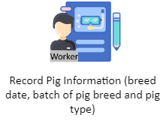**Current Technical Situation**

Figure 7: Pig Breeding Process

The worker records the pig information such as date of breed, batch of pig breed and the type of pig in the logbook.

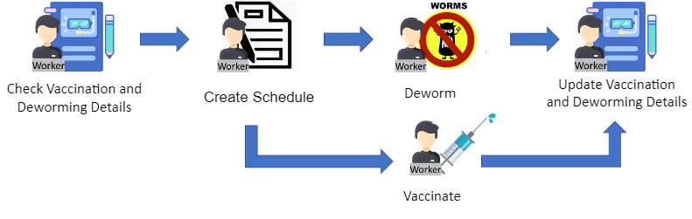

Figure 8: Pig Vaccination and Deworming Process

The worker first checks the vaccinate and deworm status of the pigs. Once the worker done checking, they now create a schedule to be follow by vaccinate and deworm of the pig. Then they conduct a vaccination and deworming for the pigs. Once the work done, they update the vaccination and deworming status of the pigs.

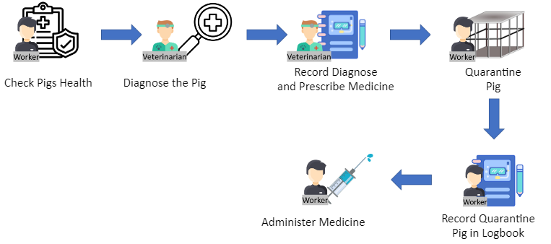

Figure 9: Veterinarian Diagnose Process

The worker checks the pig’s health. When the checking done, the veterinarian diagnoses the pig, then record the diagnose result along with the prescribed medicine in the logbook. The worker quarantines the pig and record the number of quarantine pigs in the logbook and administer medicine to the pig.

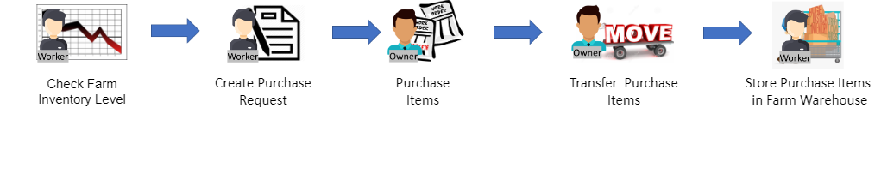

Figure 10: Inventory Process

The worker checks the farm inventory level in the warehouse. After he determine the items, he will create a purchase request and send it to the owner. The owner buys those items, transfer the items to the store worker, and them in the farm warehouse.

Data Flow Diagram of the Current System (Gane and Sarson Model)

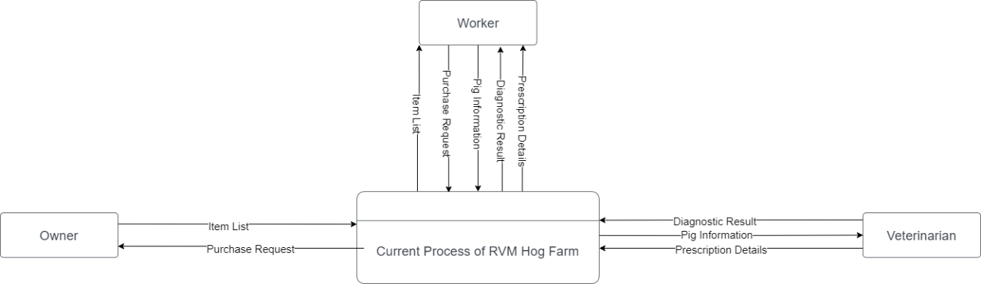

Figure 11: Context Diagram of the Current System

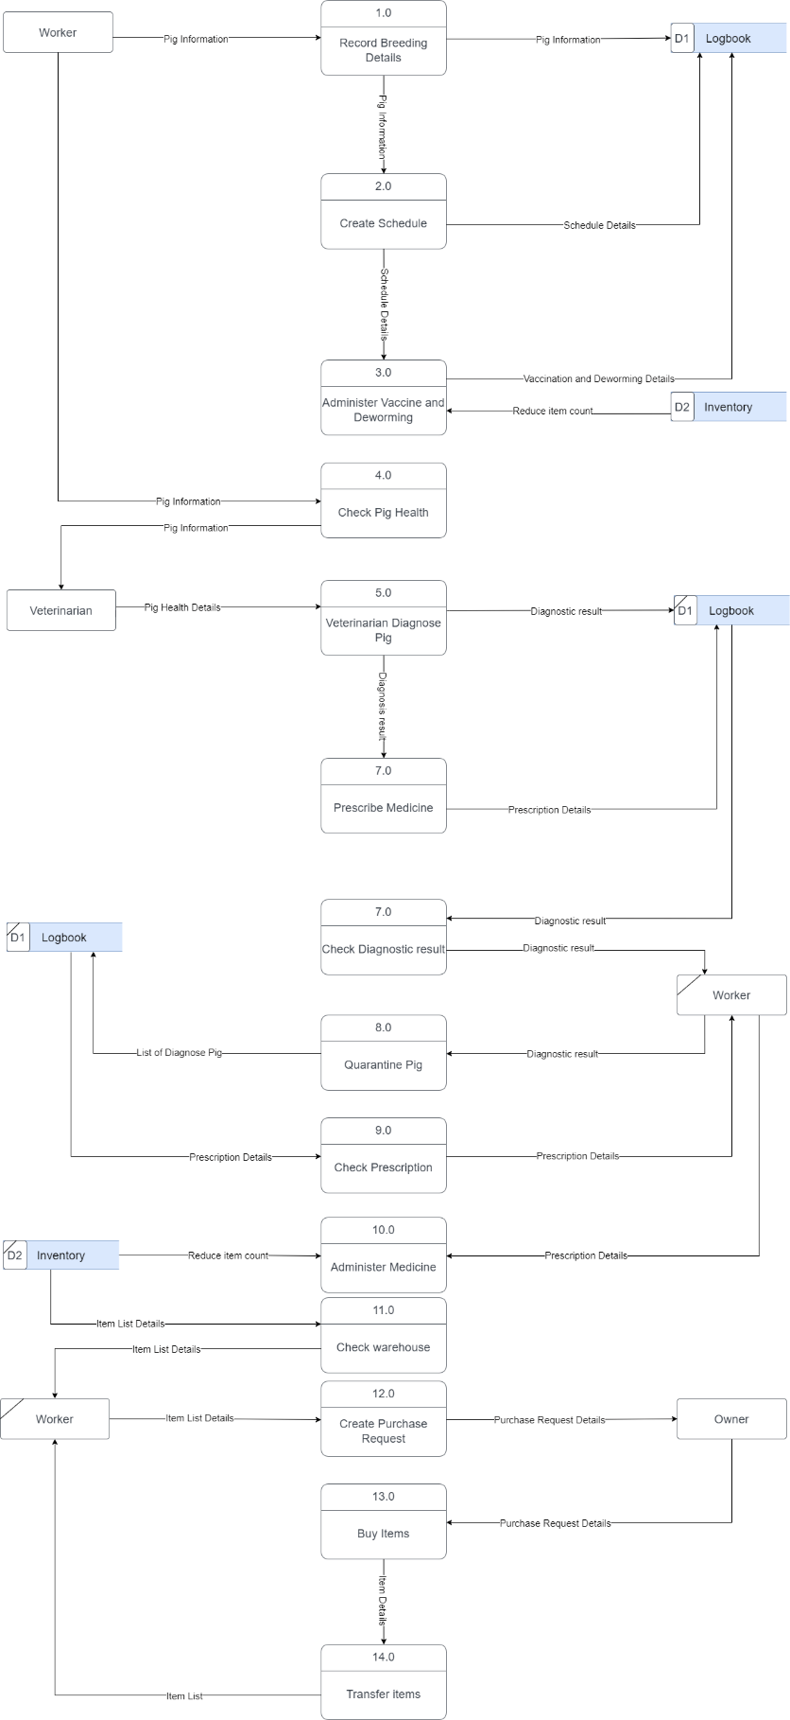

Figure 12: Logical Data Flow Diagram of the Current System (Level 1)

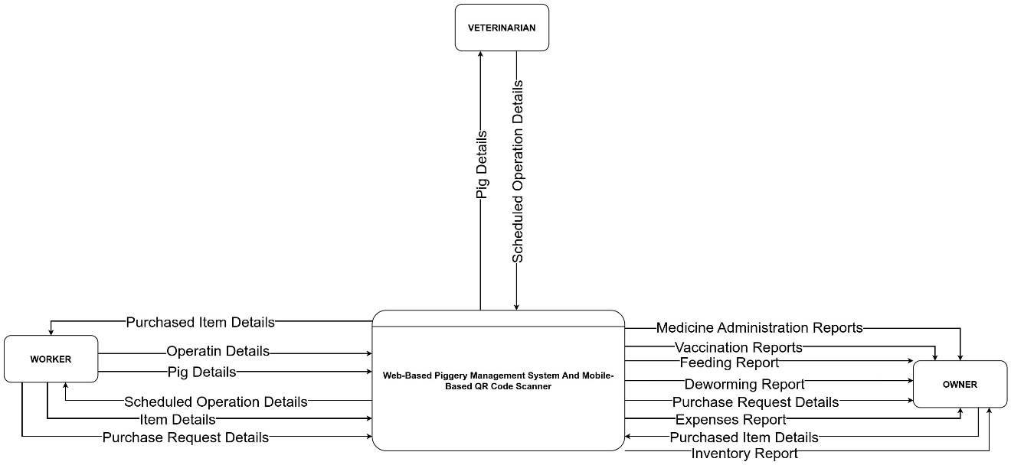

Figure 13: Context Diagram of the Proposed System

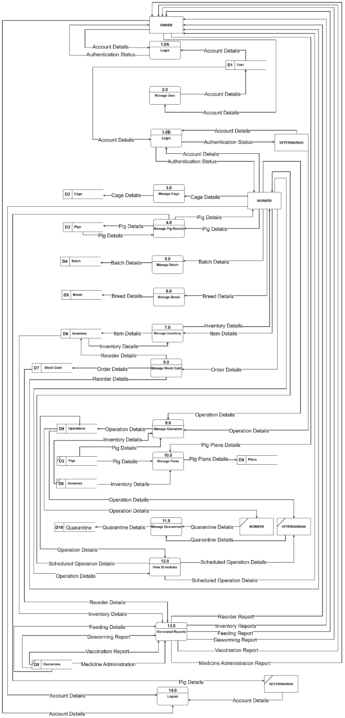

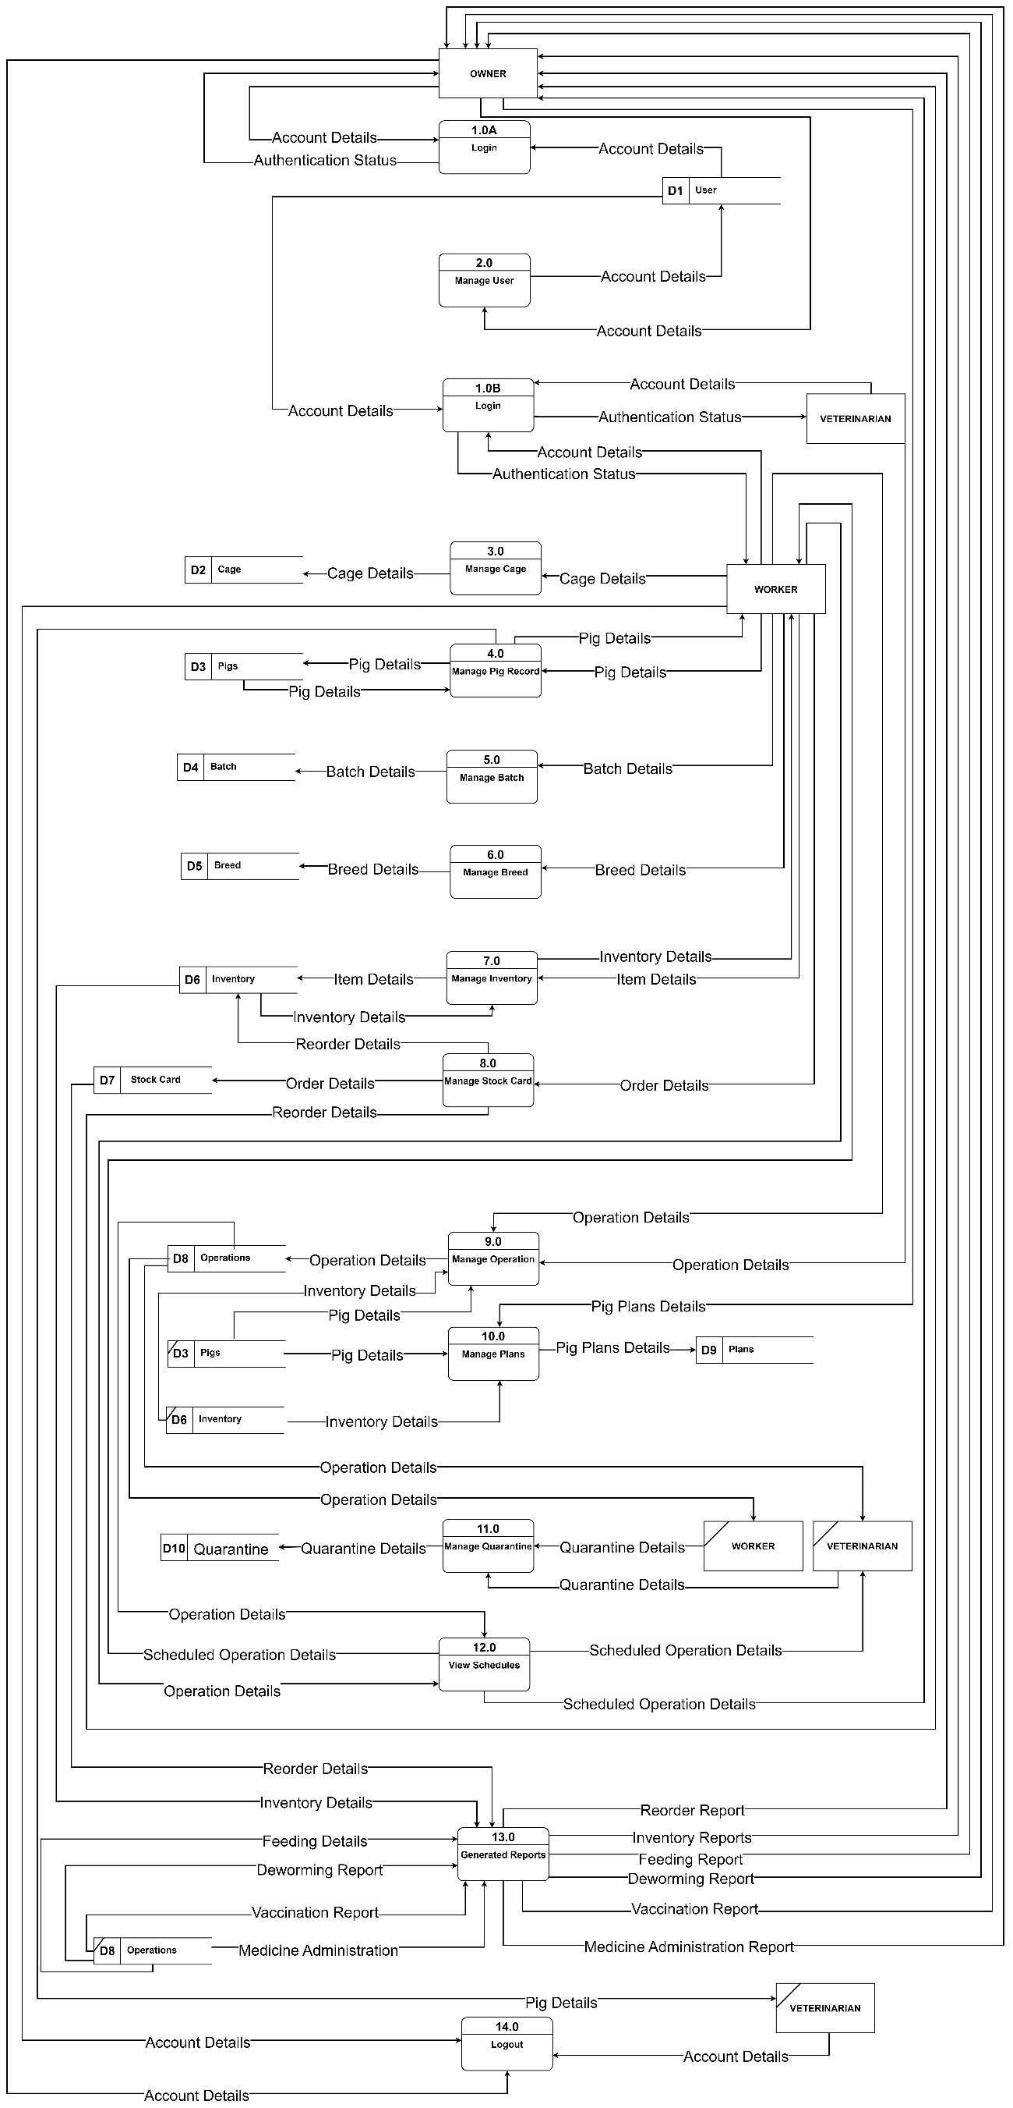

Figure 14: Logical Data Flow Diagram of the Proposed System (Level 0)

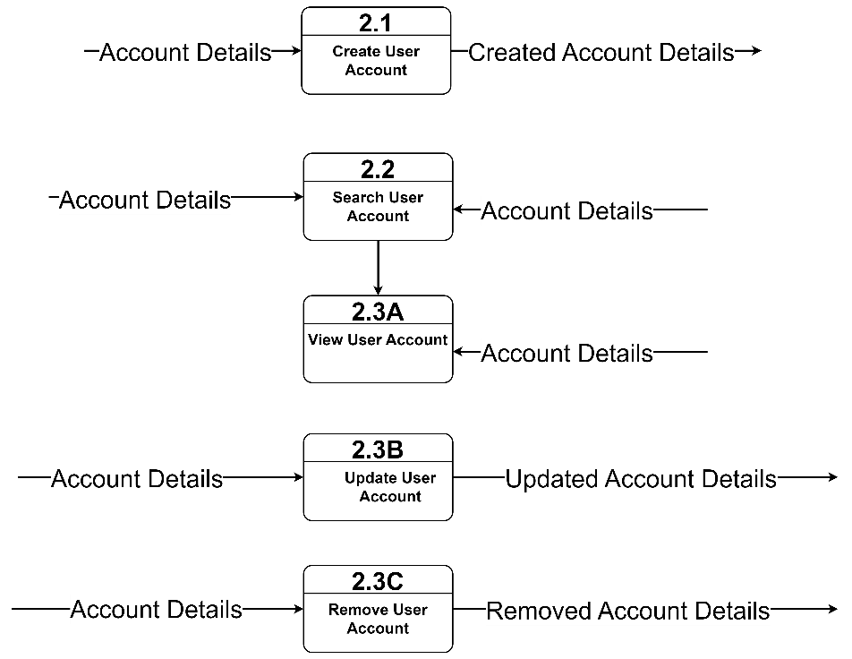

Figure 15: Physical Data Flow Diagram of the Proposed System (Level 1 - User)

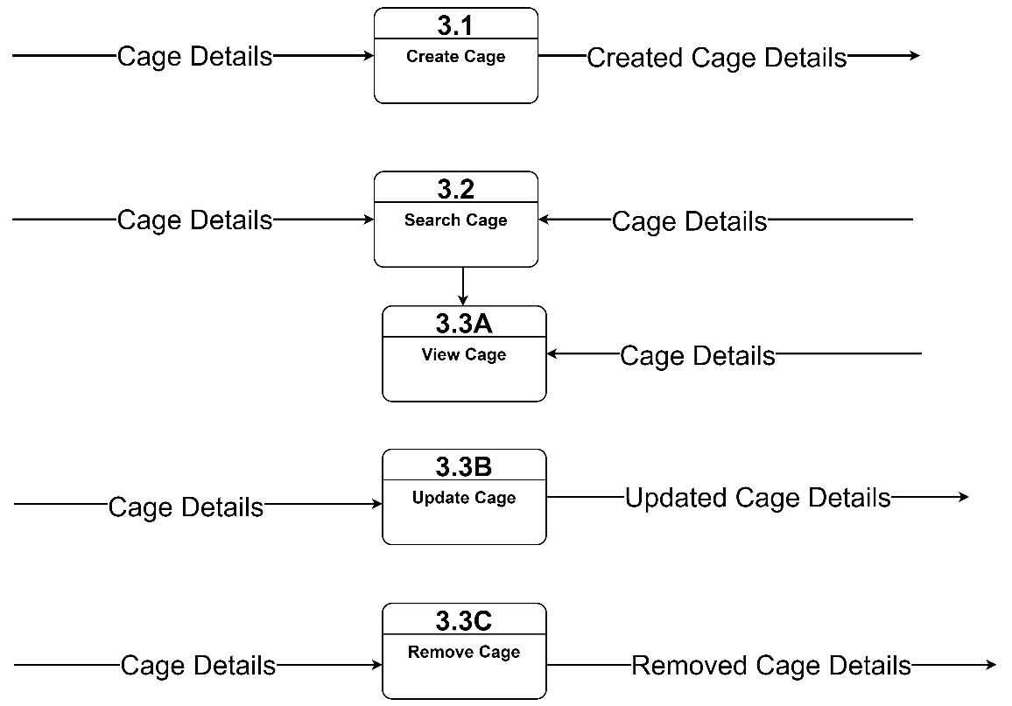

Figure 16: Physical Data Flow Diagram of the Proposed System (Level 1 - Cage)

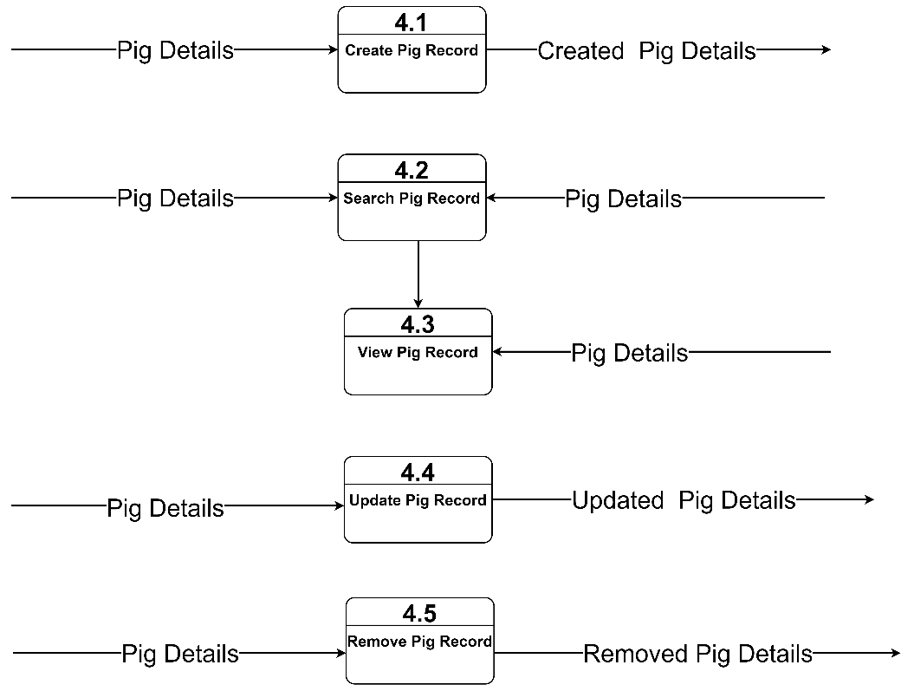

Figure 17: Physical Data Flow Diagram of the Proposed System (Level 1 - Pig)

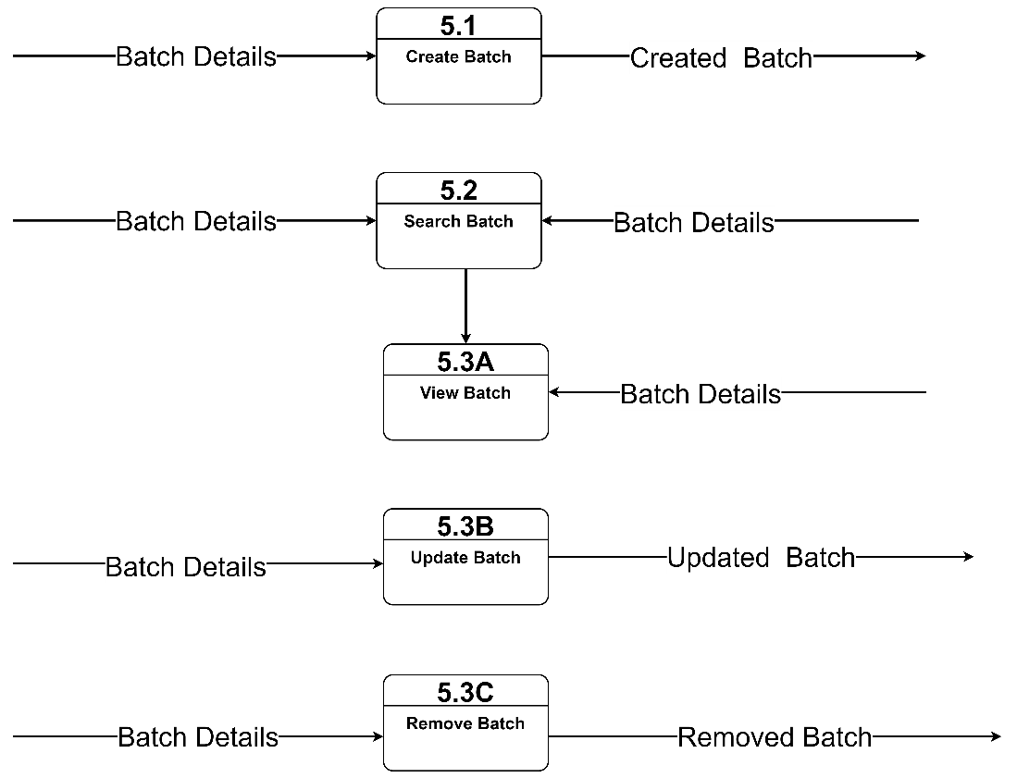

Figure 18: Physical Diagrm of the Proposed System (Level 1 – Batch)

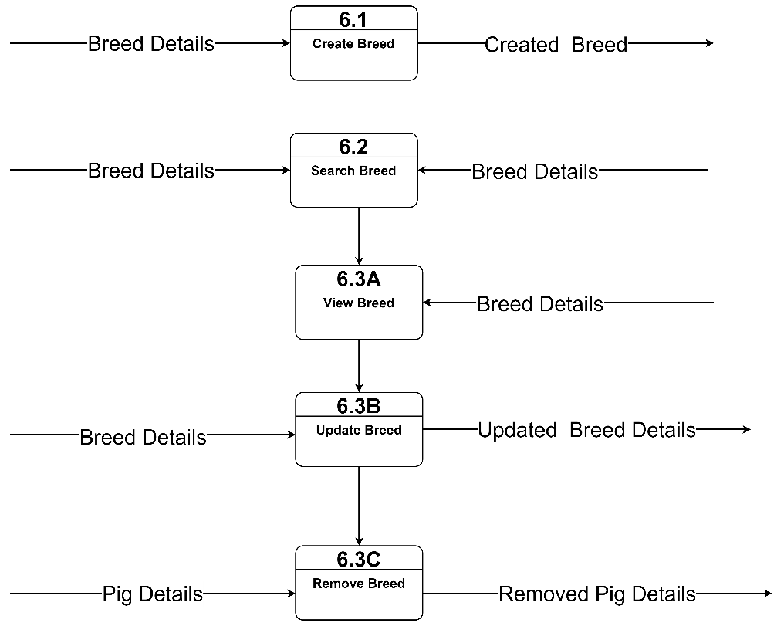

Figure 19: Physical Data Flow Diagram of the Proposed System (Level 1 - Breed)

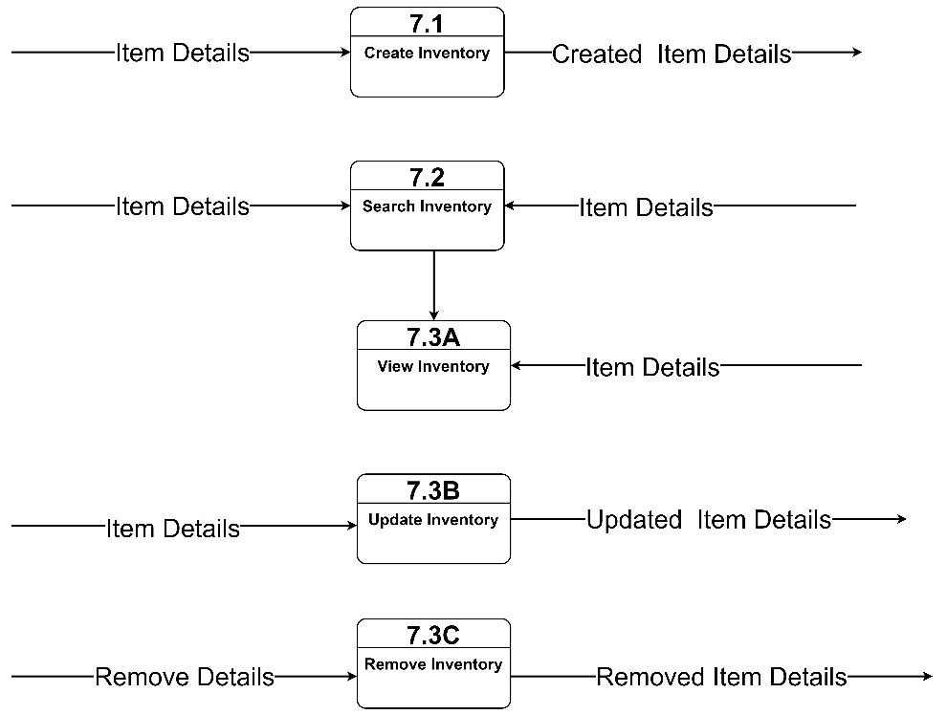

Figure 20: Physical Data Flow Diagram of the Proposed System (Level 1 - Inventory)

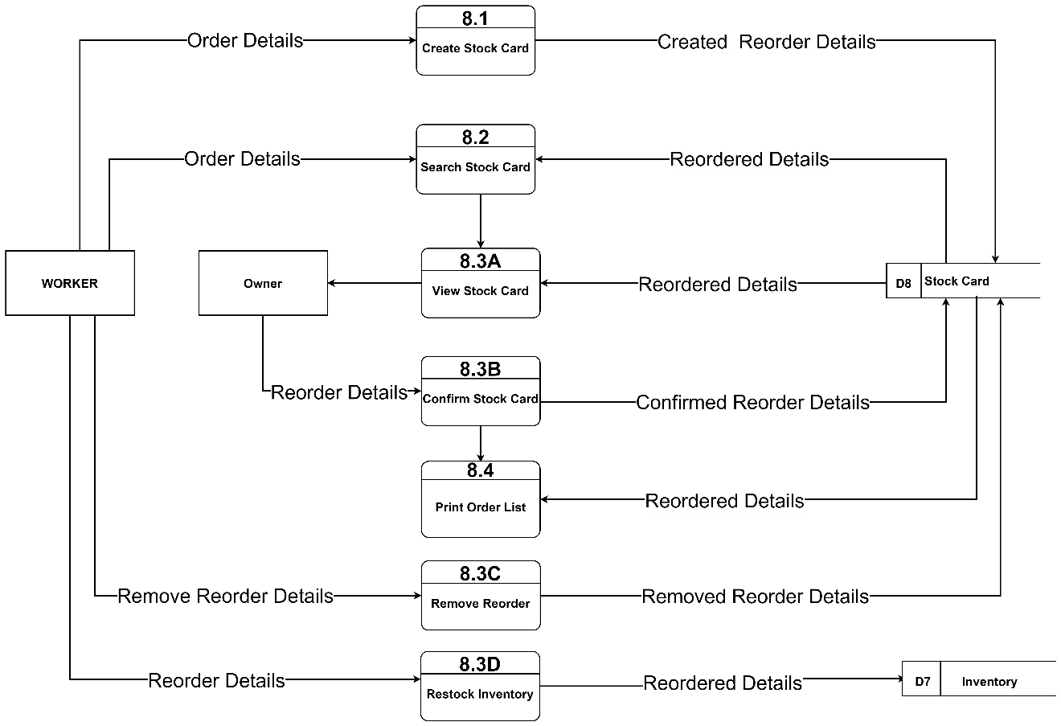

Figure 21: Physical Data Flow Diagram of the Proposed System (Level 1 - Reorder)

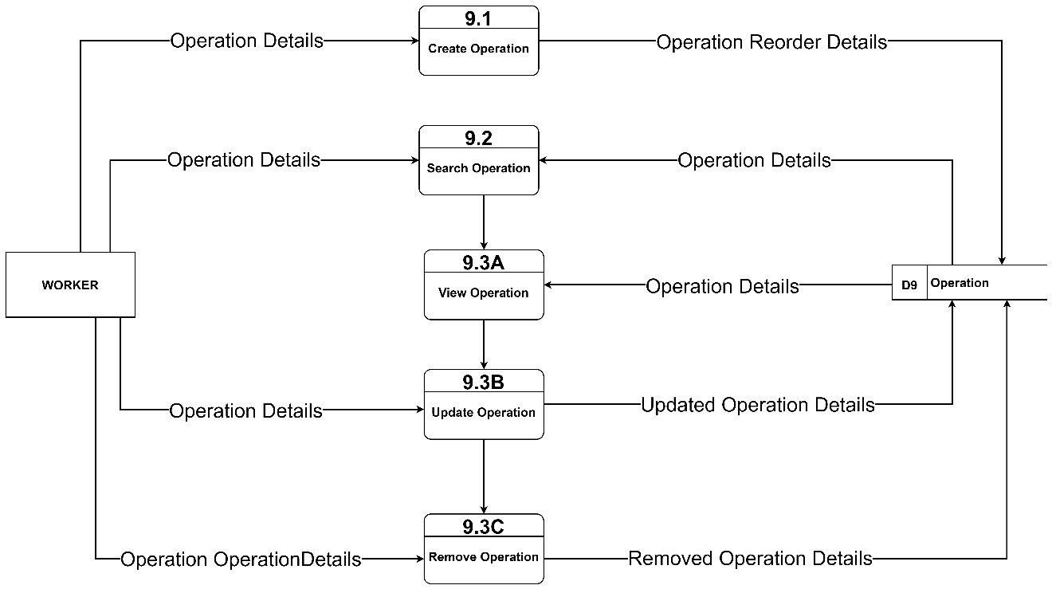

Figure 22: Physical Data Flow Diagram of the Proposed System (Level 1 – Worker Operation)

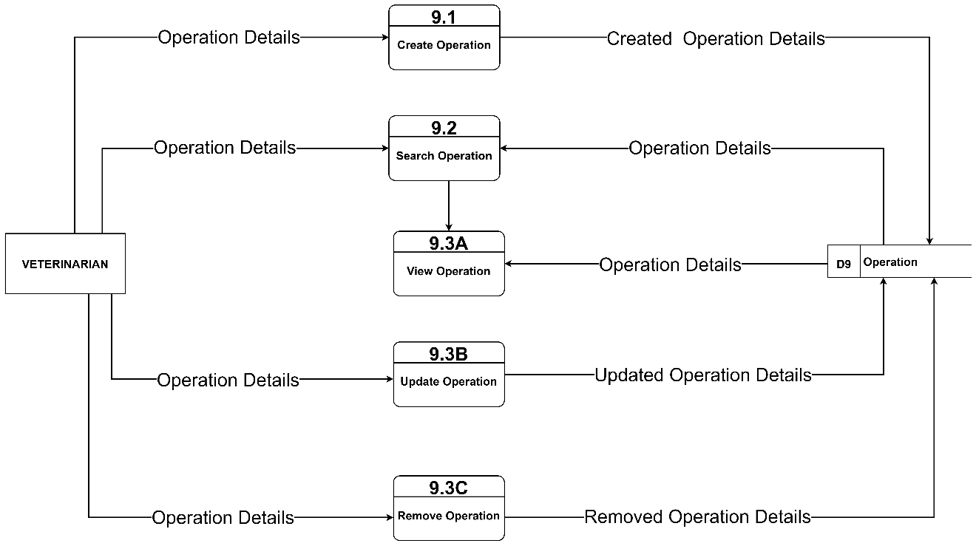

Figure 23: Physical Data Flow Diagram of the Proposed System (Level 1 – Veterinarian Operation)

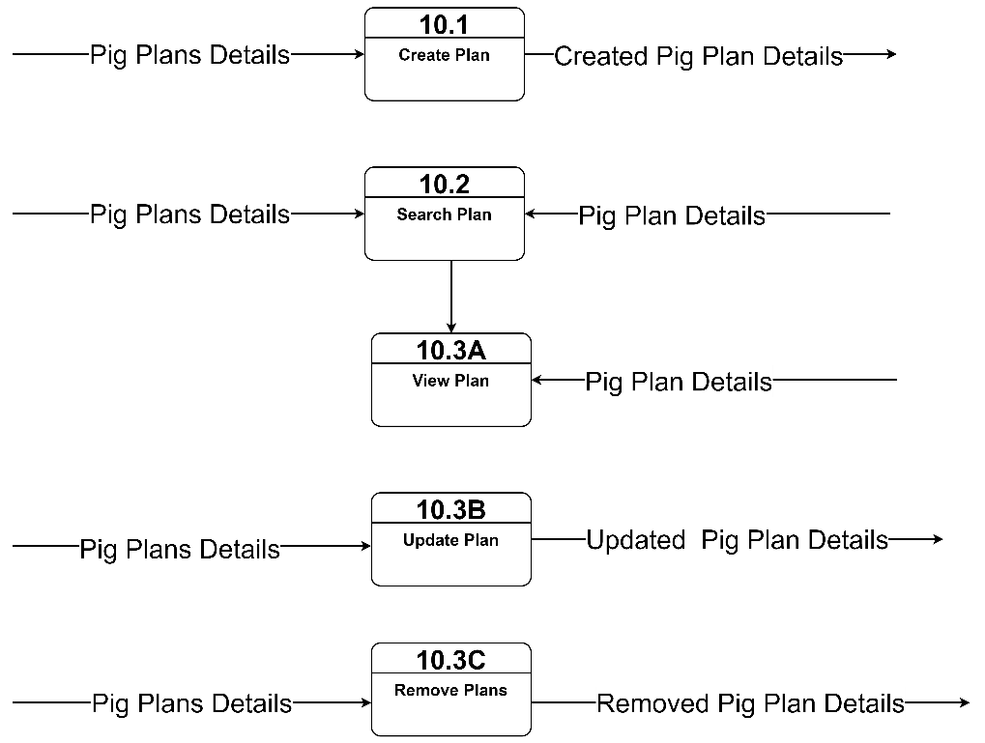

Figure 24: Physical Data Flow Diagram of the Proposed System (Level 1 - Plan)

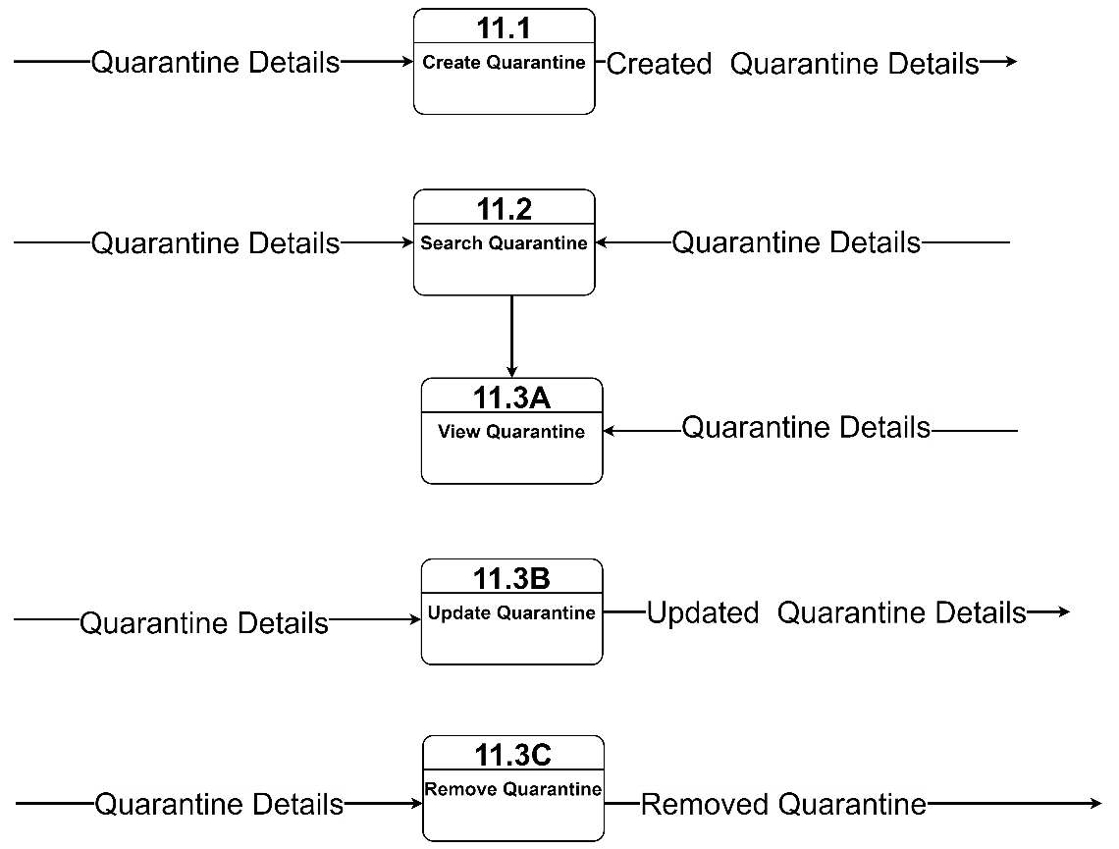

Figure 25: Physical Data Flow Diagram of the Proposed System (Level 1 - Quarantine)

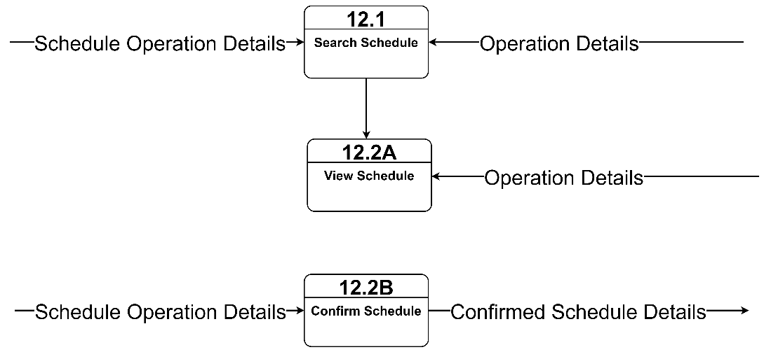

Figure 26: Physical Data Flow Diagram of the Proposed System (Level 1 – Schedule)

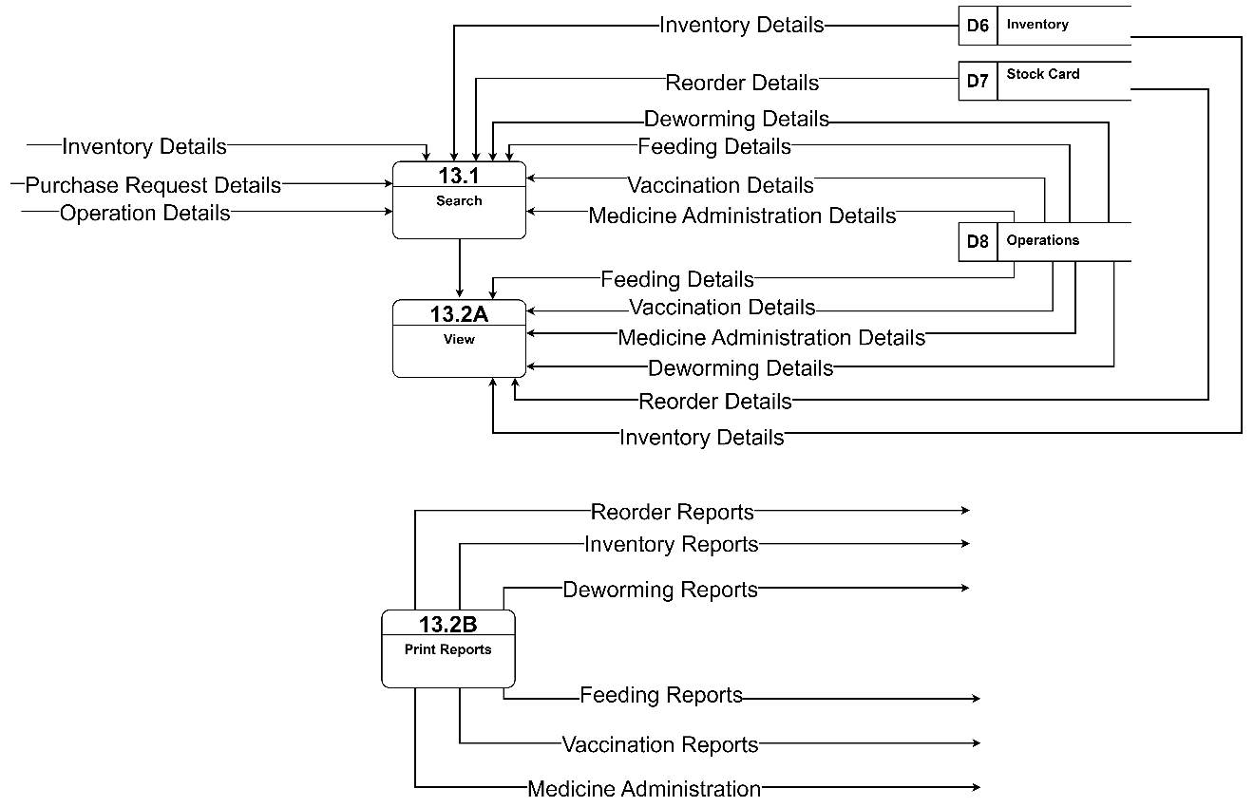

Figure 27: Physical Data Flow Diagram of the Proposed System (Level 1 - Reports)

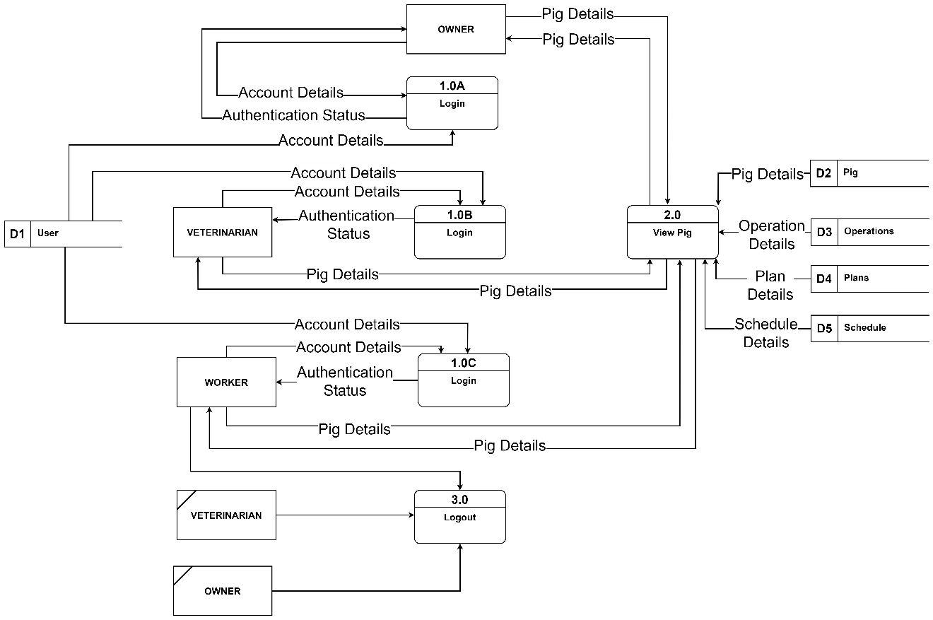

Figure 28: Logical Data Flow Diagram of the Proposed Mobile Application (Level 0)

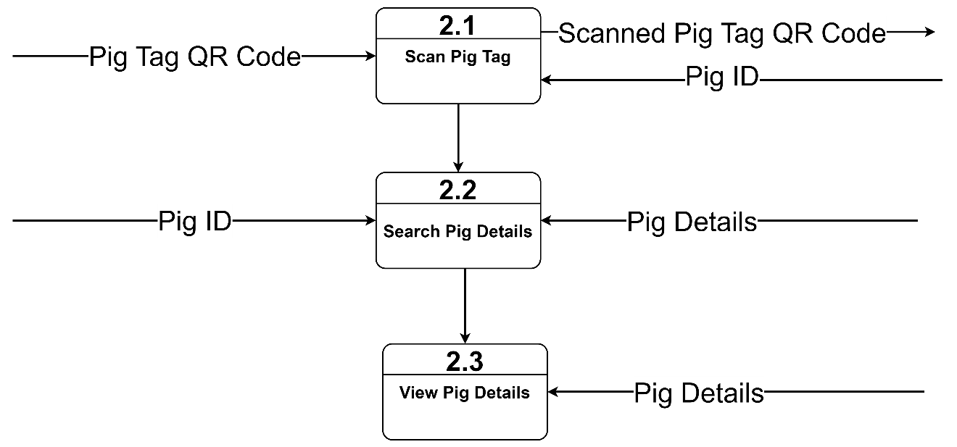

Figure 29: Physical Data Flow Diagram of the Proposed Mobile Application (Level 1 – View Pig)

Requirement Documentation

Requirement Documentation is the procedure for writing a software requirement of the project. Software Requirement is how the system is deliberate to function. The Requirement Documentation serves as guide in developing a project and outlining the features that will be included. This places the functional and non-functional requirements of the proposed Web-based Piggery Management System with Mobile-based QR Code Scanner in Lamba, Banga South Cotabato.

The Functional requirements are the basic functions of the system which have primarily what the system must or must not do and how the system responds to inputs. The functional requirements of Web-based Piggery Management System with Mobile-based QR Code Scanner in Lamba, Banga South Cotabato are shown through system storyboard models.

The illustration below shows the functional requirements for the Web-based Piggery Management System with Mobile-based QR Code Scanner in Lamba, Banga South Cotabato web application.

The illustration below are the functional requirements of the proposed system web application.

User Management

The user management allows the owner, workers, and veterinarian to login into the web-based system by inputting the default username and password. It uses authentication to allow the user to access the system.

REQ1. The owner, workers, and veterinarian shall be able to login to the website using the default username and password.

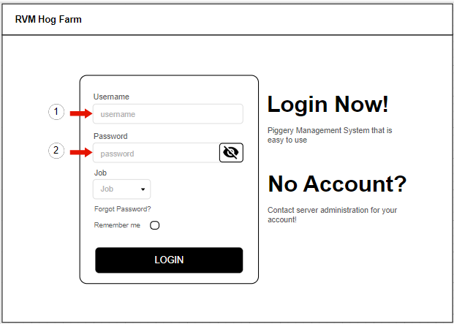

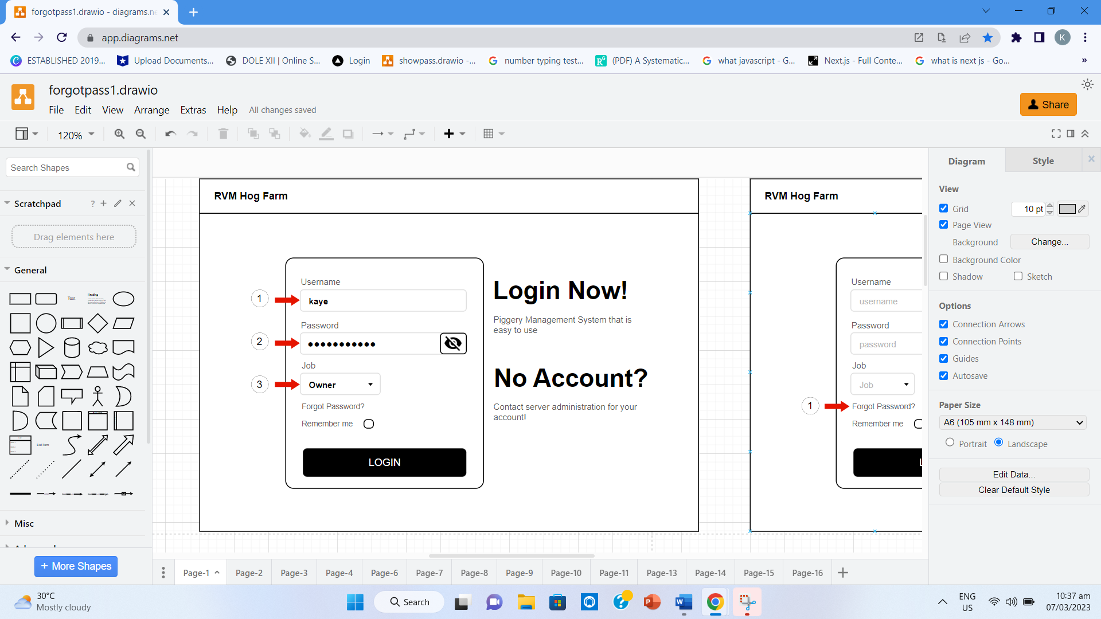

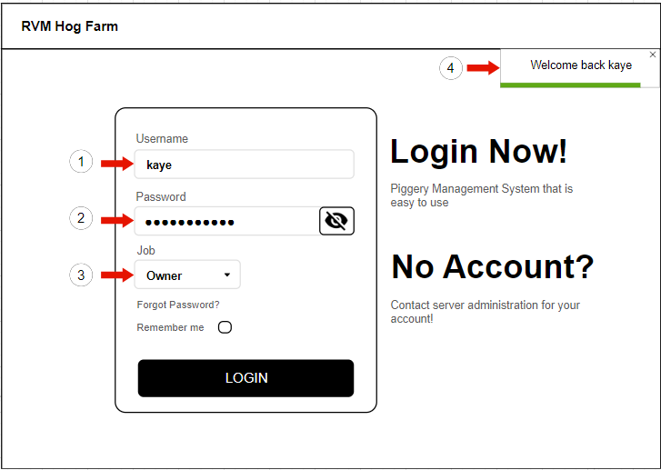

Figure 30 A-C. Login User Storyboard

The user should enter user credentials as shown in item number one (1) and two (2) then the user should select its job as shown in item number three (3) and log in by clicking the button “Login” button.

REQ2. The users shall be able to change the password by clicking the forgot password.

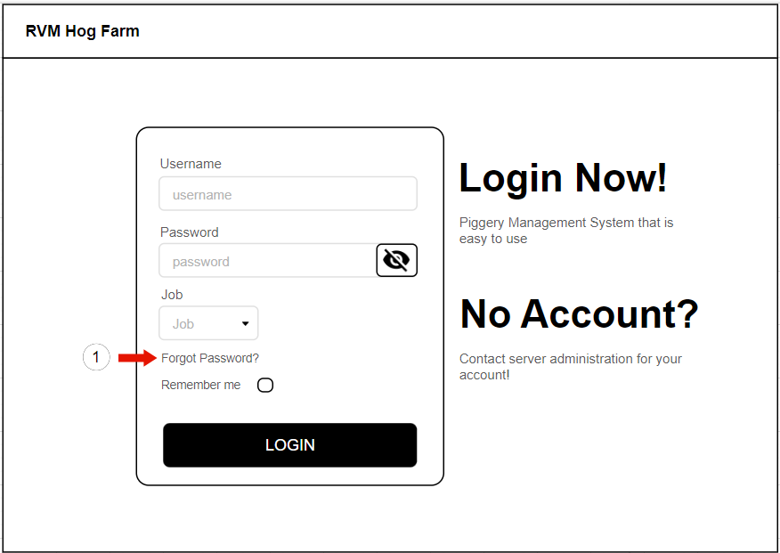

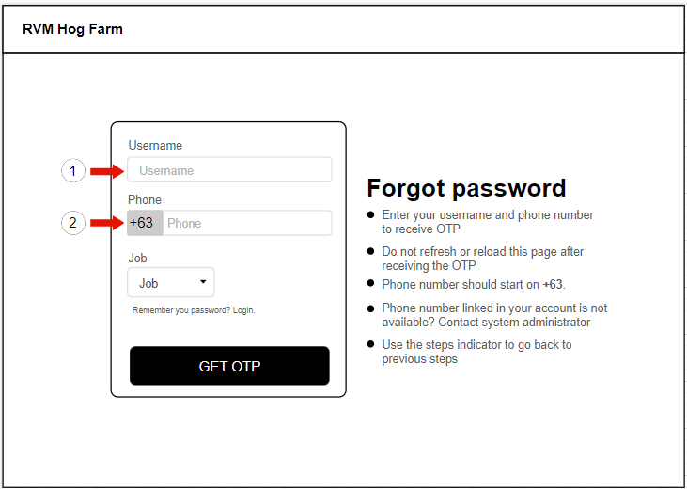

After clicking the forgot password, the user should enter the registered username and phone number from the system to receive OTP shown in item number one (1) and two (2).

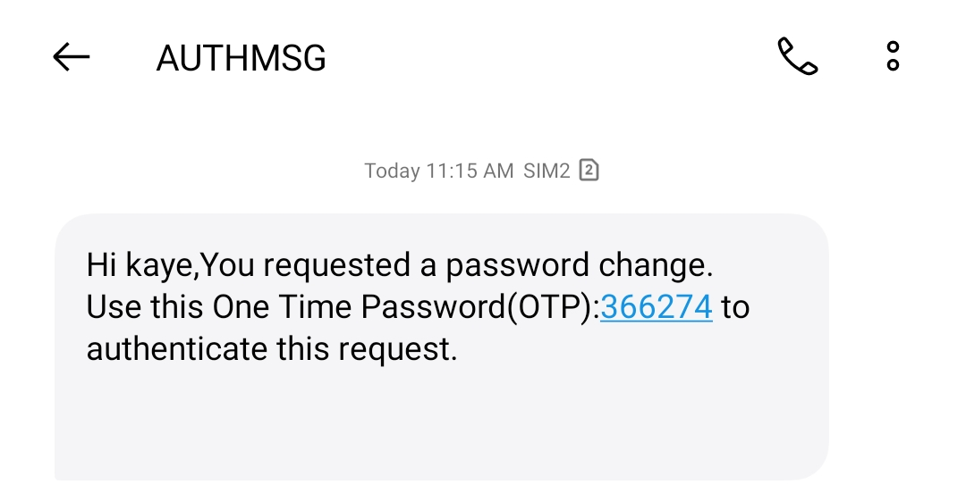

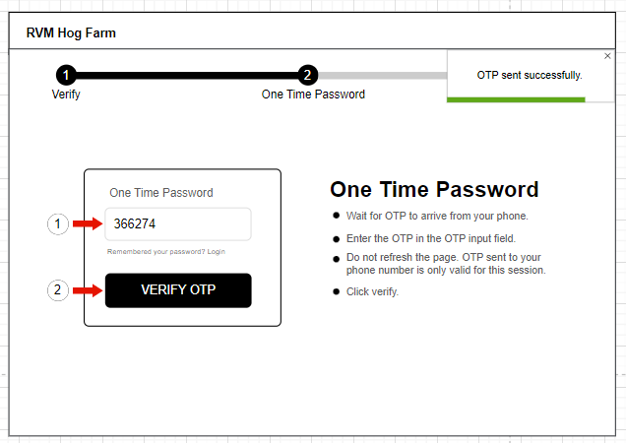

The user should enter the OTP received from phone to reset a password as shown in item number one (1) and by clicking the button “Verify OTP” as shown in item number two (2).

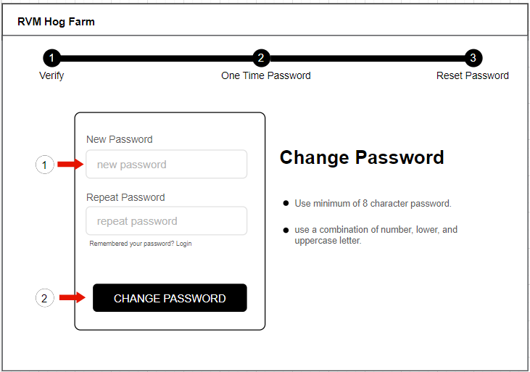

The user should enter the new password to update as shown in item number one (1) and click the button “Change Password” as shown in item number two (2).

Figure 31 A-E. Forgot Password Storyboard

REQ3. The owner shall be able to create user account.

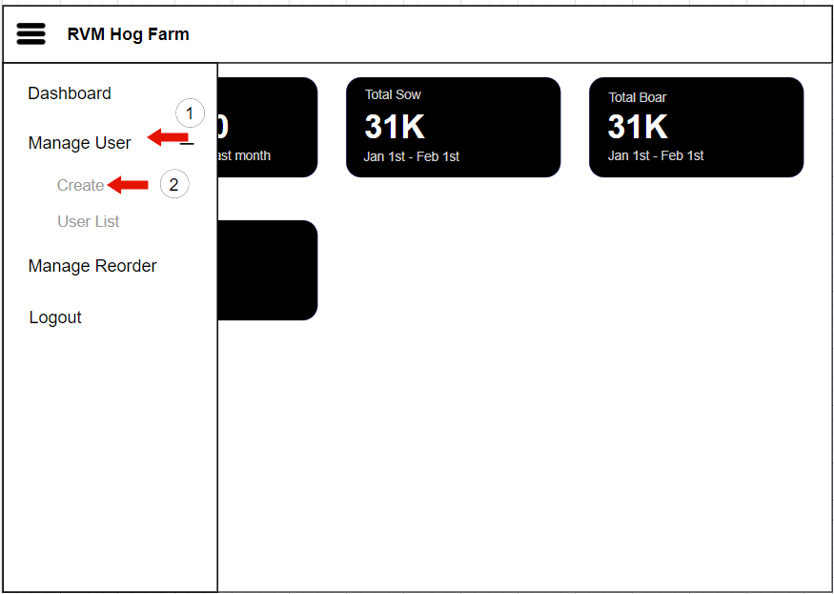

The user should click the “Manage User” as shown in item number one (1) to show the “Create” button to create new user as shown in item number two (2).

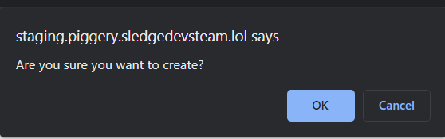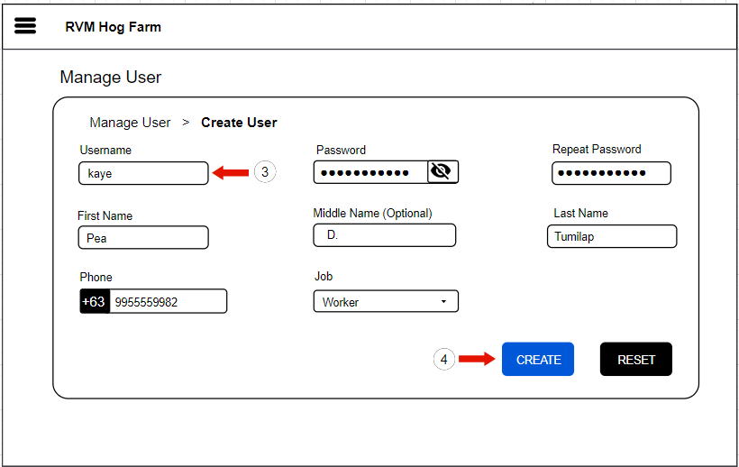

The owner should register a new user by entering the user credentials as shown in item number three (3) and clicking the “Create” button to create new user’s information as shown in item number four (4).

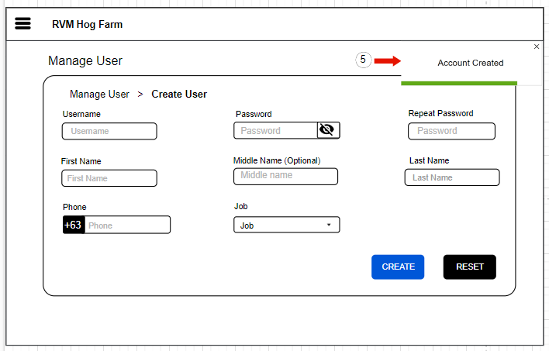

The owner should click the “OK” button as shown above the item number three (3) and showing the “Account Created” as shown in item number five (5) if the account is created.

Figure 32 A-C. Manage User Storyboard

REQ4. The owner shall be able to view user list.

REQ5. The owner shall be able to search user.

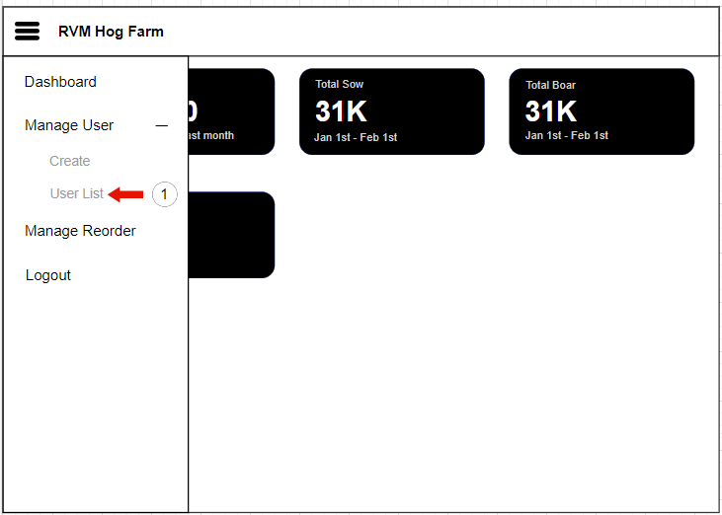

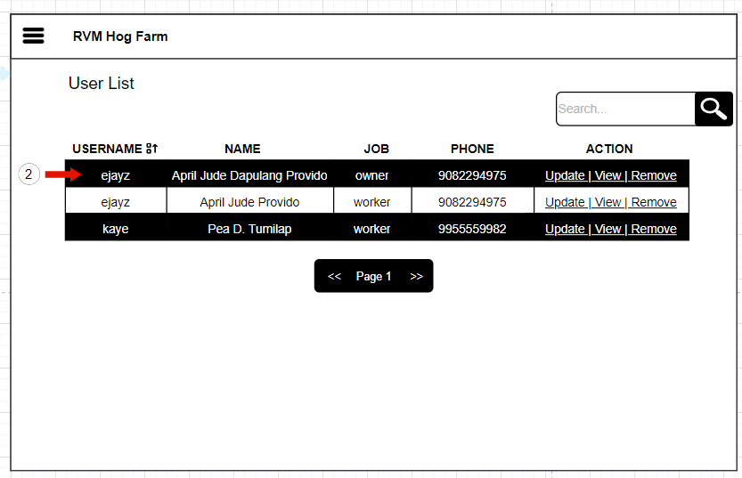

The owner should click the “User List” as shown in item number one (1) to view the lists of users as shown in item number two (2).

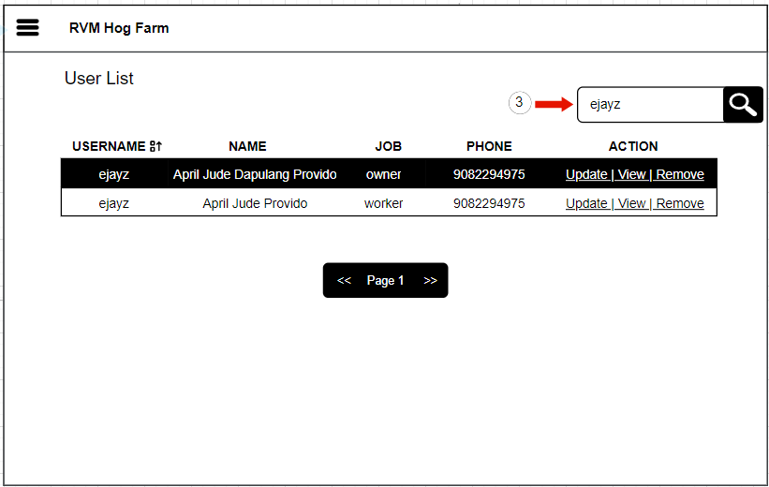

The owner should enter the user details in search bar as shown in item number three (3) to see how many users with the same username are.

Figure 33 A-C. View User List Storyboard

REQ6. The owner shall be able to update user details.

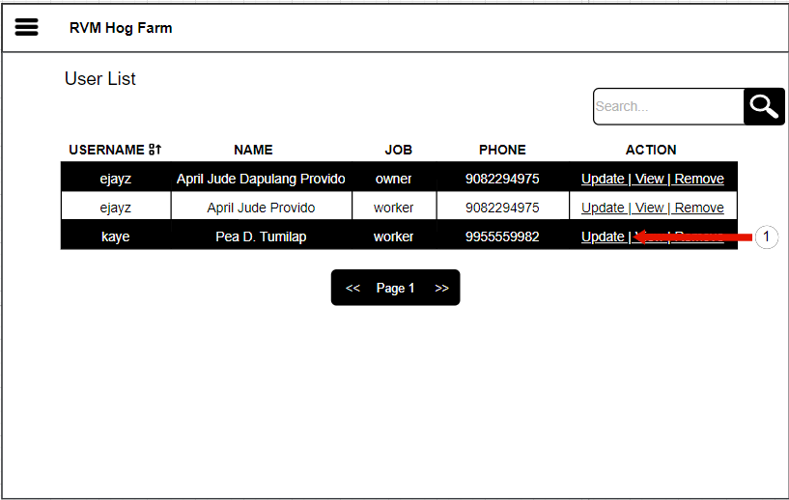

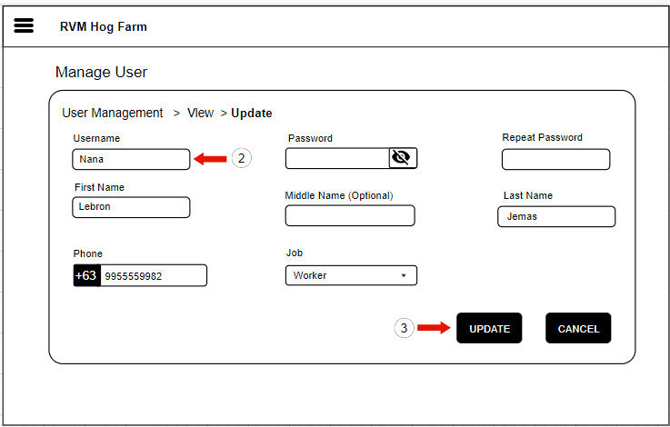

The user should click the “Update” action button as shown in item number one (1) and enter the updated user details as shown in item number two (2) then update user details by clicking the “Update” button as shown in item number three (3).

Figure 34 A-B. Update User Account Storyboard

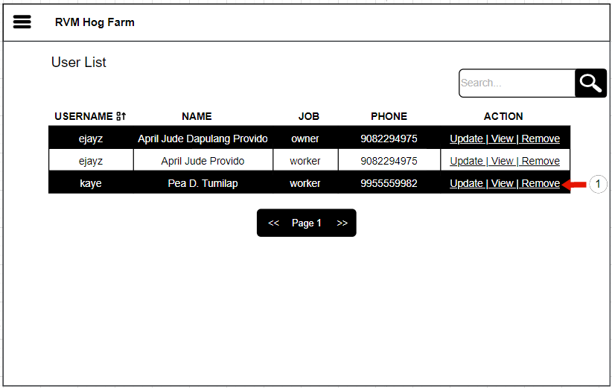REQ7. The owner shall be able to remove user account.

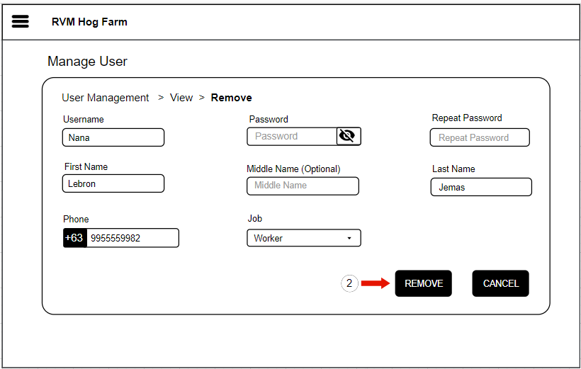

The user should click the “Remove” action button as shown in item number one (1) to see whose user account will be remove and by clicking the “Remove” button as shown in item number two (2) to remove the user account.

Figure 35 A-B. Remove User Account Storyboard

REQ8. The owner shall be able to view the reorder list of inventory.

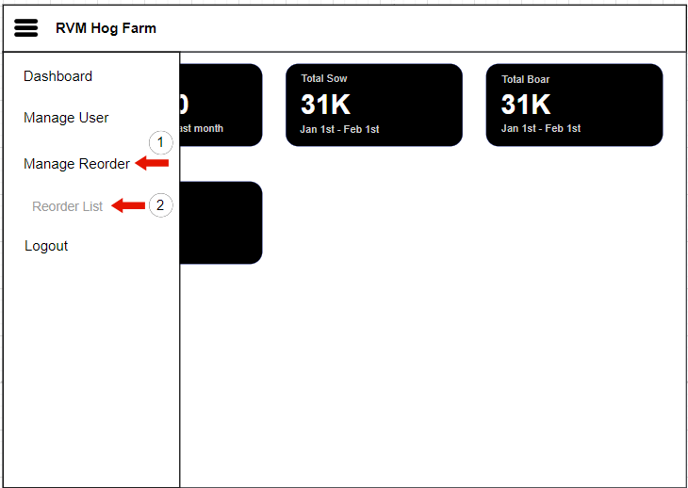

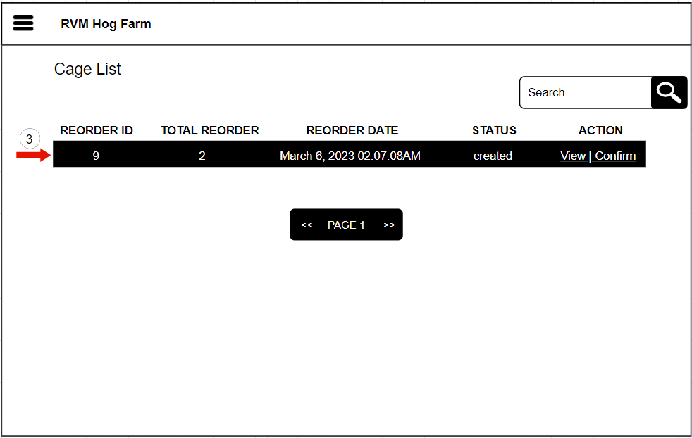

The user should click the “Reorder Module” as shown in item number one (1). And by clicking the “Reorder List” as shown in item number two (2) to see the list of the reordered items as shown in item number three (3).

Figure 36 A-B. Reorder List Storyboard

REQ9. The owner shall be able to view the list.

REQ10. The owner shall be able to print list.

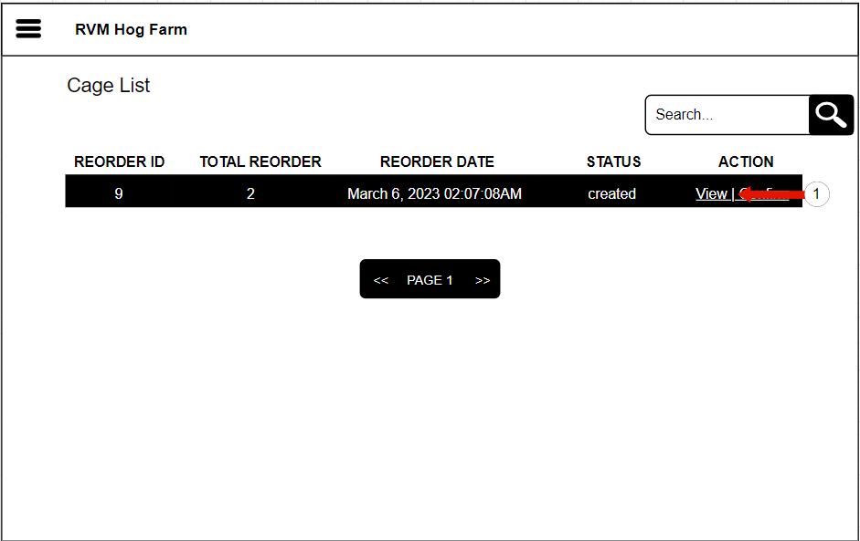

REQ 9. The owner shall be able to view the items in inventory.

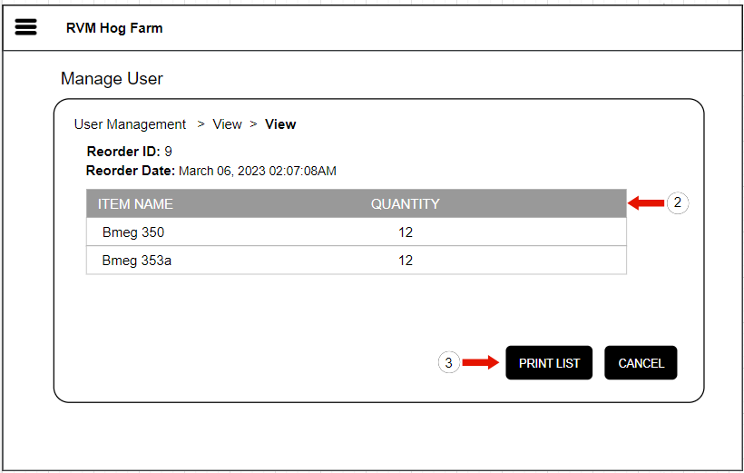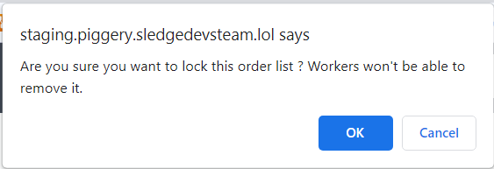

The user should click the “View” action button as shown in item number one (1) to show the list of items to be printed and by clicking the “Print List” as shown in item number two (2) to print the list.

Figure 37 A-B. View Item List Storyboard

REQ11. The owner shall be able to confirm the list of items that can be printed.

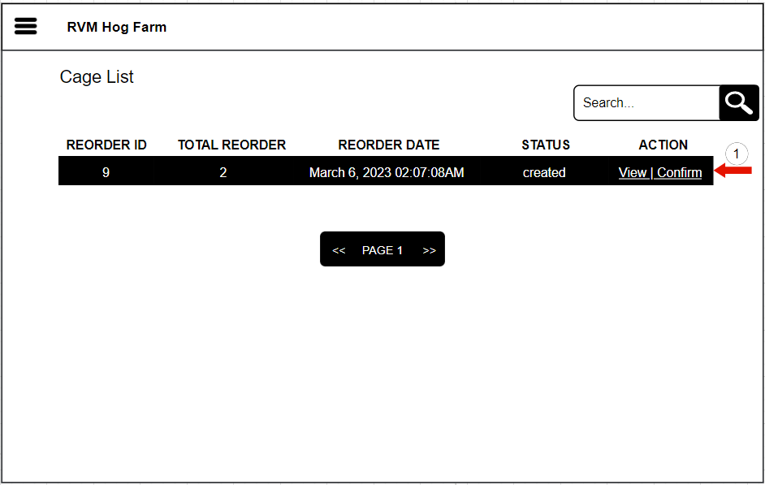

REQ12. The owner shall be able to attach a file.

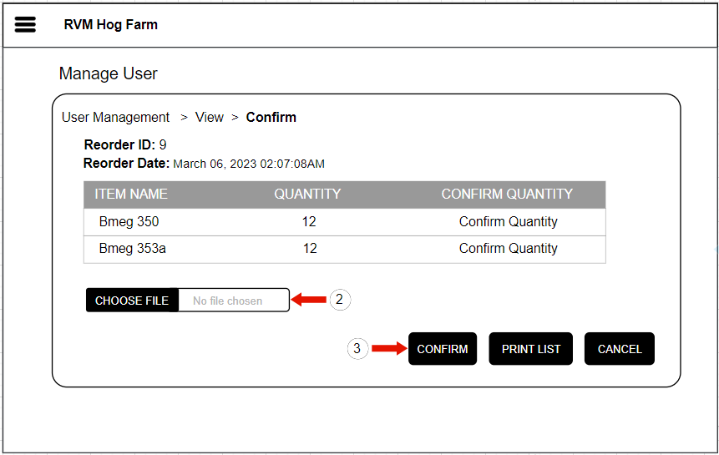

The user should click the “Confirm” action button as shown in item number one (1), click the “Choose File” to attach a file that is already printed as shown in item number two (2) and clicking “Confirm” button as shown in item number three (3).

Figure 38 A-B. Confirm Attach File Storyboard

REQ13. The worker shall be able to manage the cage of the farm.

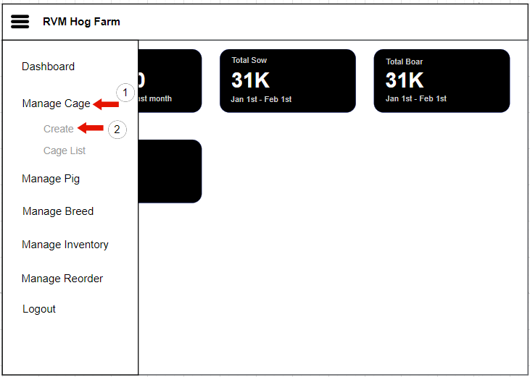

The user should click the “Manage Cage” module as shown in item number one (1) and by clicking the “Create” as shown in item number two (2) to create a cage.

**Non-Functional Requirements**

The non-functional requirements are requirement that include the categories that are used to examine the operation of the system. It describes the measurement of the time spent in processing the web and mobile pages, its dependability in storing and retrieving data of the web application. Here are the non-functional requirements of Web-based Piggery Management System with Mobile-based QR Code Scanner for RVM Hog Farm in Lamba, Banga South Cotabato, which includes the operational, performance, security, usability, reliability, efficiency, maintainability, and portability requirements.

**Web Application:**

**Operational Requirements**

REQ001. The web application should operate on all platforms with web browsers. Google Chrome and Mozilla Firefox are recommended browsers.

REQ002. The web application should operate to use printer for printing reports.

**Performance Requirements**

REQ003. The web application should retrieve data in 3 to 8 seconds with stable internet connection of 100mbps.

REQ004. The web application should upload 5000 data of pigs, sow, and boar within 5 minutes with stable internet connection of 100mbps.

**Security Requirements**

REQ005. Owner, Workers, and Veterinarian should be able to use modules in the mobile application to scan and search pig information.

REQ006. The web application shall be able to provide user authentication and unauthorized users shall not be able to access the system so that the integrity and security of each user and the data must be maintained.

**Usability Requirements**

REQ007. The interface of website application is easy to use, rather than intimidating and demanding.

REQ008. The web application interface should be a user friendly.

REQ009. The system uses the English language only.

**Reliability Requirements**

REQ010. The web application should be able to validate user input.

REQ011. The web application should be able to recover all the data in the system.

**Efficiency Requirements**

REQ012. Website application modules should be able to load in 5 seconds or less with stable internet connection of 100mbps.

REQ013. Back-up & restore data on the web application should be able to load in 5 second or less with stable internet connection of 100mbps.

REQ014. The website application should be able to retrieve data in 3 to 5 seconds with a stable internet connection of 50mbps to 100mbps.

REQ015. The website application should be able to add data in 3 to 5 seconds with a stable internet connection of 50mbps to 100mbps.

REQ016. The website application should be able to update data in 3 to 5 seconds with a stable internet connection of 50mbps to 100mbps.

**Maintainability Requirements**

REQ017. The system database should be able to back-up & restore data.

REQ018. The average preventive maintenance time for performing system updates should be less than twenty-four (24) hours per month.

**Portability Requirements**

REQ14: The web application should be able to be accessible to any operating system with latest browser. Google Chrome and Mozilla Firefox are recommended browsers.

**Mobile Application:**

**Operational Requirements**

REQ001. The mobile application should be able to operate on all android devices with lollipop version 5.0-5.1.1 or higher versions.

**Performance Requirements**

REQ002. The mobile application should be able to retrieve data in 3 to 8 seconds with stable internet connections of 100mbps.

REQ003. The mobile application should upload 5,000 data of pigs, sow, and boar within 5 minutes with stable internet connection of 100mbps.

**Security Requirements**

REQ004. Owner, Workers, and Veterinarian should be able to use modules in the mobile application to scan and search pig information.

REQ005. The mobile application should be able to provide data security and unauthorized users should not be able to access the system so that the integrity and security of each user and the data must be maintained.

**Usability Requirements**

REQ006. The interface of website and mobile application appears easy to use, rather than intimidating and demanding.

REQ007. The mobile application interface should be a user friendly.

REQ008. The system uses the English language only.

**Reliability Requirements**

REQ009. The mobile application should be able to validate user input.

REQ010. The mobile application scanner should be able to scan QR code.

**Efficiency Requirements**

REQ011. Mobile application modules should be able to load in 5 seconds or less with stable internet connection of 100mbps.

REQ012. Retrieving data on the mobile application should be able to load in 5 seconds or less with stable internet connection of 100mbps.

**Maintainability Requirements**

REQ013. The maintenance time of mobile application should not take up to 24 hours every month.

**Portability Requirements**

REQ014. The mobile application should be able to be accessible to any android devices with lollipop version 5.0-5.1.1 or higher versions.

REQ015. The system should be able to send SMS notification to any Android devices with lollipop version 5.0 – 5.1.1 or higher versions.

Design of Software, Systems, Product, and/or Process

This chapter describes the conceptual framework in developing the Web-based Piggery Management System with Mobile-based QR Code Scanner for RVM Hog Farm in Lamba, Banga South Cotabato. This chapter presented in the review related literature and methodology that are used to design the conceptual framework of this current study. The proponents used the Input-Process-Output Model (IPO Model) Conceptual Framework, and the Three-Tier Model Systems Architecture to develop the proposed system.

Conceptual Framework

The figure below presents the conceptual framework of the Web-based Piggery Management System with Mobile-based QR Code Scanner for RVM Hog Farm in Lamba, Banga South Cotabato. It illustrates based on Input-Process-Output Model or IPO Model.

Input

Below is the input phase or the system requirements that consists of the following:

* **User Requirements** – the Web-based Piggery Management System allows the owner, workers, and veterinarian to create user account in managing the farm.
* **Back-end Requirements** – in developing the proposed system, NextJs and tailwind CSS is used as the web framework of the JavaScript programming language. The tailwind CSS framework is used in UI development that would give a flexibility and productivity when it comes to the design. For the mobile application, Java programming language with Android Studio IDE which is the current latest IDE version is used in developing the system. Also, XZing QR Code Library or called Zebra Crossing used to read or scan QR Code and Camera X library make camera app development easy.
* **Database Requirements** – the Digital Ocean VPS with installed software like Apache to run the web-based system and act as API end point for the mobile application to access data and MySQL Database service to store data that are needed for the system.
* **Front-end Requirements** – the Web-based Piggery Management System with Mobile-based QR Code Scanner uses QRCode.js to create QR Code with unique identifier and can be save and printed when needed and the Twilio SMS API an Application Program Interface use to send text message automatically.
* **Hardware Requirements** – the Web-based Piggery Management System with Mobile-based QR Code Scanner uses monitor, processor/CPU faster Intel or AMD processor, and hard disk space with HDD or SSD for web application. For mobile application, memory (RAM) with 4GB RAM or higher, (ROM) 8GB ROM or higher, storage and display.
* **Software Requirements** - the Web-based Piggery Management System with Mobile-based QR Code Scanner uses Operating System (OS) any OS that supports web browser and a browser include Google Chrome and Mozilla Firefox for web applications. For mobile application, it uses Operating System (OS) Lollipop version 5.0 - 5.1.1 or higher versions.

**Process**

The process uses the Agile Software Development Life Cycle which consists of the following phases in developing a system:

* **Planning** – initialization of the proposed system based on the identified problem on clients’ experiences.
* **Requirement Analysis** – gather and analyze current business process and outlines through graphical models that include the current and proposed system.
* **Documentation** – analyzed the processes, problem experience and create a technical document for the proposed system.
* **Design** – the developers analyzed the functional and non-functional requirement of the proposed system and the design for the web and mobile interface.
* **Coding** – start to develop the web and mobile application of the proposed system.
* **Unit Testing** – start to test each developed modules of the proposed system, detect, debug and fix errors.
* **Alpha Testing** – final testing of the proposed system web and mobile application, test the system, implement, and deploy the system.

**Output**

In conclusion, the final output of the Web-based Piggery Management System with Mobile-based QR Code Scanner for RVM Hog Farm in Lamba, Banga South Cotabato will change the paper and pen process of recording and monitoring of the RVM Hog Farm.

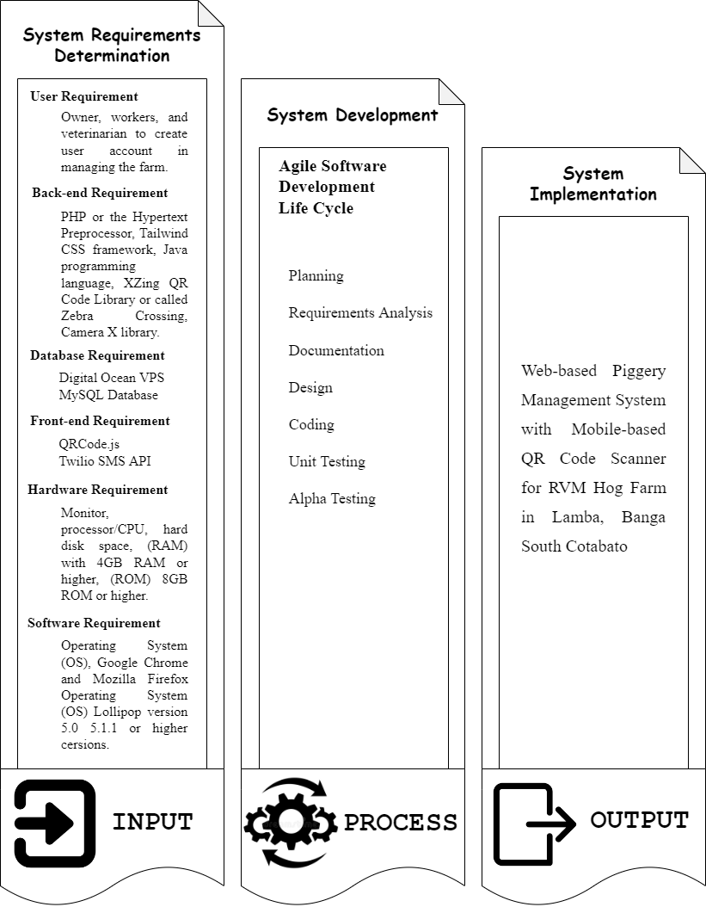

Figure 26: Conceptual Framework

System Architecture

The illustration below shows system architecture of the Web-based Piggery Management System with Mobile-based QR Code Scanner for RVM Hog Farm in Lamba, Banga South Cotabato. Based on the Three-Tier Architecture model it consists of presentation, application, and database tier. The Web-based Piggery Management System with Mobile-based QR Code Scanner for RVM Hog Farm in Lamba, Banga South Cotabato is composed of two user types: web user and the android user.

Presentation Tier

The web user screen is composed of the following interfaces:

* Login
* Dashboard
* User Management
* Pig Management
* Inventory Management
* Scheduling Management
* Record Management
* Reports
* Backup & Restore

The android user screen is composed of the following interfaces:

* Login
* Dashboard
* QR Scan

Application Tier

The web user screen is composed of the following data:

* Users – manages the authentication and authorization of the users from login interface system. It manages the CRUD operation for the web user account.
* User Management – manages the CRUD operation for creating user accounts in User Management module.
* Pig Management – manages the CRUD operation in managing the pig information in Pig Management module.
* Inventory Management – manages the CRUD operation in managing the inventory of the hog farm supplies in Inventory Management module.
* Scheduling Management – manages the CRUD operation for creating a schedule of operation of the pig in Scheduling Management module.
* Record Management – manages the CRUD operation for the records of giving a vaccine, deworm, feeds, medicine, and the stock records in inventory.
* Reports – generates a report regarding to the operation that has done in the farm.
* Back-up & restore – manages the CRUD operation in retrieving and delete data.

Database Tier

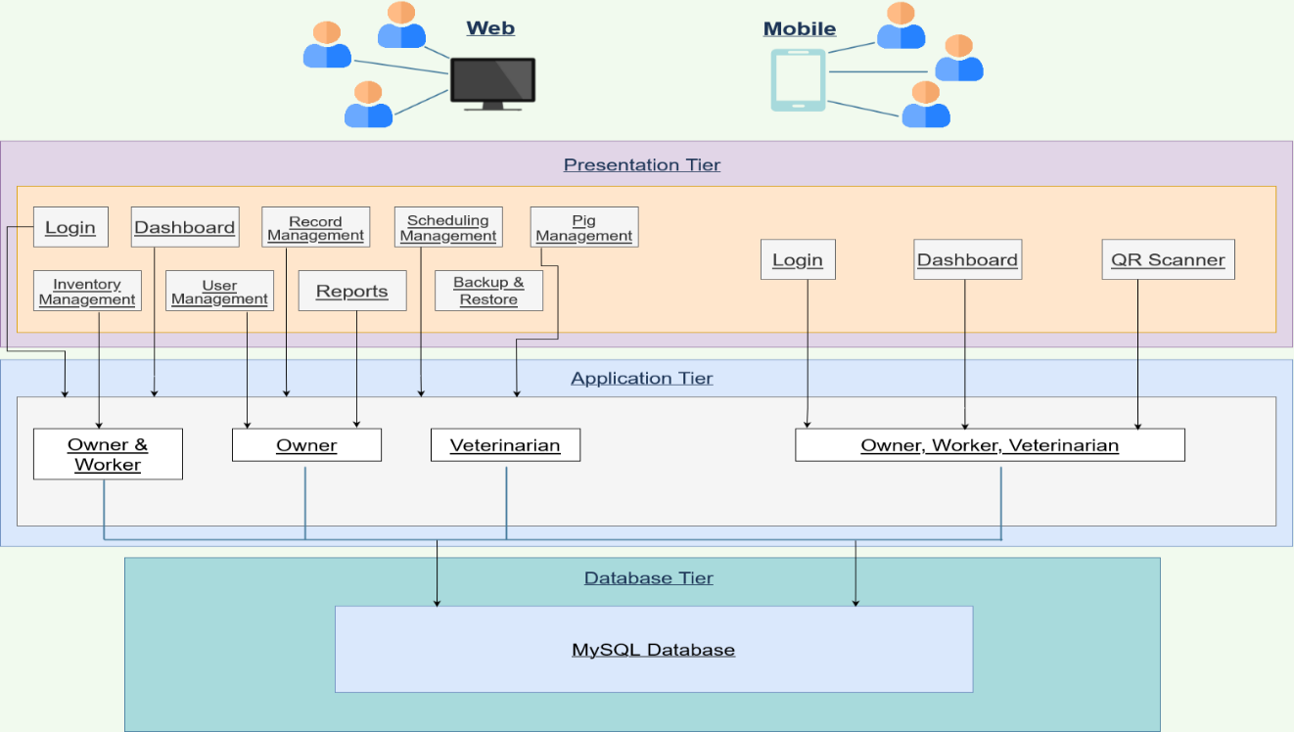

Figure 27: System Architecture of the Web-Based Piggery Management System

Object Modeling

This section places the use case model and activity diagrams for every interaction of the owner, worker, and veterinarian to the Web-based Piggery Management System with Mobil-based QR Code Scanner for RVM Hog Farm in Lamba, Banga South Cotabato.

The following illustration presents the Web-based Piggery Management System with Mobil-based QR Code Scanner for RVM Hog Farm in Lamba, Banga South Cotabato use case model and activity diagrams for each web application modules.

User Management Module

|  |  |  |
| --- | --- | --- |
| Use Case | Description | User/Actor (Roles) |
| Login | The user/actor enters the default username and password to log in. | Owner, Worker, and Veterinarian |
| Create User Accounts | The user/actor enters the user account details to register. | Owner |
| Search and View User Account | The user/actor searches for specific user account details and enters the registered user's username to view details. | Owner |
| Search and Update User Account | The user/actor searches for specific user account details and enters the user details to update. | Owner |
| Search and Remove User Account | The user/actor searches for specific user account details to remove. | Owner |
| Logout | The user/actor selects the logout in the sidebar navigation panel to exit the system. | Owner, Worker, and Veterinarian |

Table 8: Event Decomposition of the User Management Module

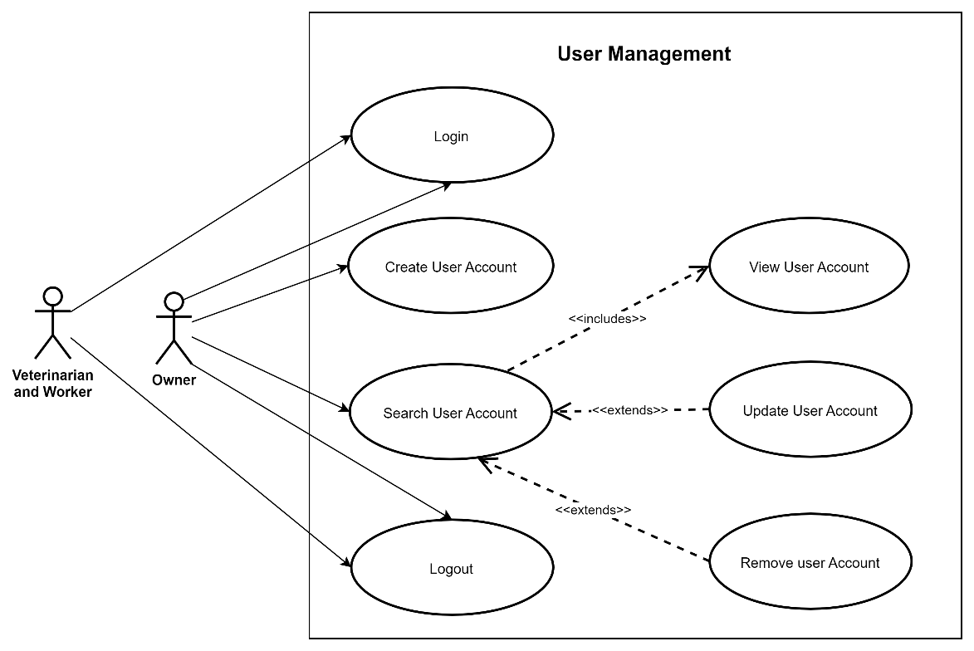

Figure 28: Use Case Diagram involving the Owner, Worker, and Veterinarian of Piggery Management System of User Management Module

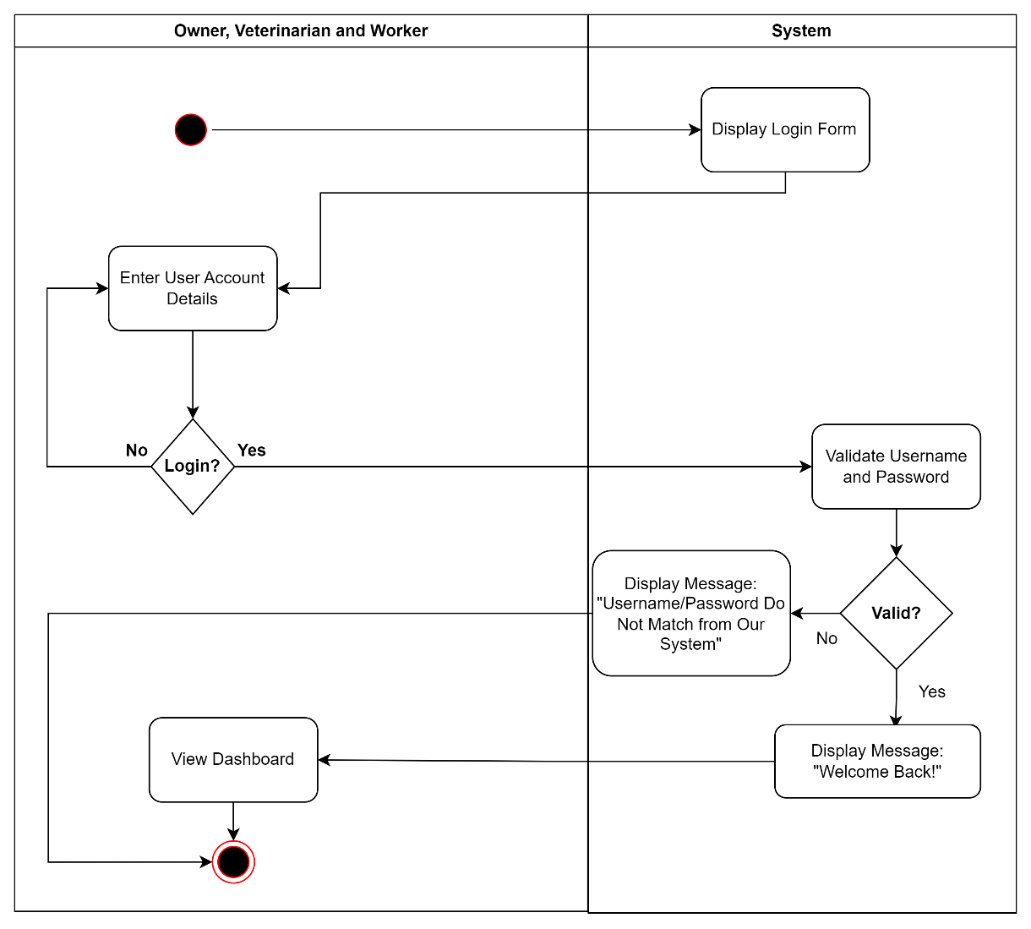

Figure 29: Activity Diagram of Enter Username and Password of Login Module Use Case

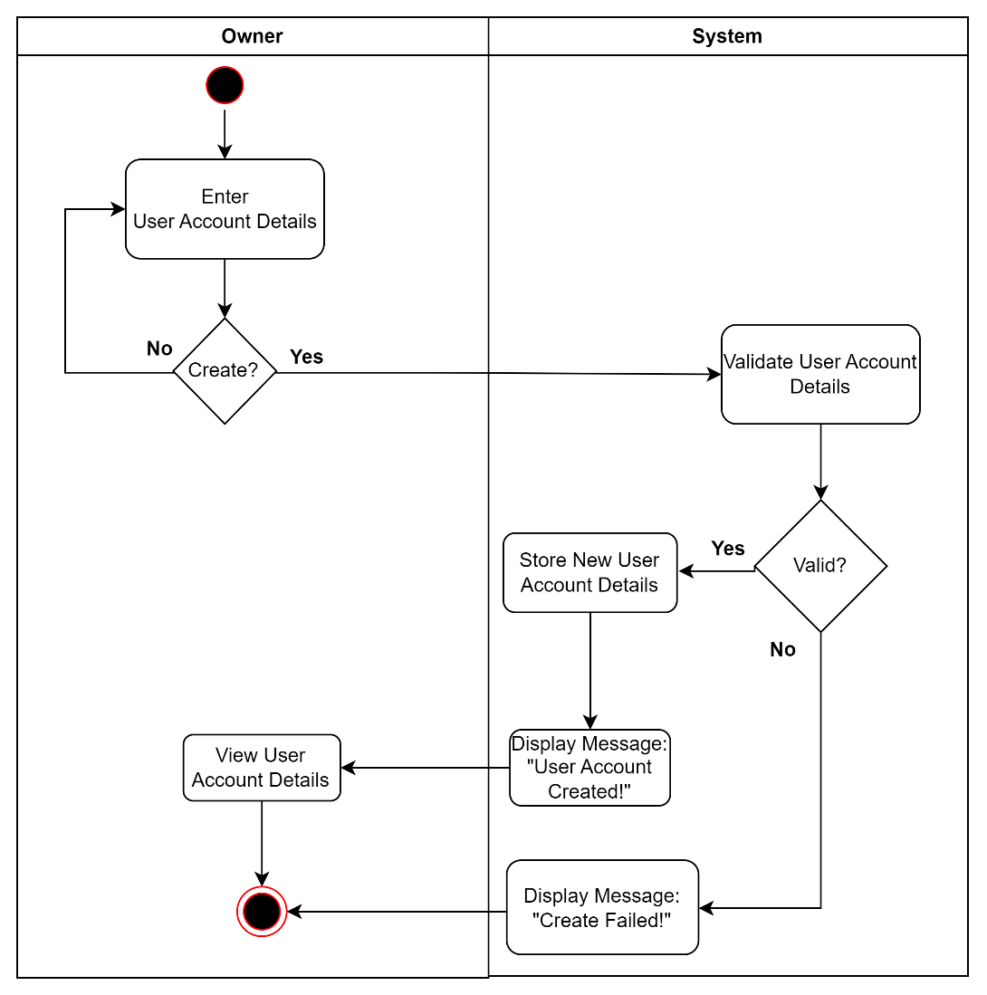

Figure 30: Activity Diagram of Create User Account of User Module Use Case

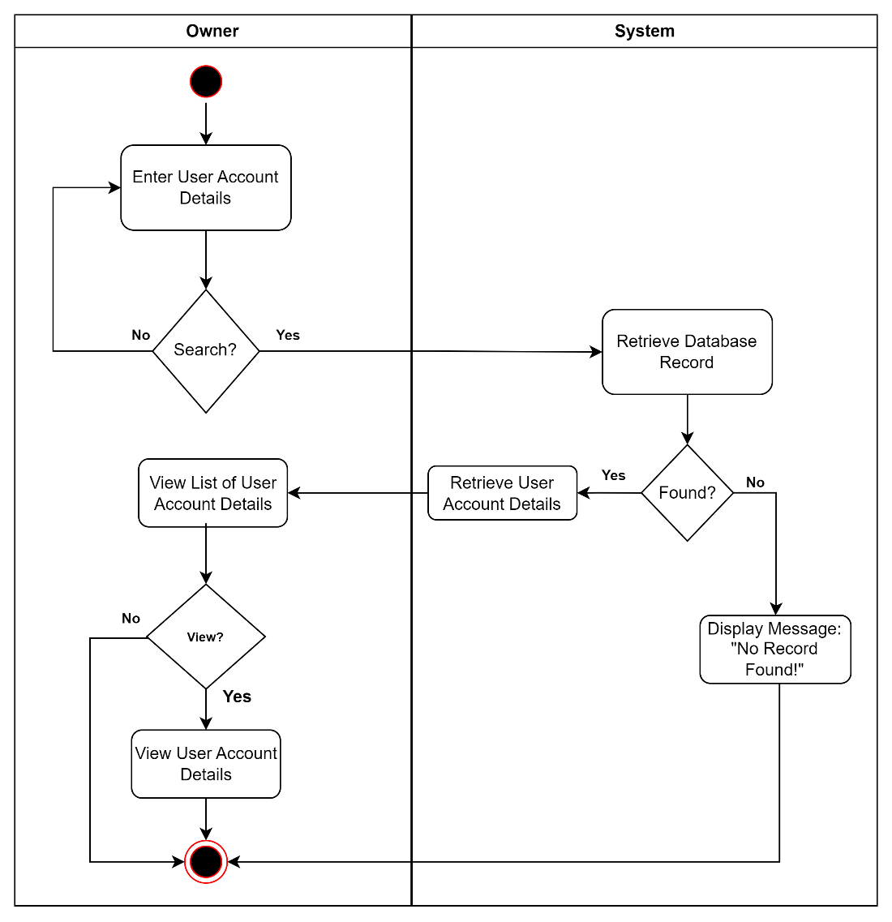

Figure 31: Activity Diagram of Search and View User Account of User Module Use Case

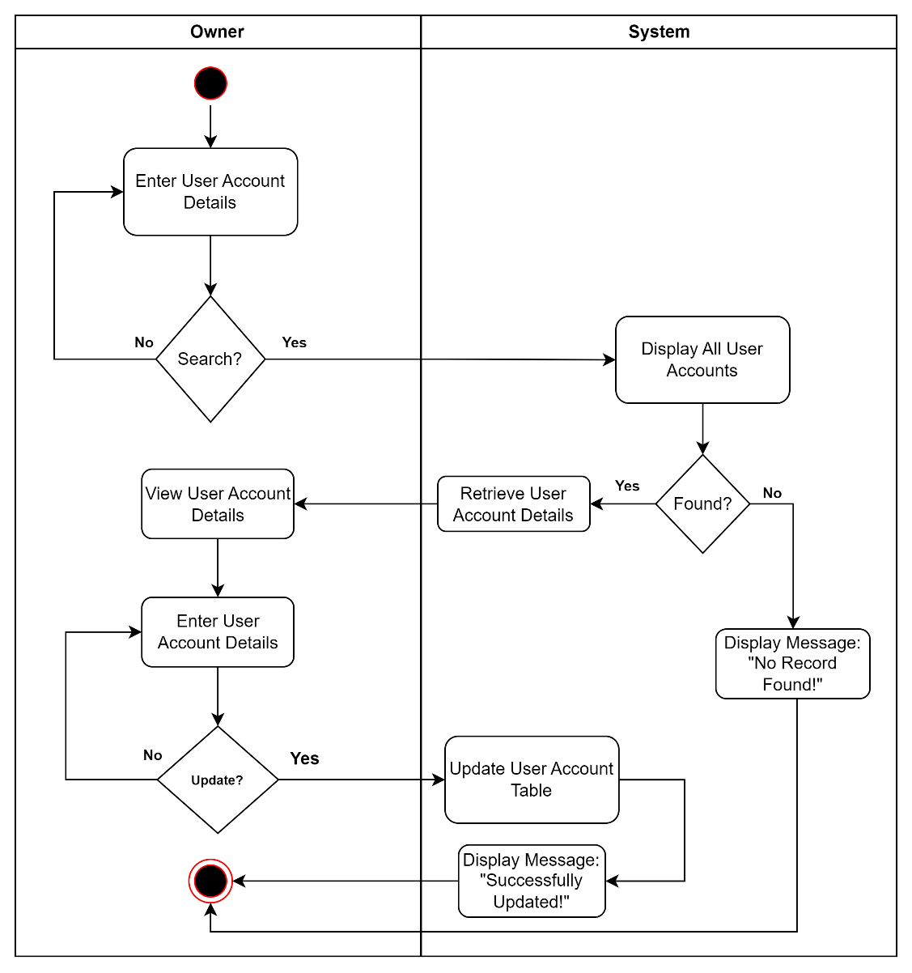

Figure 32: Activity Diagram of Search and Update User Account of User Module Use Case

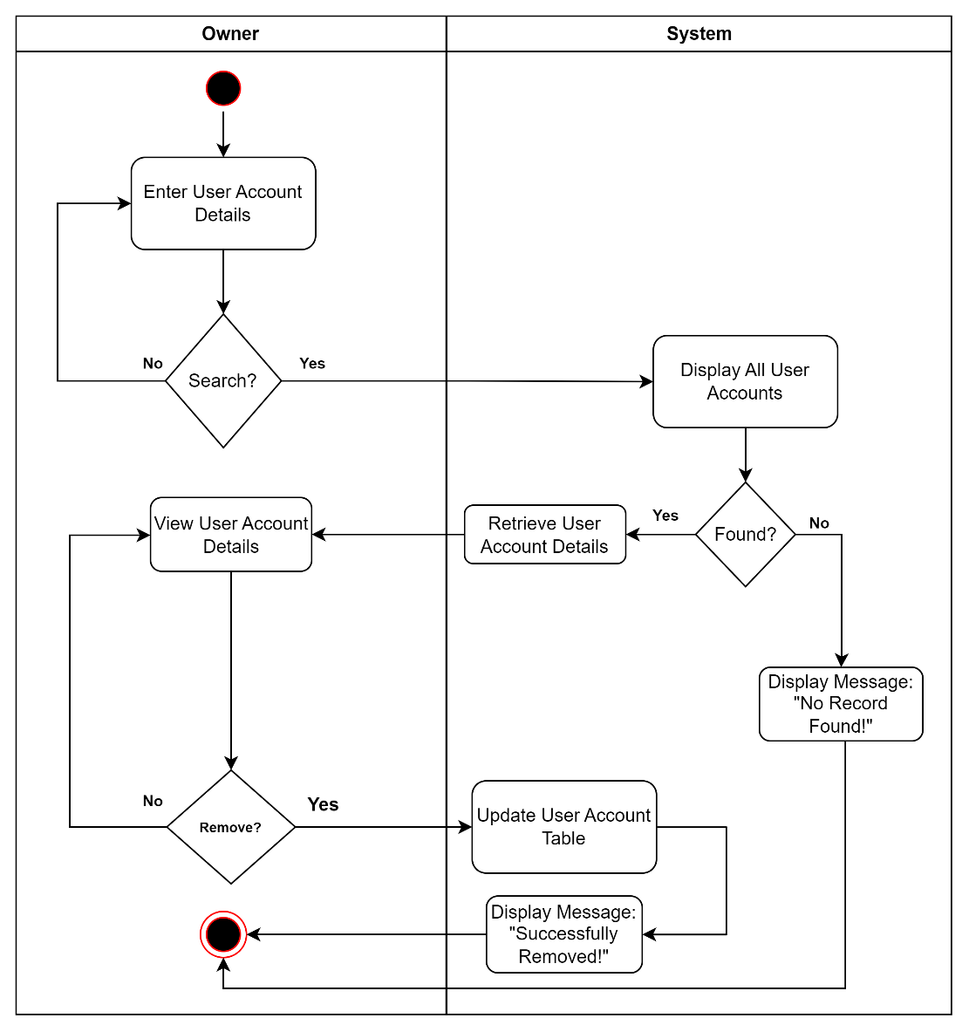

Figure 33: Activity Diagram of Search and Remove User Account of User Module Use Case

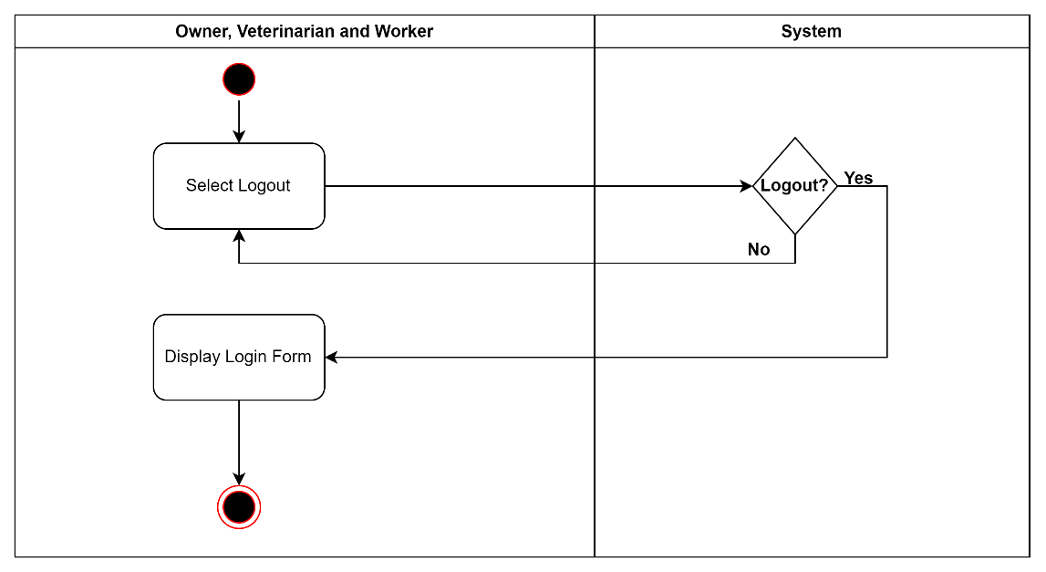

Figure 34: Activity Diagram of Logout User Account of User Module Use Case

Dashboard Module

|  |  |  |
| --- | --- | --- |
| Use Case | Description | User/Actor (Roles) |
| Enter and view dashboard interface | The user/actor enters the dashboard after logging in to the system and views the dashboard interface. | Owner, Worker, and Veterinarian |

Table 9: Event Decomposition of the Piggery Management System Dashboard Module

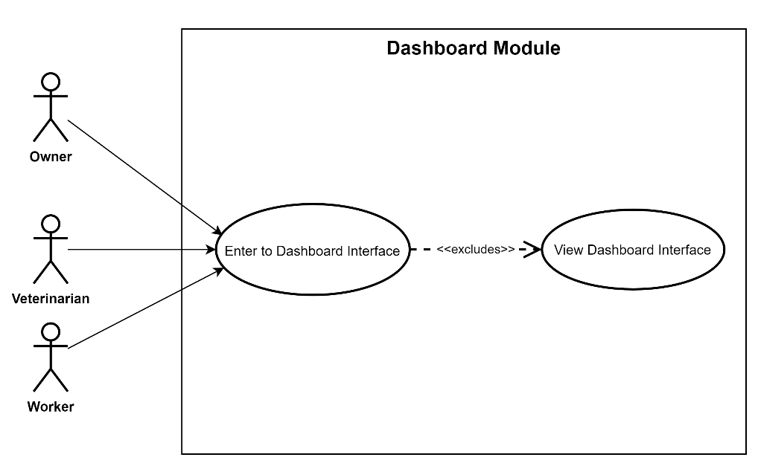

Figure 35: Use Case Diagram involving the Owner, Worker, and Veterinarian of Piggery Management System of Dashboard Module

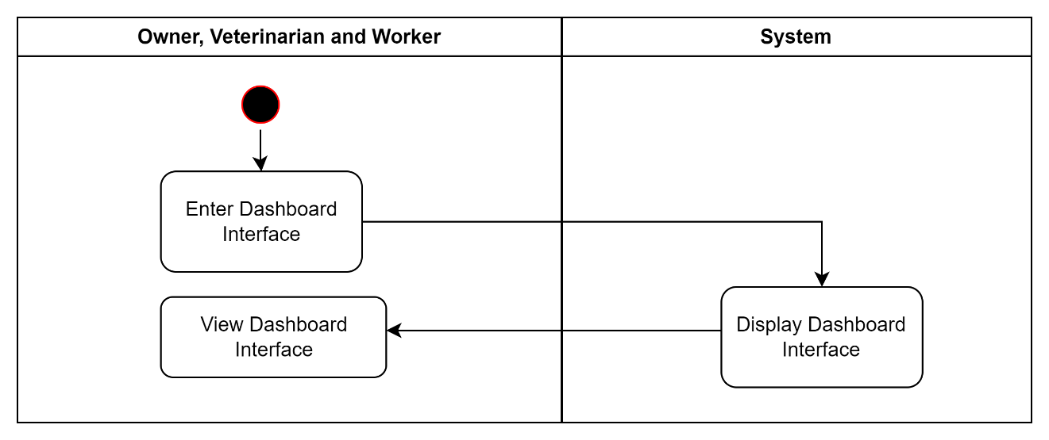

Figure 36: Activity Diagram of View Dashboard Interface of Dashboard Module Use Case

Cage Management Module

|  |  |  |
| --- | --- | --- |
| Use Case | Description | User/Actor (Roles) |
| Create Cage | The user/actor enters the cage details to register. | Worker |
| Search and View Cage | The user/actor searches for specific cage details and selects a cage to view details. | Worker |
| Search and Update Cage | The user/actor searches for specific cage details and then enters the cage details to update. | Worker |
| Search and Remove Cage | The user/actor searches cage details to remove. | Worker |

Table 10: Event Decomposition of the Piggery Management System Cage Management Module

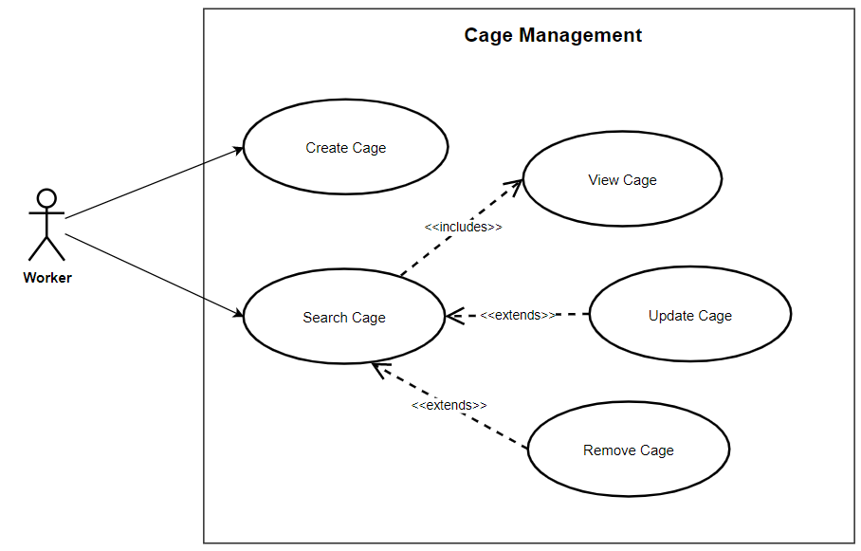

Figure 37: Use Case Diagram involving the Worker of Piggery Management System of Cage Management Module

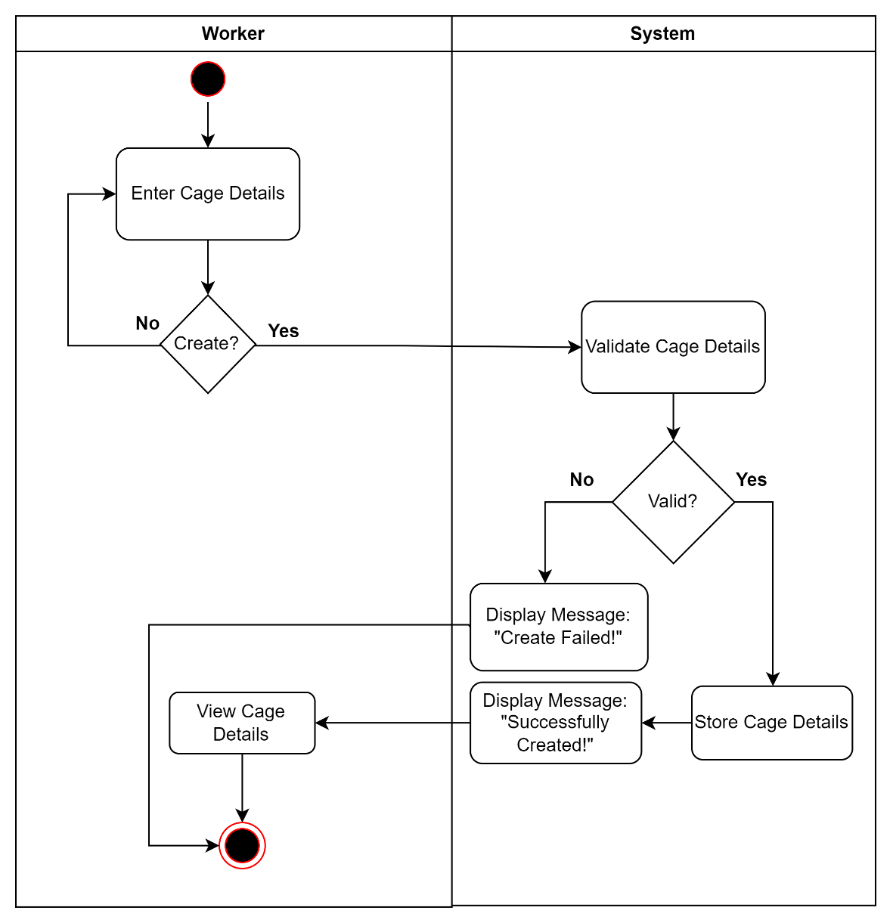

Figure 38: Activity Diagram of Create Cage of Cage Management Module Use Case

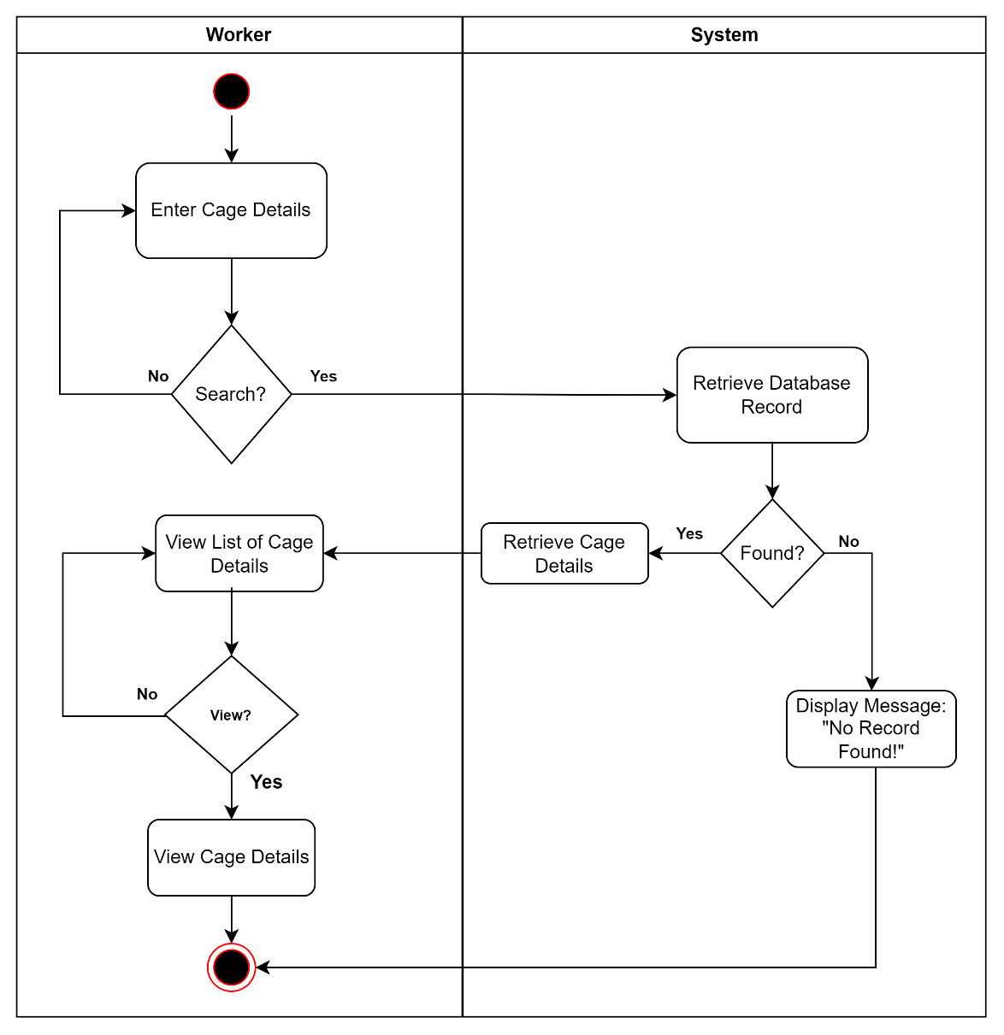

Figure 39: Activity Diagram of Search and View Cage of Cage Management Module Use Case

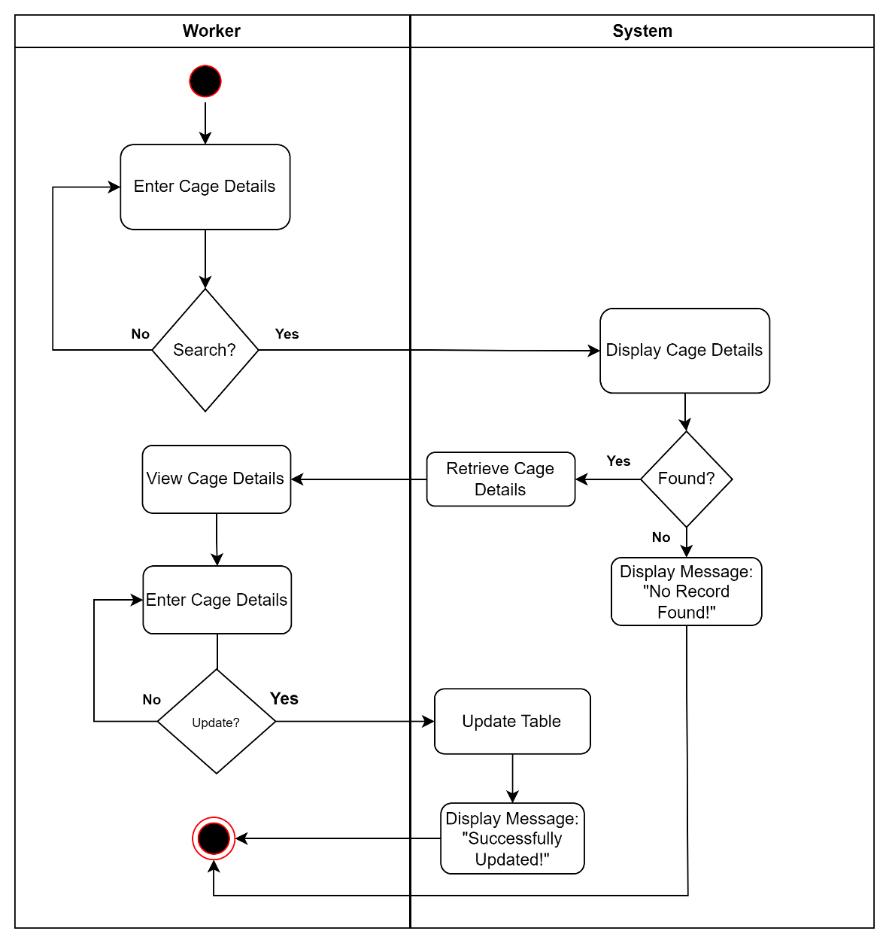

Figure 40: Activity Diagram of Search and Update Cage of Cage Management Module Use Case

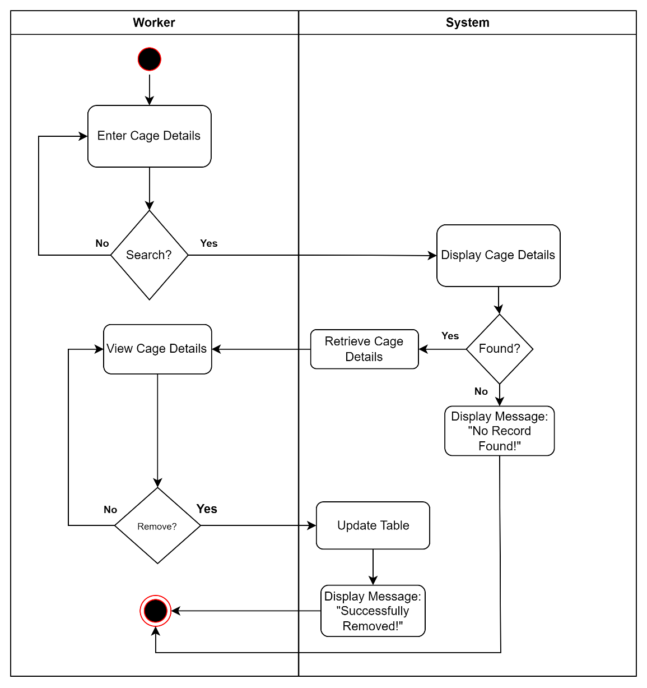

Figure 41: Activity Diagram of Search and Remove Cage of Cage Management Module Use Case

Pig Management Module

|  |  |  |
| --- | --- | --- |
| Use Case | Description | User/Actor (Roles) |
| Create Pig | The user/actor enters the pig details to register. | Worker |
| Search and View Pig | The user/actor searches for specific pig details and selects a pig to view details. | Worker |
| Search and Update Pig | The user/actor searches for specific pig details and then enters the pig details to update. | Worker |
| Search and Remove Pig | The user/actor searches pig details to remove. | Worker |

Table 11: Event Decomposition of the Piggery Management System Pig Management Module

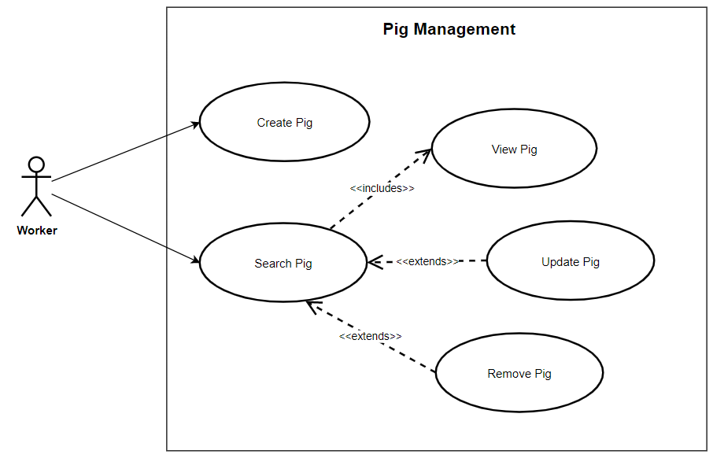

Figure 42: Use Case Diagram involving the Worker of Piggery Management System of Pig Management Module

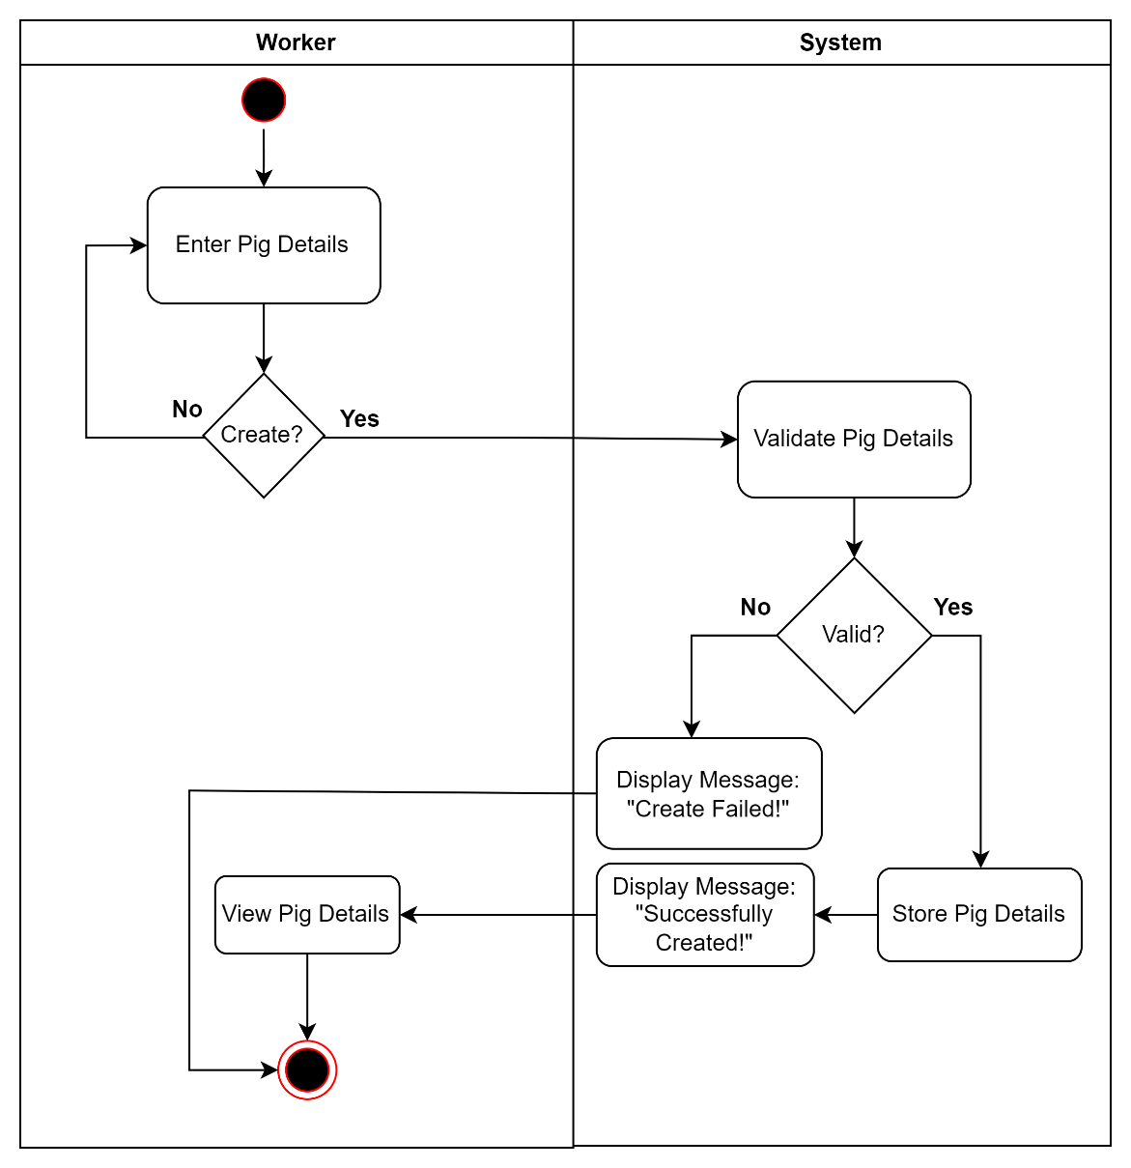

Figure 43: Activity Diagram of Create Pig of Pig Management Module Use Case

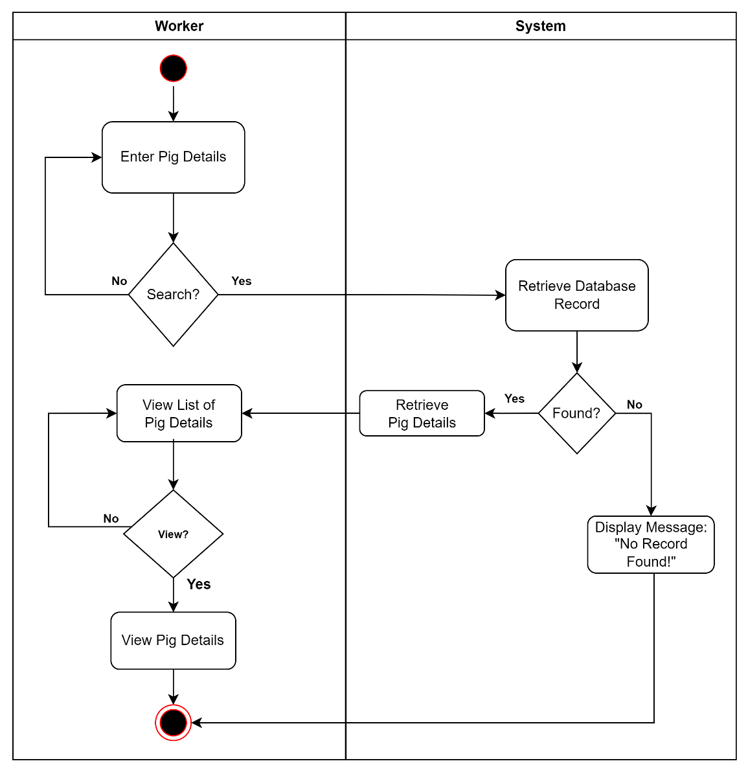

Figure 44: Activity Diagram of Search and View Pig of Pig Management Module Use Case

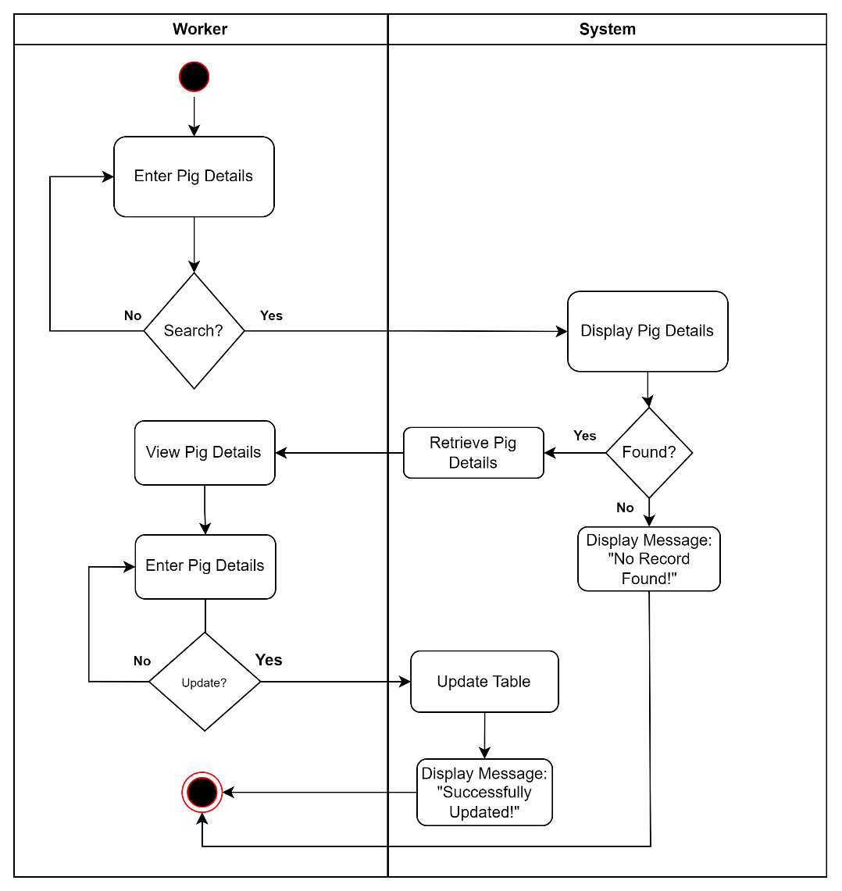

Figure 45: Activity Diagram of Search and Update Pig of Pig Management Module Use Case

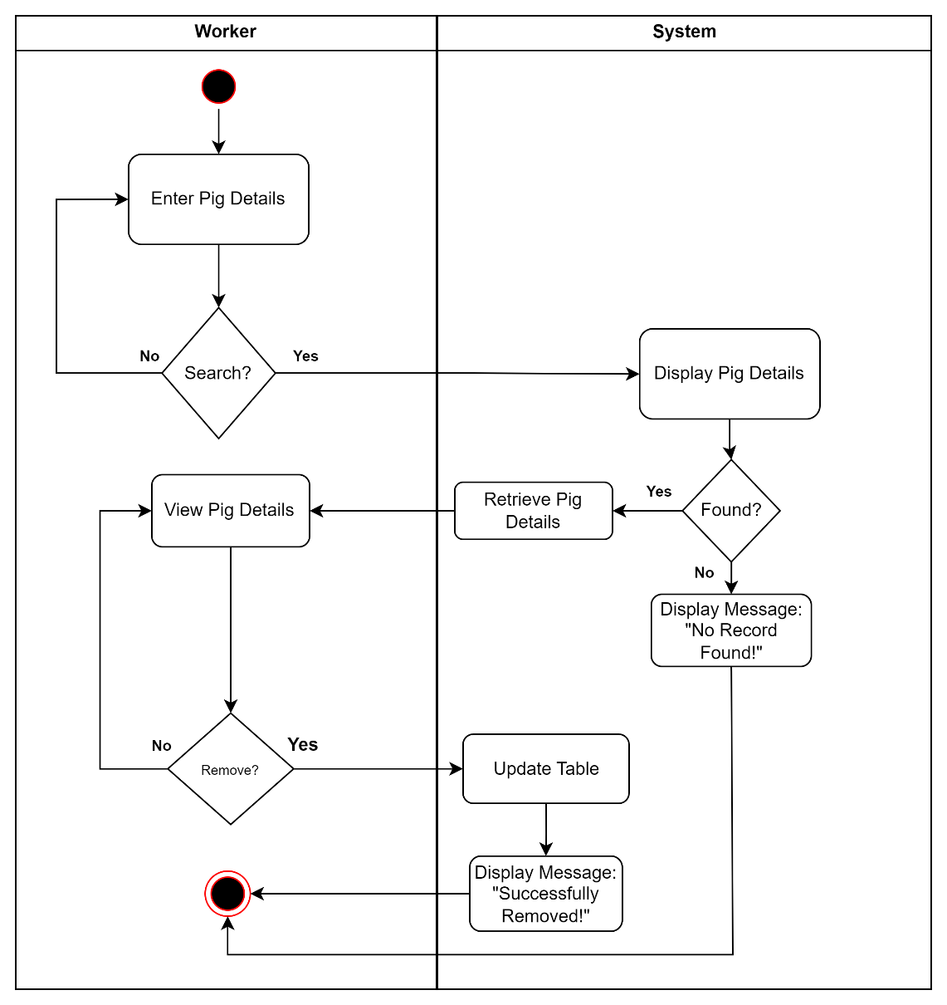

Figure 46: Activity Diagram of Search and Remove Pig of Pig Management Module Use Case

Batch Management Module

|  |  |  |
| --- | --- | --- |
| Use Case | Description | User/Actor (Roles) |
| Create Batch | The user/actor enters the batch details to register. | Worker |
| Search and View Batch | The user/actor searches for specific batch details and select batch to view details. | Worker |
| Search and Update Batch | The user/actor searches for specific batch details and then enters the batch details to update. | Worker |
| Search and Remove Batch | The user/actor searches batch details to remove. | Worker |

Table 12: Event Decomposition of Batch Management Module

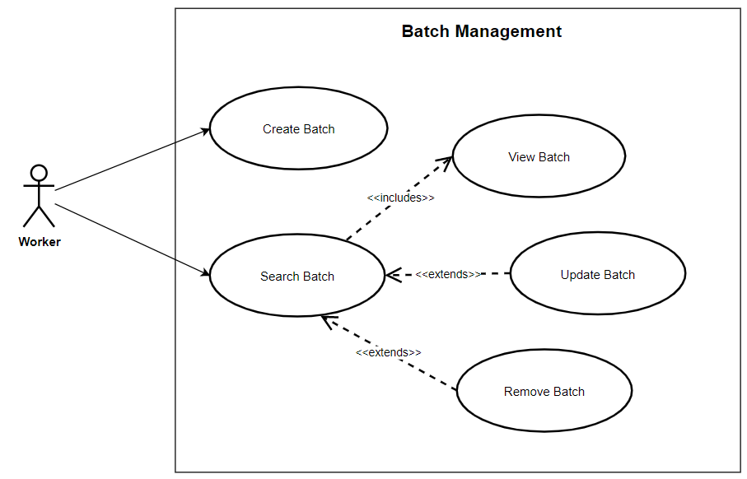

Figure 47: Use Case Diagram involving the Worker of Piggery Management System of Batch Management Module

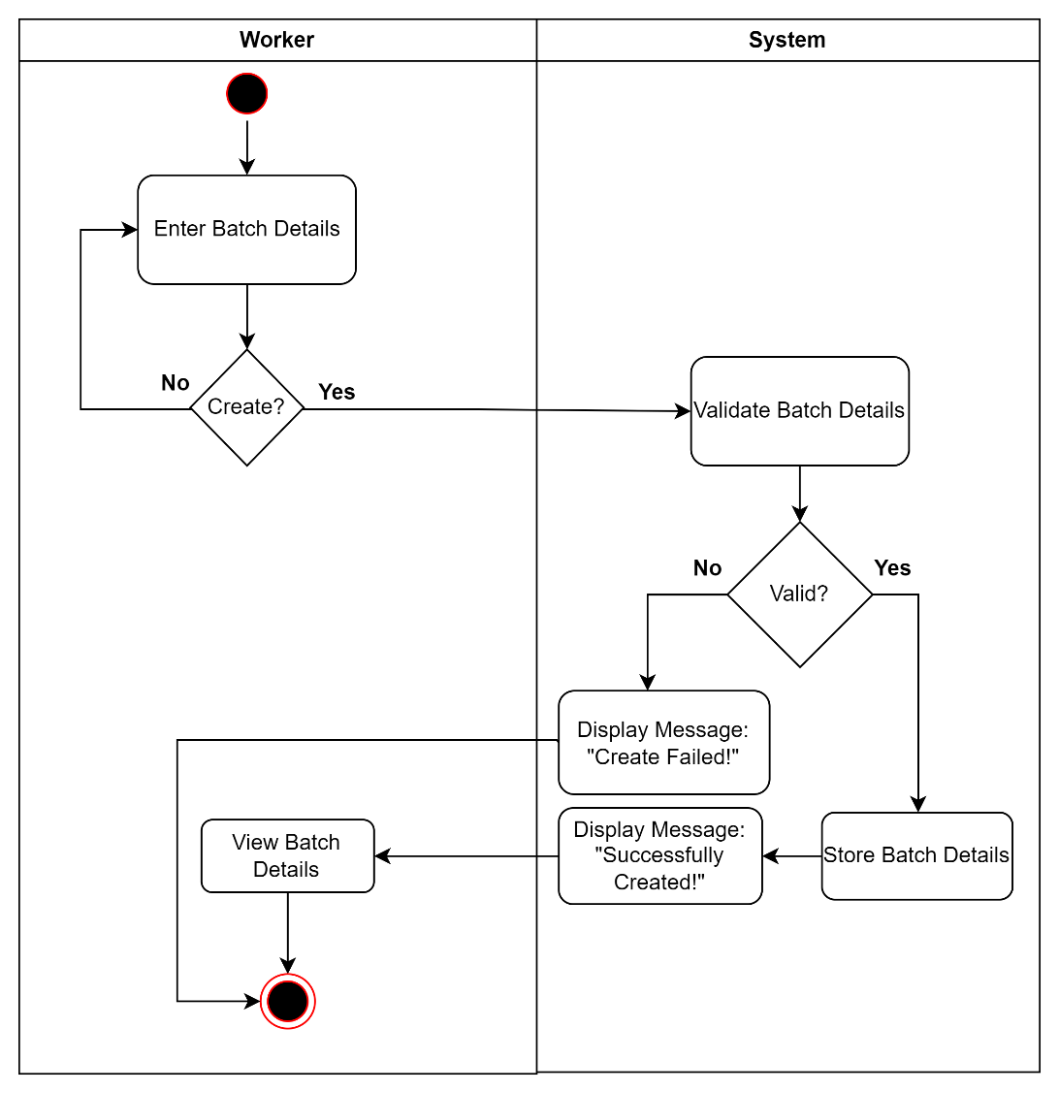

Figure 48: Activity Diagram of Create Batch of Batch Management Module Use Case

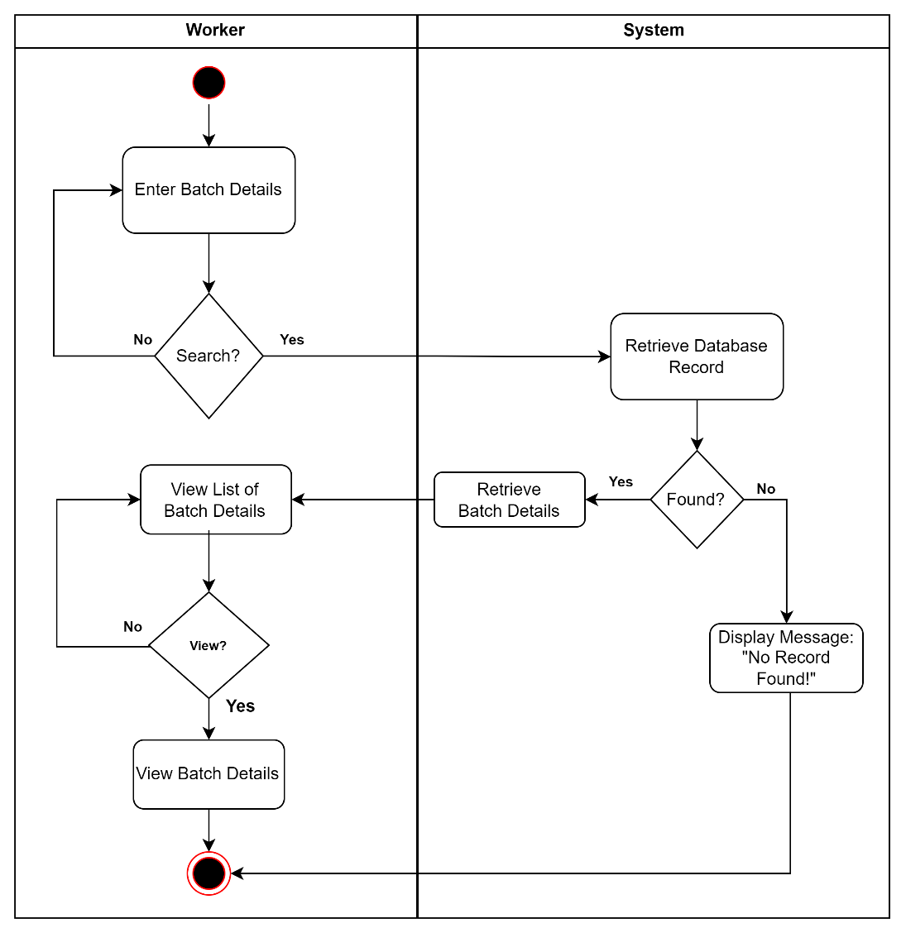

Figure 49: Activity Diagram of Search and View Batch of Batch Management Module Use Case

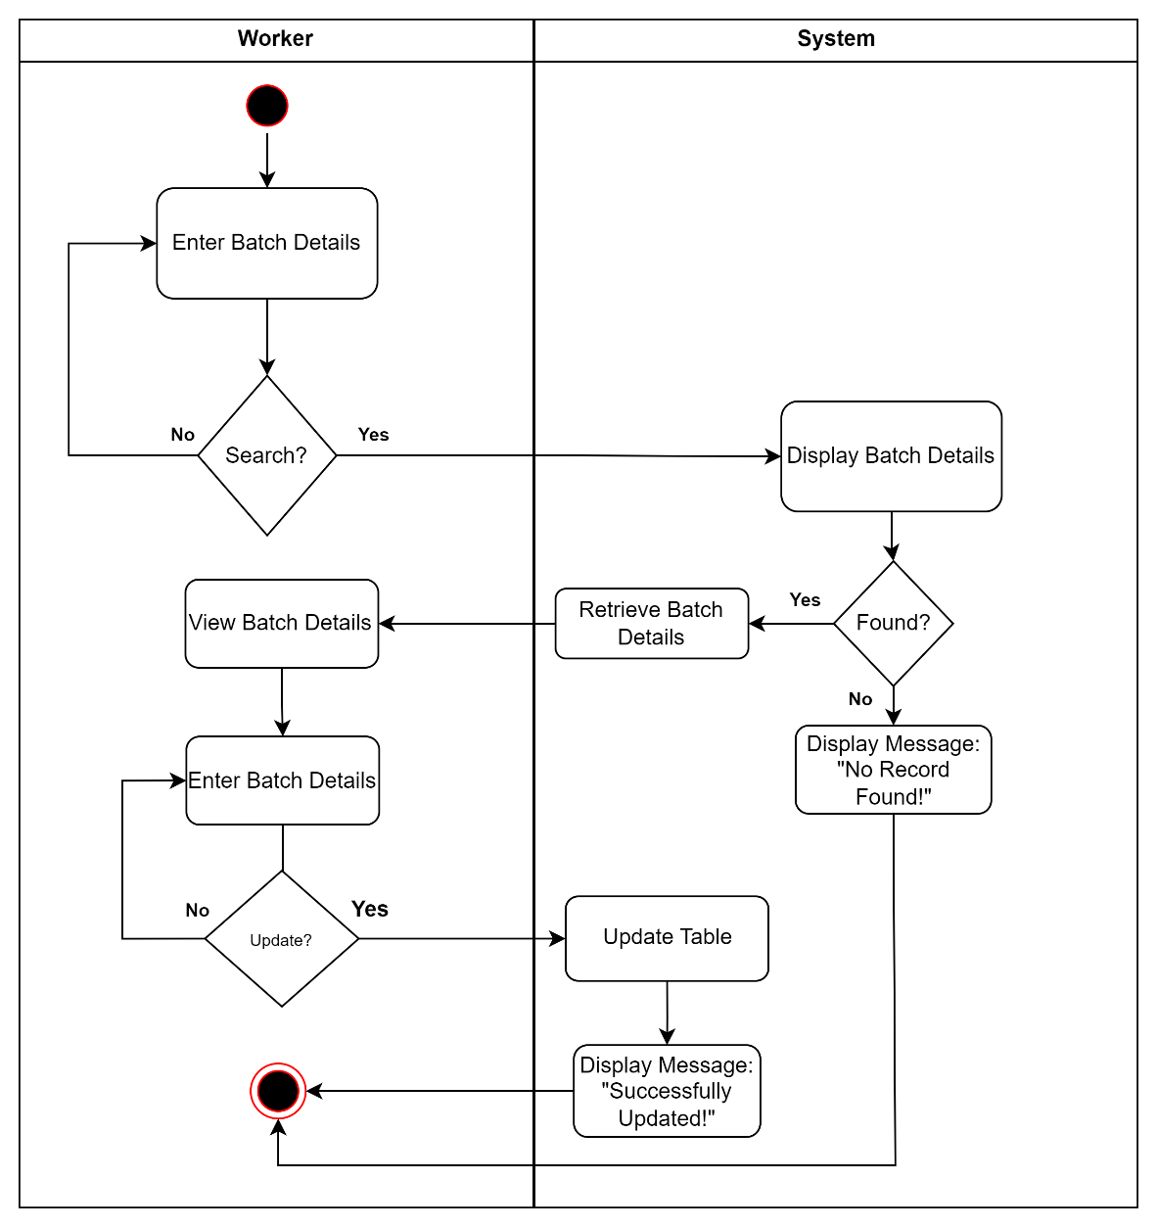

Figure 50: Activity Diagram of Search and Update Batch of Batch Management Module Use Case

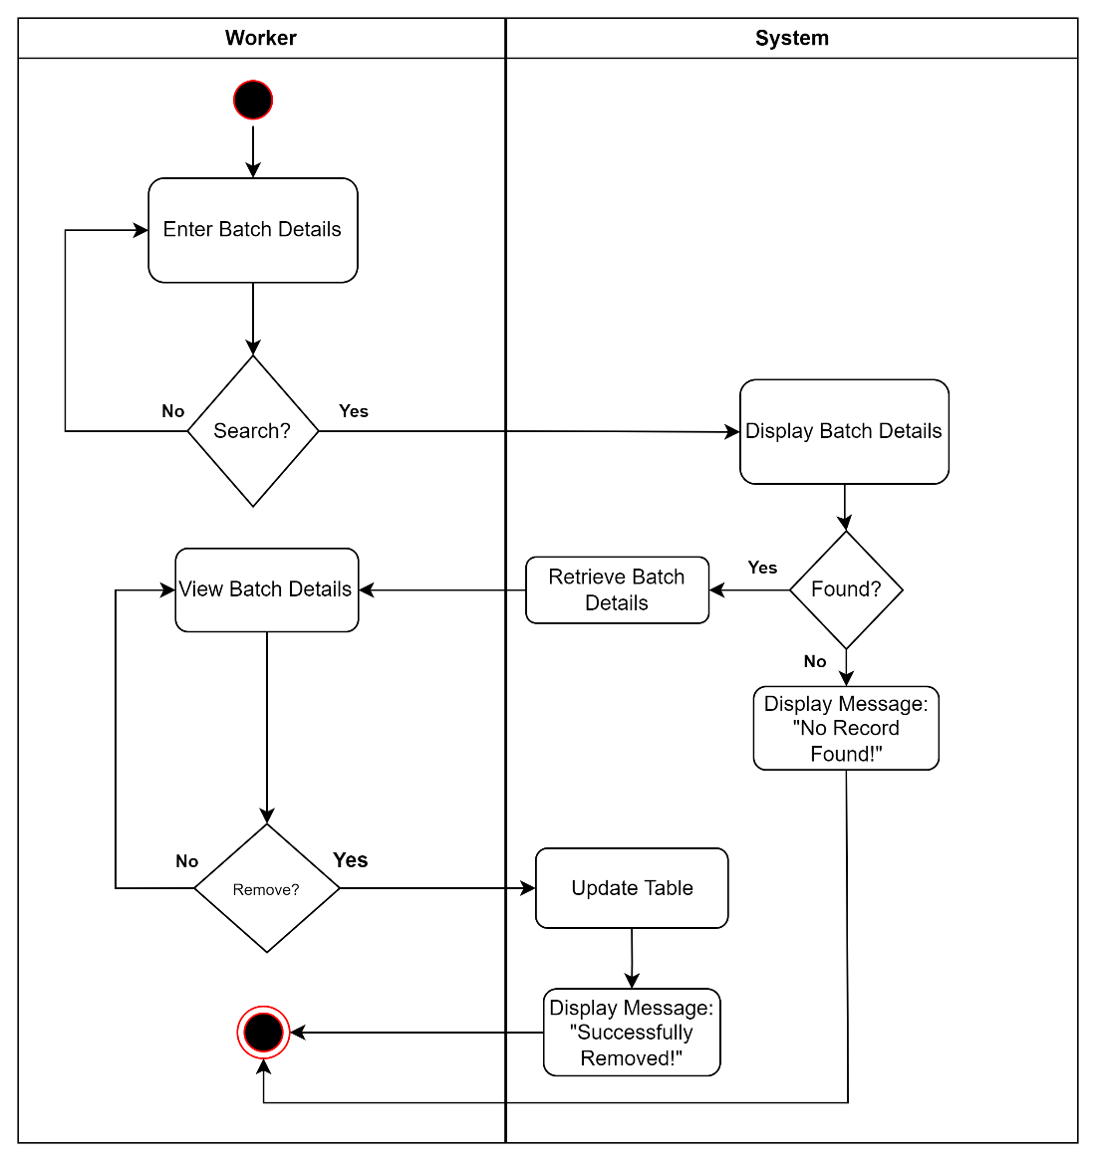

Figure 51: Activity Diagram of Search and Remove Batch of Batch Management Module Use Case

Breed Management Module

|  |  |  |
| --- | --- | --- |
| Use Case | Description | User/Actor (Roles) |
| Create Breed | The user/actor enters the breed details to register. | Worker |
| Search and View Breed | The user/actor searches for specific breed details and selects a breed to view details. | Worker |
| Search and Update Breed | The user/actor searches for specific breed details and then enters the breed details to update. | Worker |
| Search and Remove Breed | The user/actor searches breed details to remove. | Worker |

Table 13: Event Decomposition of Breed Management Module

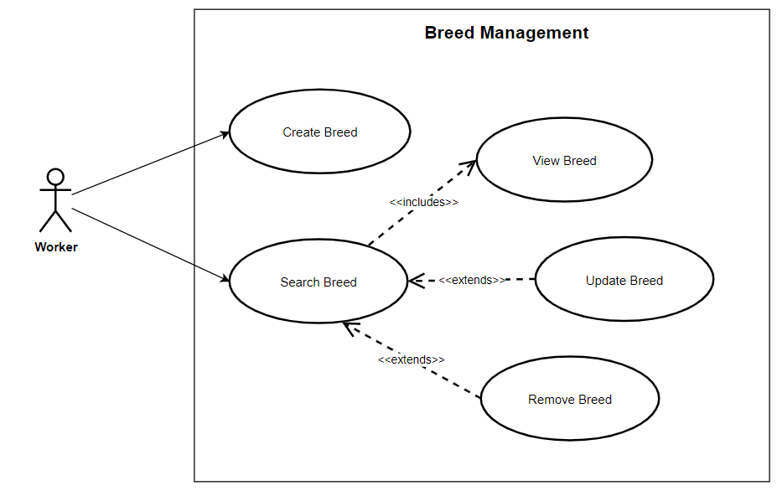

Figure 52: Use Case Diagram involving the Worker of Piggery Management System of Breed Management Module

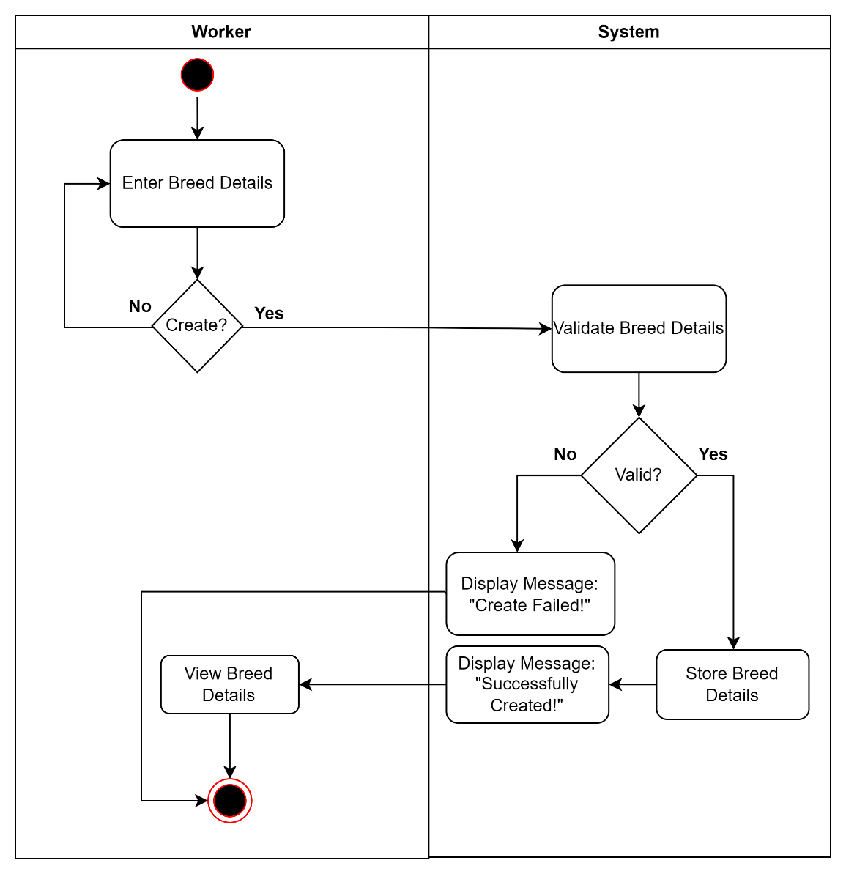

Figure 53: Activity Diagram of Create Breed of Breed Management Module Use Case

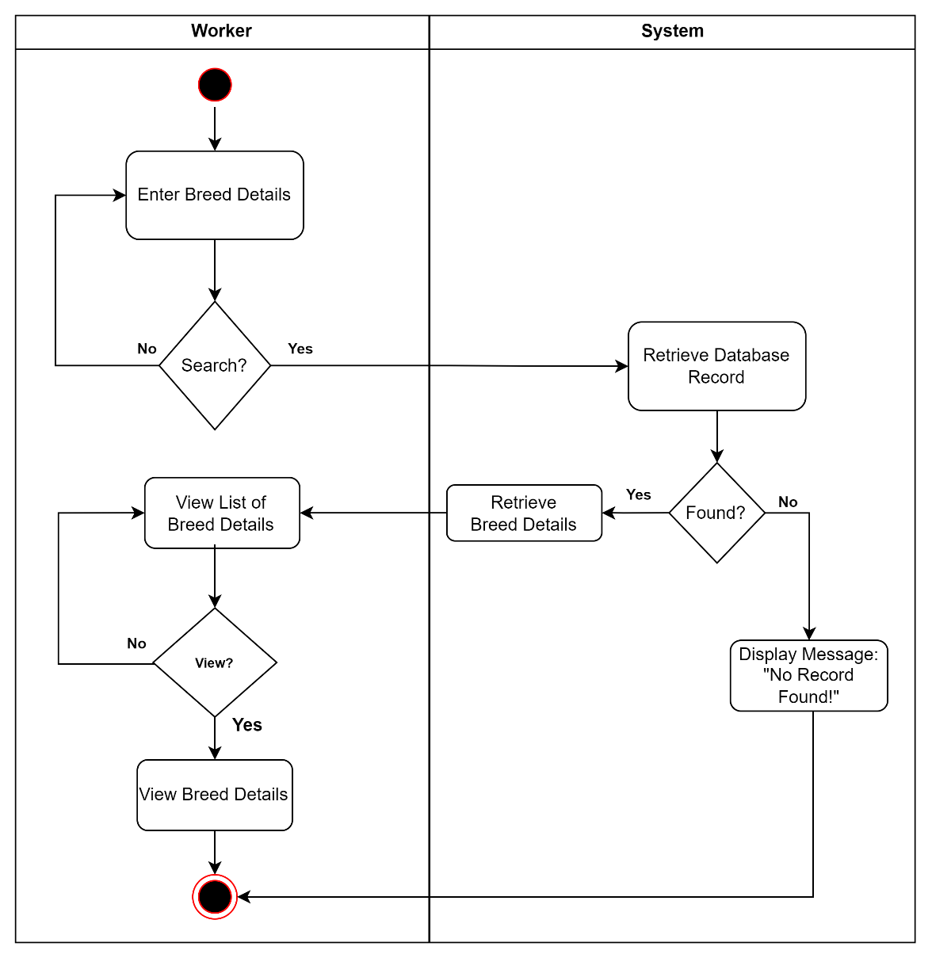

Figure 54: Activity Diagram of Search and View Breed of Breed Management Module Use Case

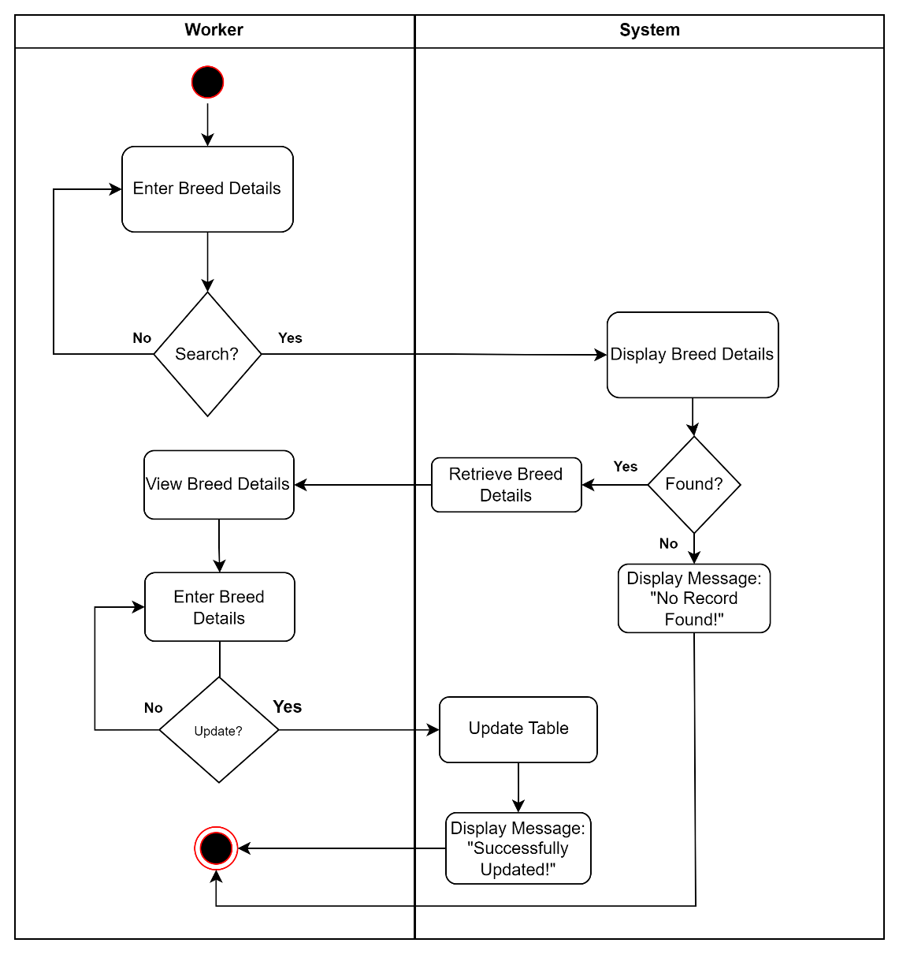

Figure 55: Activity Diagram of Search and Update Breed of Breed Management Module Use Case

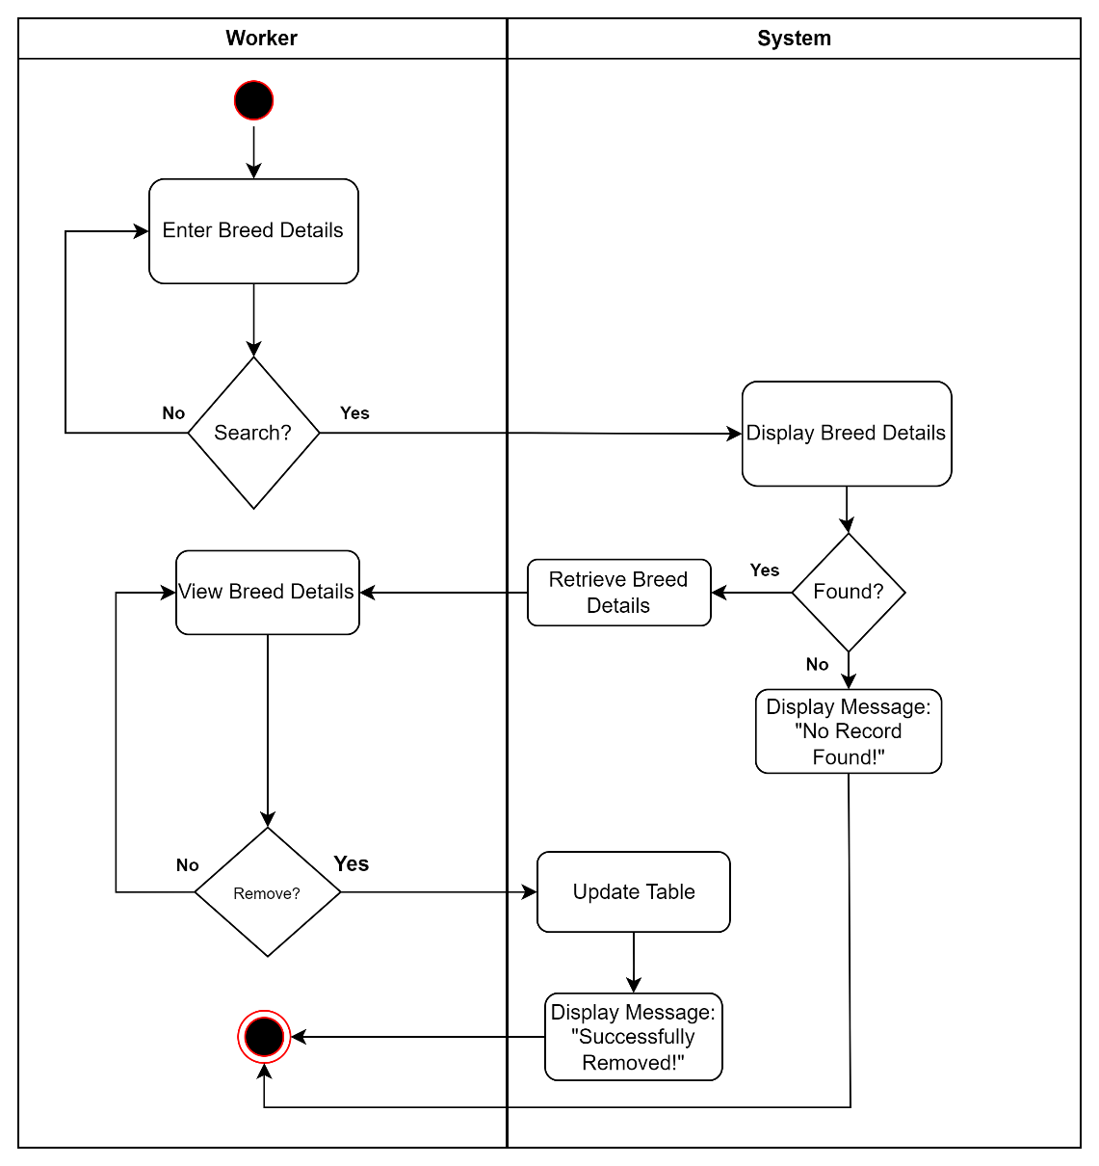

Figure 56: Activity Diagram of Search and Remove Breed of Breed Management Module Use Case

Inventory Management Module

|  |  |  |
| --- | --- | --- |
| Use Case | Description | User/Actor (Roles) |
| Create Inventory | The user/actor enters the inventory details to register. | Worker |
| Search and View Inventory | The user/actor searches for specific inventory details and select inventory to view details. | Worker |
| Search and Update Inventory | The user/actor searches for specific inventory details and then enters the inventory details to update. | Worker |
| Search and Remove Inventory | The user/actor searches inventory details to remove. | Worker |

Table 14: Event Decomposition of Inventory Management Module

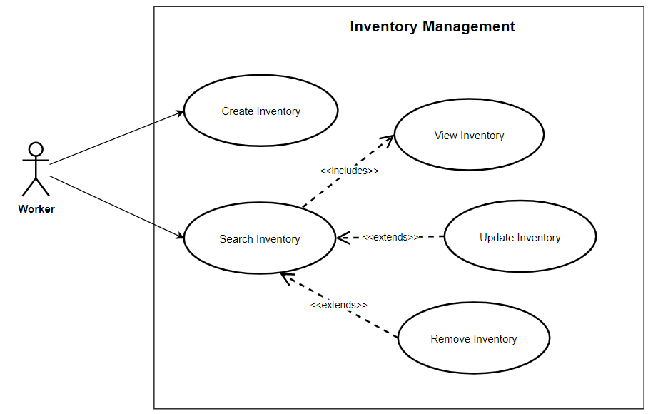

Figure 57: Use Case Diagram involving the Worker of Piggery Management System of Inventory Management Module

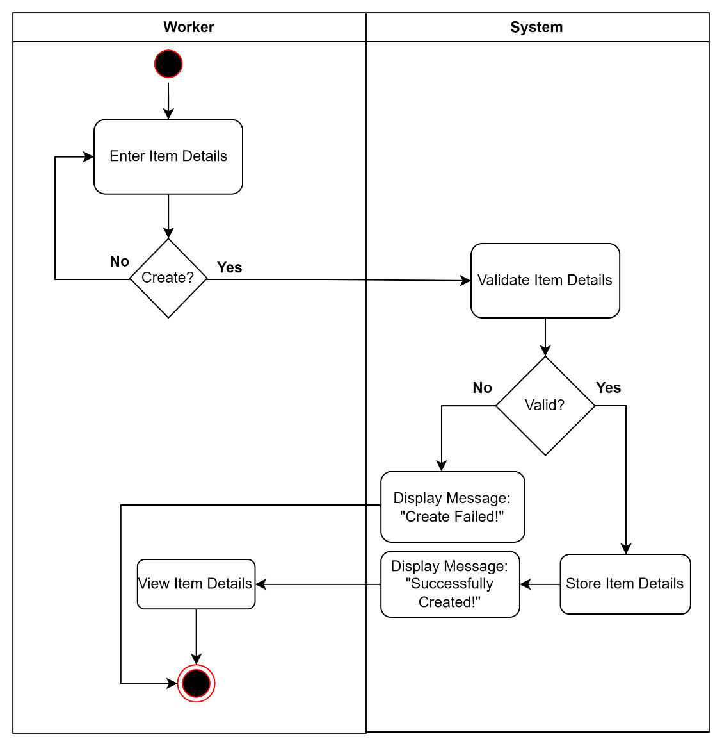

Figure 58: Activity Diagram of Create Inventory of Inventory Management Module Use Case

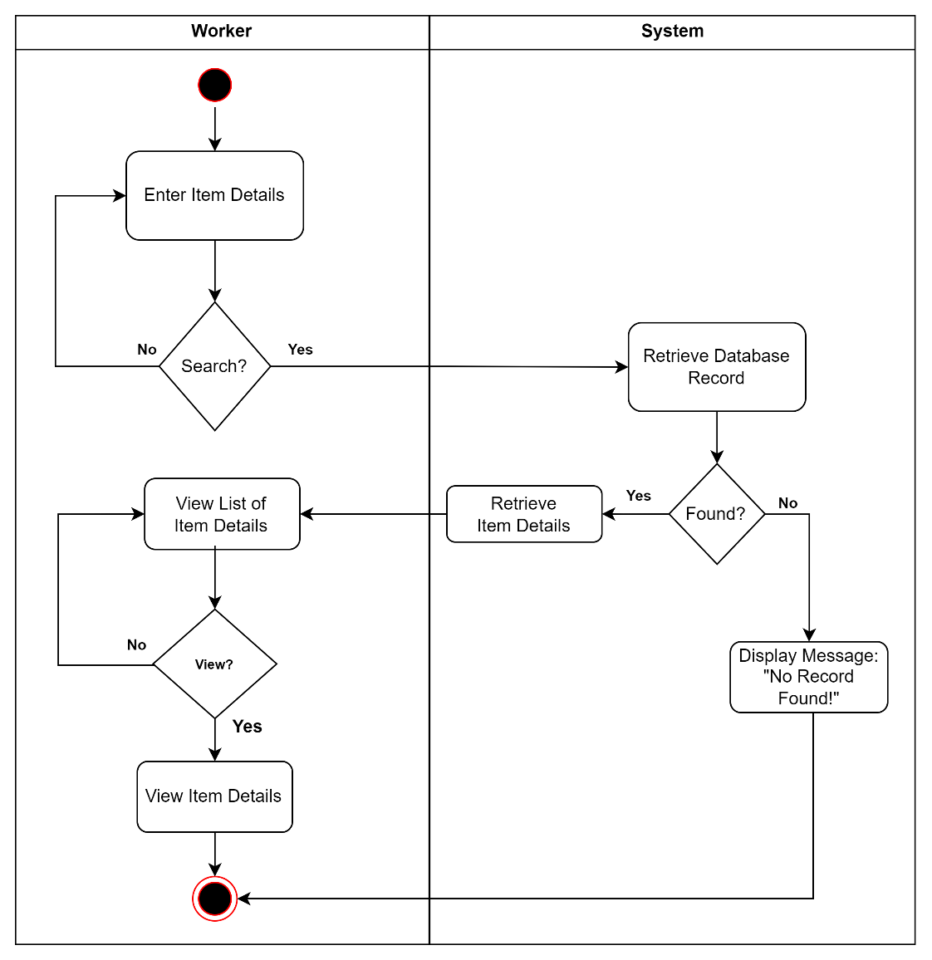

Figure 59: Activity Diagram of Search and View Inventory of Inventory Management Module Use Case

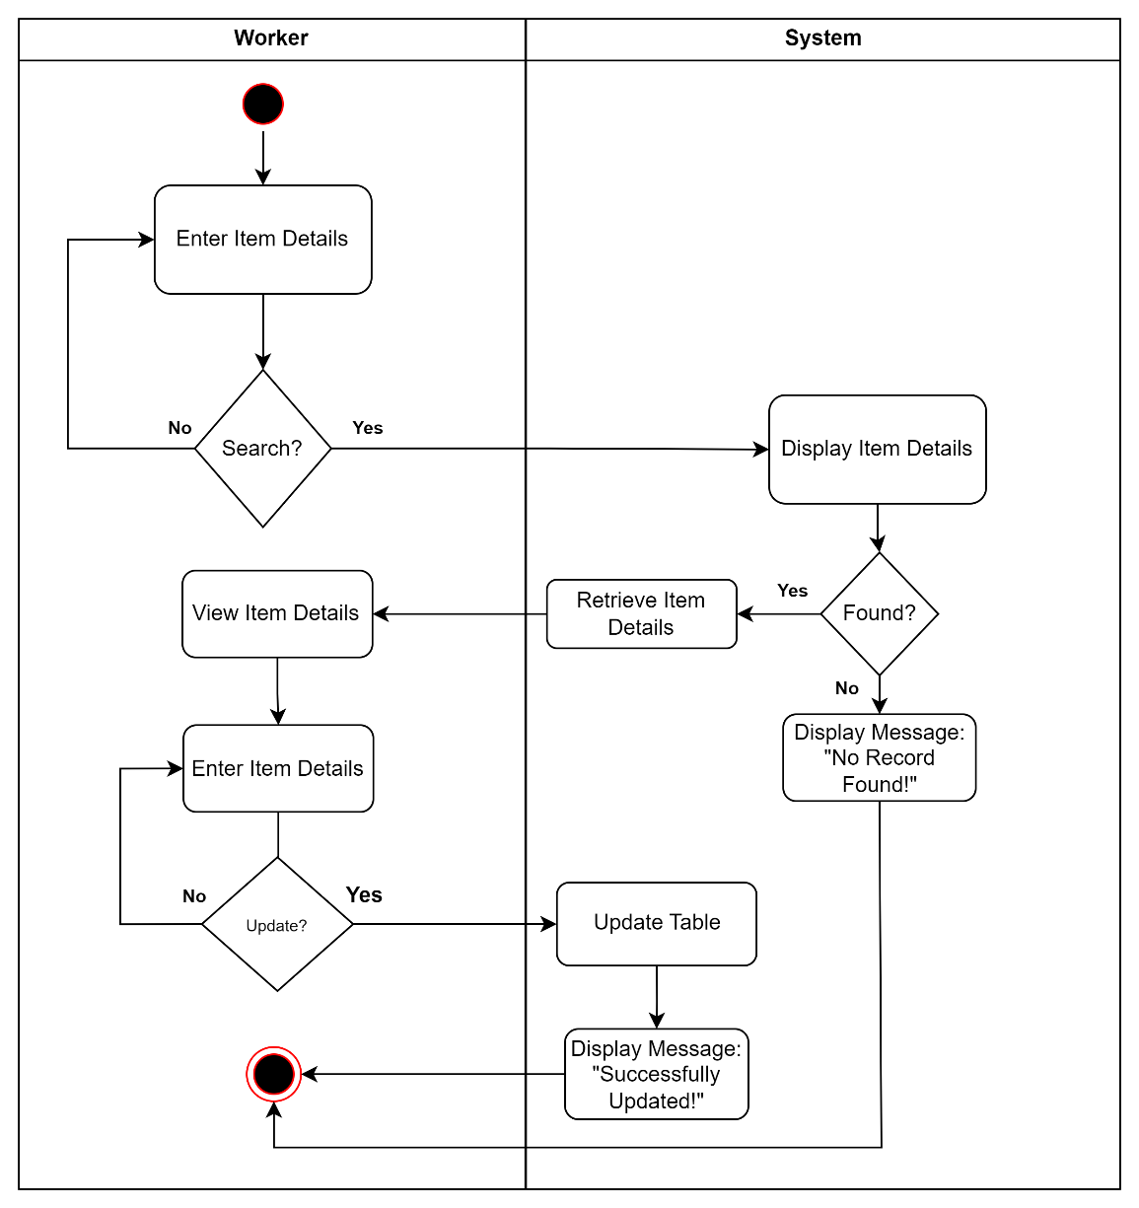

Figure 60: Activity Diagram of Search and Update Inventory of Inventory Management Module Use Case

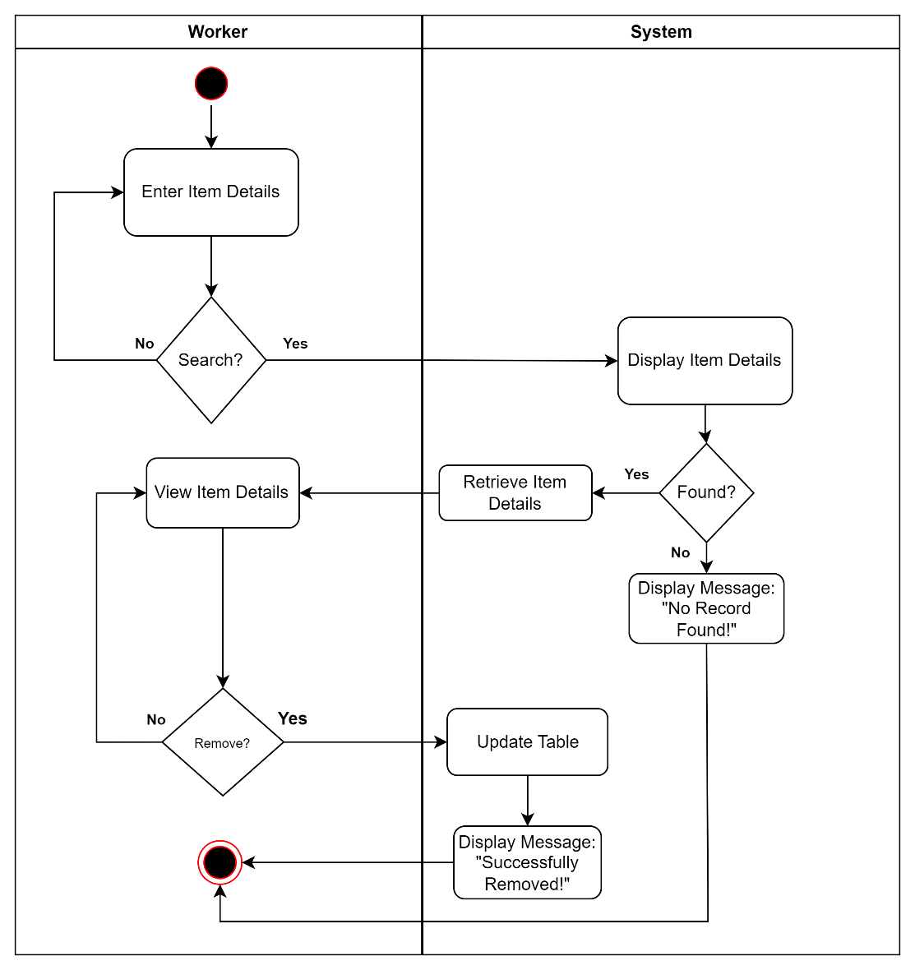

Figure 61: Activity Diagram of Search and Remove Inventory of Inventory Management Module Use Case

Stock Card Management Module

|  |  |  |
| --- | --- | --- |
| Use Case | Description | User/Actor (Roles) |
| Create Stock Card | The user/actor enters the list of the items in stock card. | Worker |
| Search and View Stock Card | The user/actor searches for specific item details and select purchase request to view details. | Worker |
| Search and Update Stock Card | The user/actor searches for specific item details and then enters the purchase request details to update. | Worker |
| Search and Remove Stock Card | The user/actor searches for item details to remove. | Worker |
| Stock Card | The user/actor enters the item details to register and updates inventory. | Worker |

Table 15: Event Decomposition of Stock Card Management Module

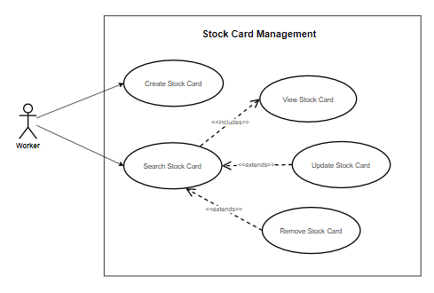

Figure 62: Use Case Diagram involving the Worker of Piggery Management System of Stock Card Management Module

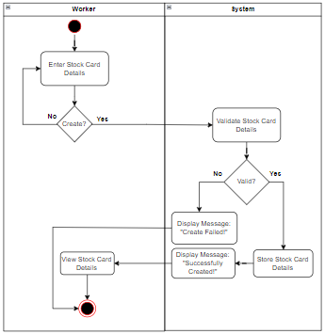

Figure 63: Activity Diagram of Create Stock Card Details of Stock Card Management Module Use Case

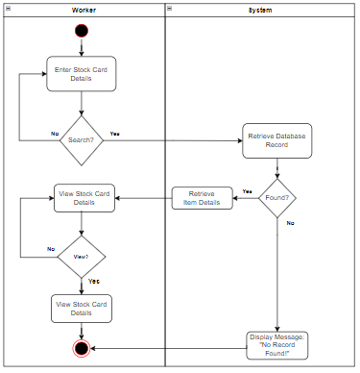

Figure 64: Activity Diagram of Search and View Stock Card of Stock Card Management Module Use Case

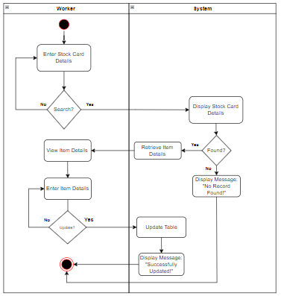

Figure 65: Activity Diagram of Search and Update Stock Card of Stock Card Management Module Use Case

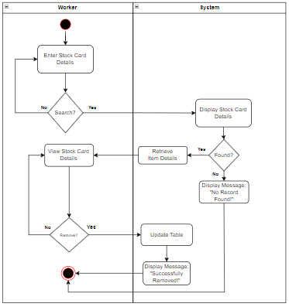

Figure 66: Activity Diagram of Search and Remove Stock Card of Stock Card Management Module Use Case

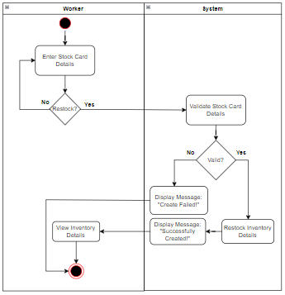

Figure 67: Activity Diagram of Restock Inventory of Purchase Request Module Use Case

Operation Management Module

|  |  |  |
| --- | --- | --- |
| Use Case | Description | User/Actor (Roles) |
| Create Operation | The user/actor enters the operation details to register. | Veterinarian and Worker |
| Search and View Operation | The user/actor searches for specific operation details and select operation to view details. | Veterinarian and Worker |
| Search and Update Operation | The user/actor searches for specific operation details and then enters the operation details to update. | Veterinarian and Worker |
| Search and Remove Operation | The user/actor searches operation details to remove. | Veterinarian and Worker |

Table 16: Event Decomposition of Operation Management Module

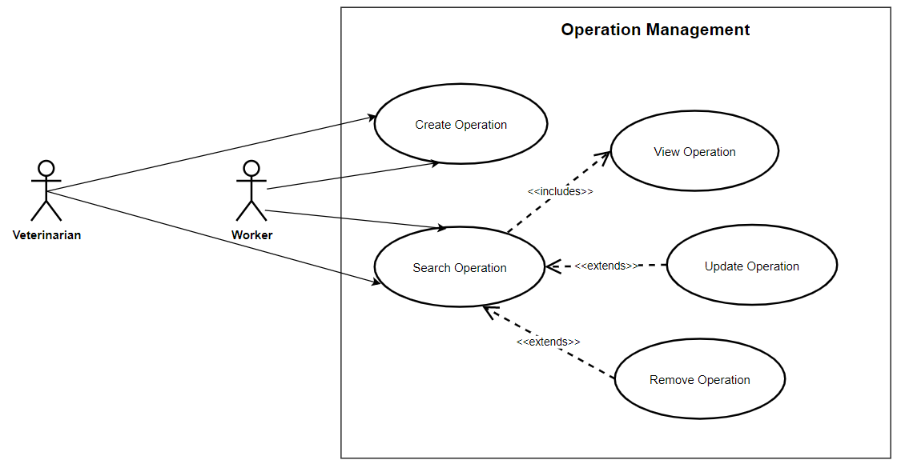

Figure 68: Use Case Diagram involving the Veterinarian and Worker of Piggery Management System of Operation Management Module

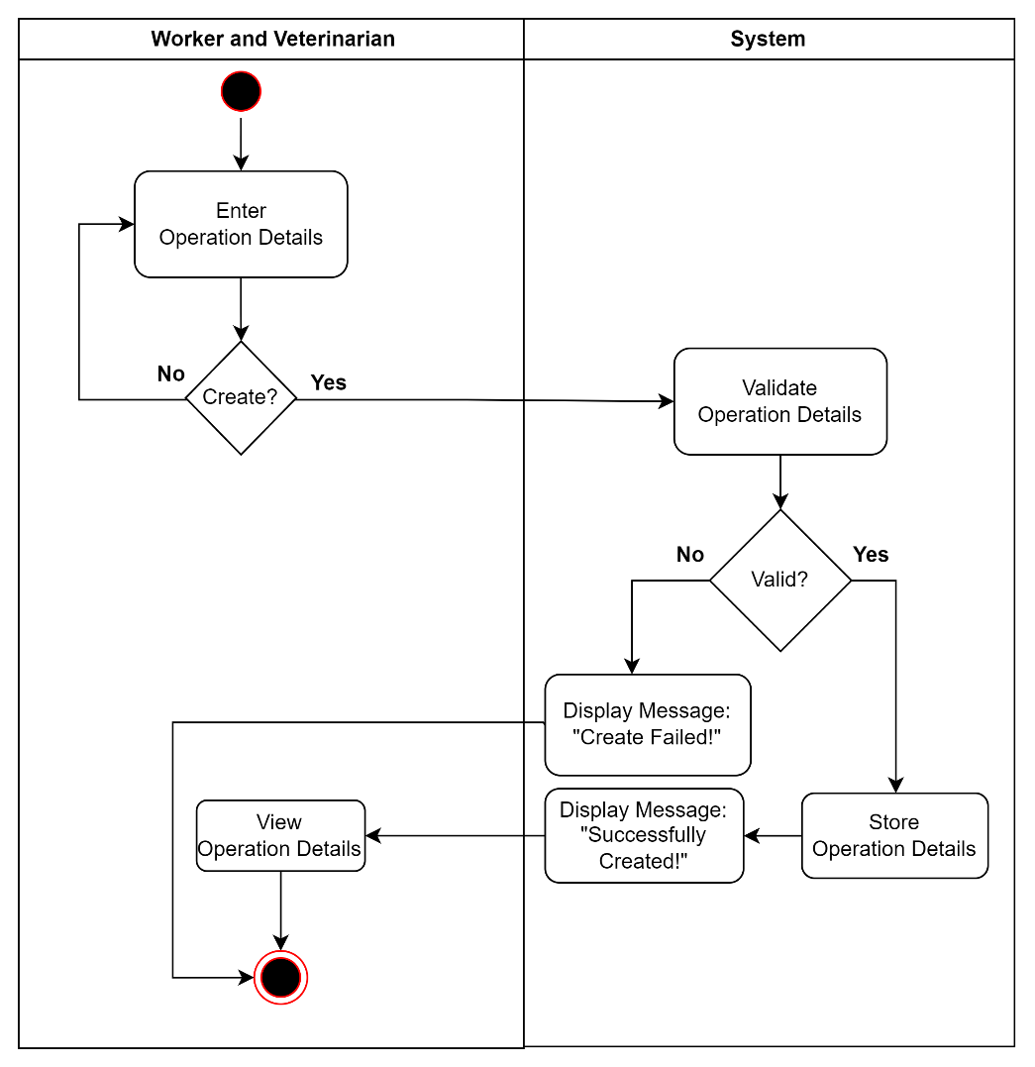

Figure 69: Activity Diagram of Create Operation of Operation Management Module Use Case

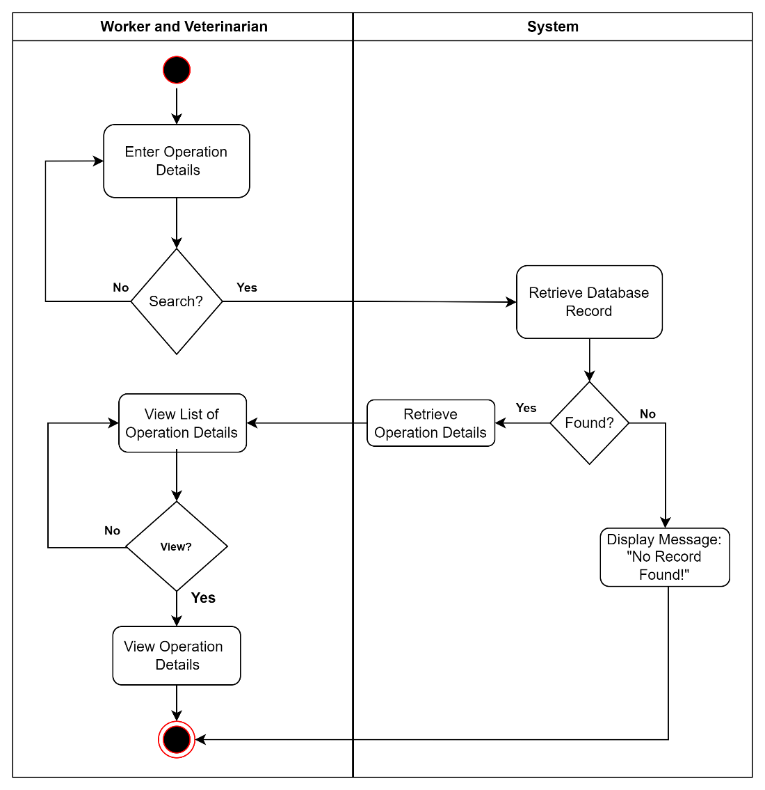

Figure 70: Activity Diagram of Search and View Operation of Operation Management Module Use Case

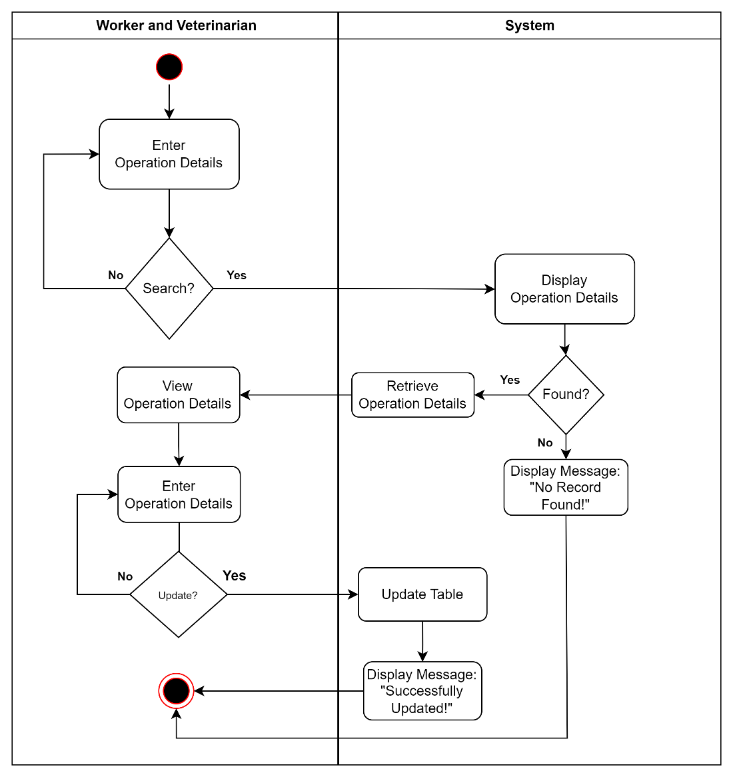

Figure 71: Activity Diagram of Search and Update Operation of Operation Management Module Use Case

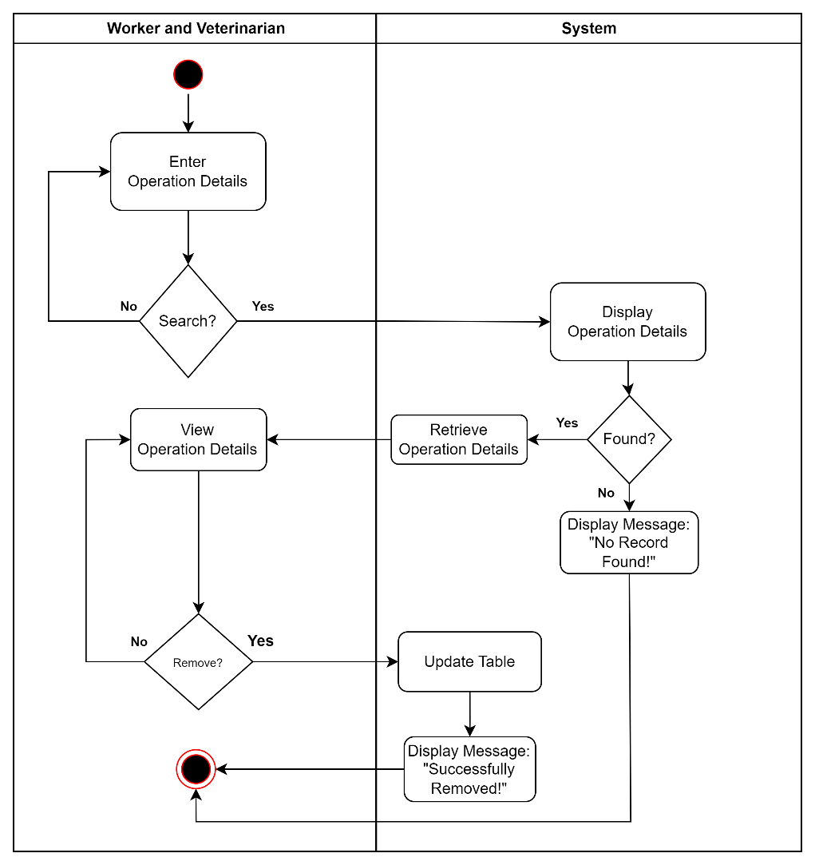

Figure 72: Activity Diagram of Search and Remove Operation of Operation Management Module Use Case

Quarantine Management Module

|  |  |  |
| --- | --- | --- |
| Use Case | Description | User/Actor (Roles) |
| Create Quarantine | The user/actor enters the quarantine details to register. | Worker |
| Search and View Quarantine | The user/actor searches for specific quarantine details and selects quarantine to view details. | Worker |
| Search and Update Quarantine | The user/actor searches for specific quarantine details and then enters the quarantine details to update. | Worker |
| Search and Remove Quarantine | The user/actor searches quarantine details to remove. | Worker |

Table 17: Event Decomposition of Quarantine Management Module

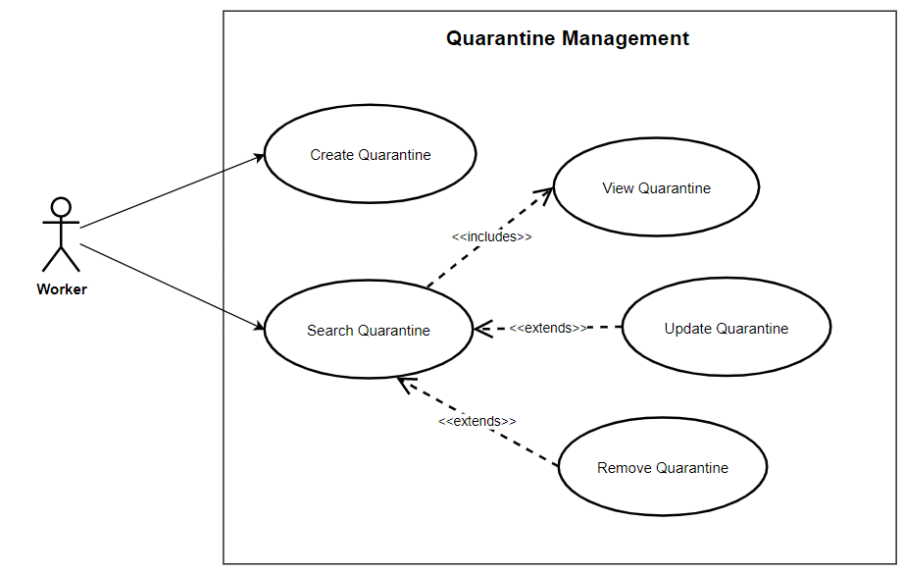

Figure 73: Use Case Diagram involving the Worker of Piggery Management System of Quarantine Management Module

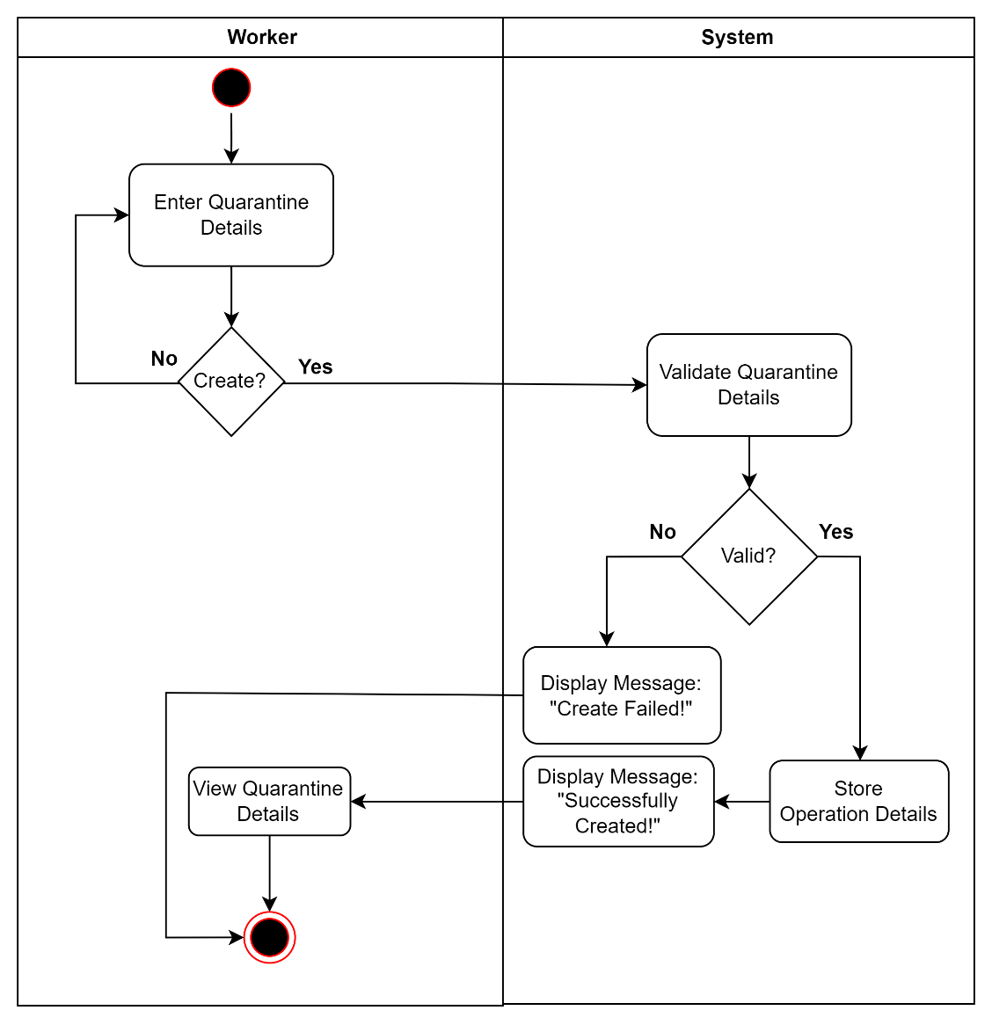

Figure 74: Activity Diagram of Create Quarantine of Quarantine Management Module Use Case

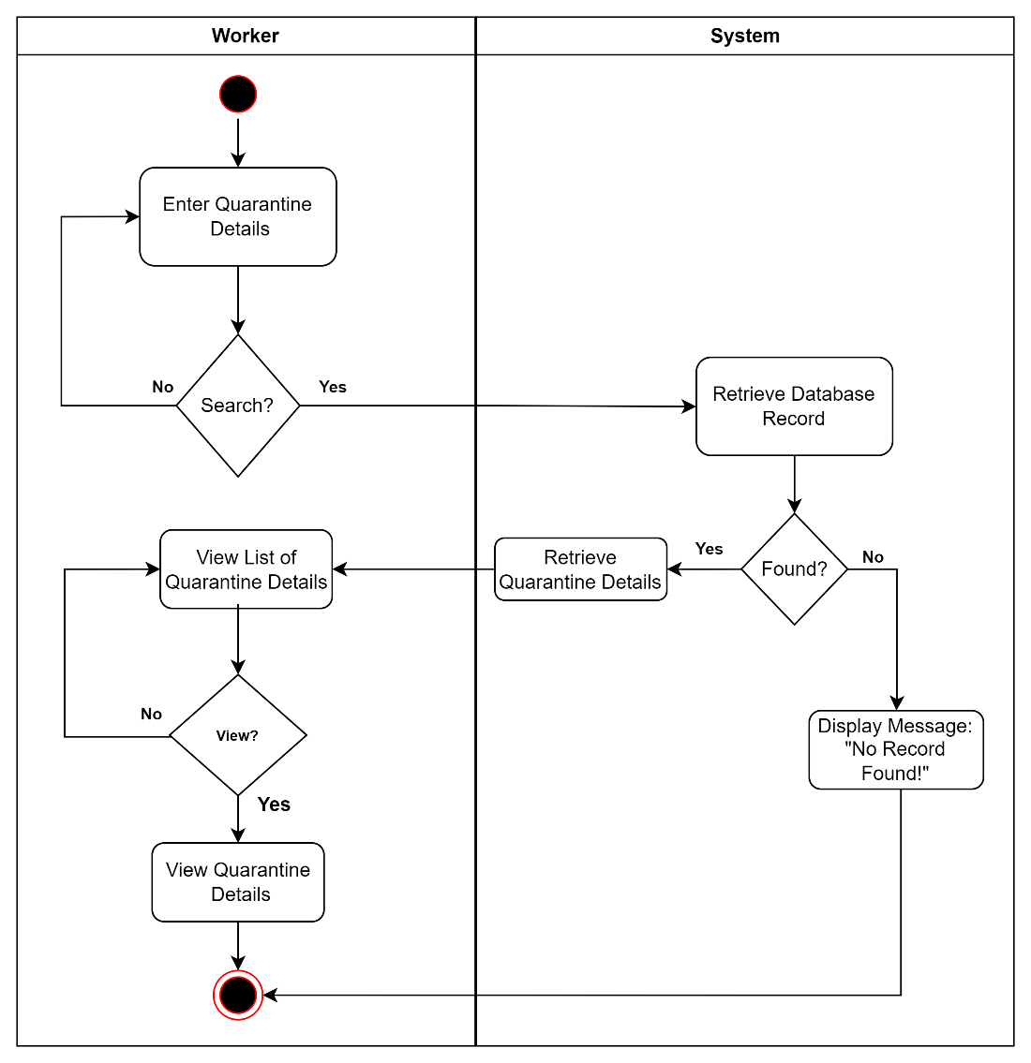

Figure 75: Activity Diagram of Search and View Quarantine of Quarantine Management Module Use Case

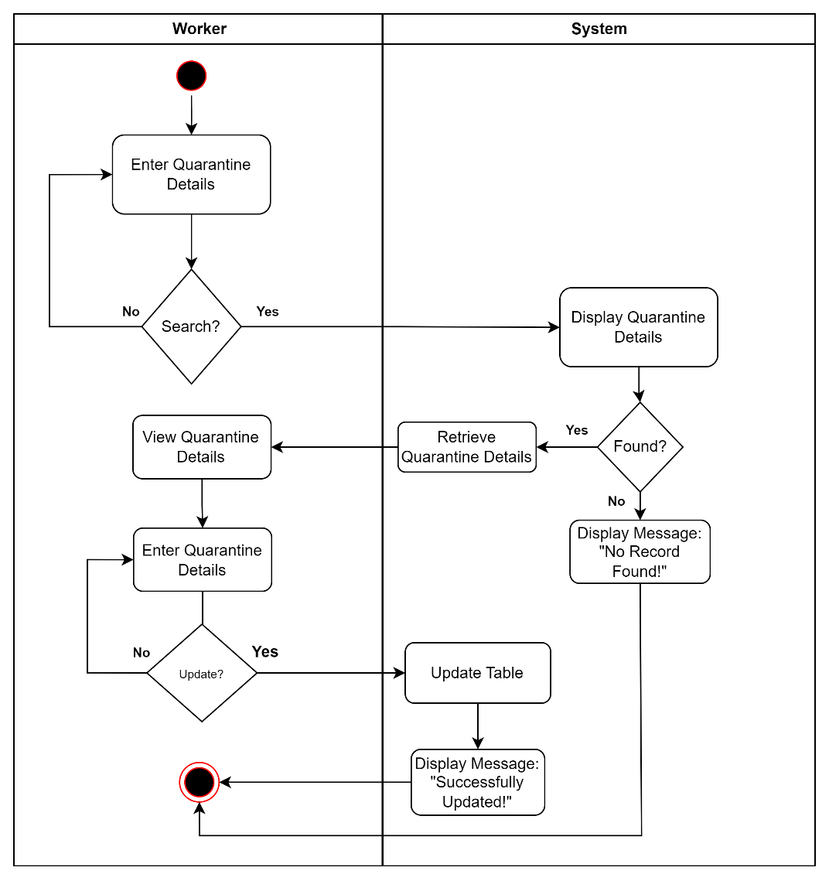

Figure 76: Activity Diagram of Search and Update Quarantine of Quarantine Management Module Use Case

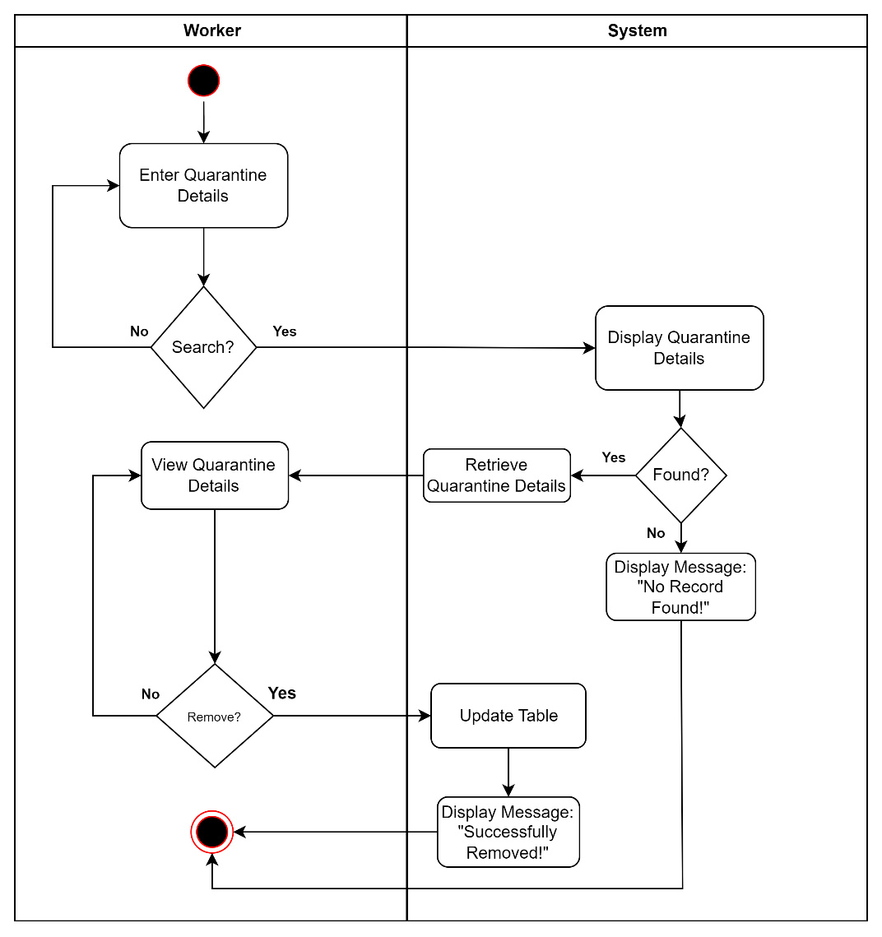

Figure 77: Activity Diagram of Search and Remove Quarantine of Quarantine Management Module Use Case

Scheduling Management Module

|  |  |  |
| --- | --- | --- |
| Use Case | Description | User/Actor (Roles) |
| Search and Confirm Schedule | The user/actor searches for specific schedule details and selects a schedule to confirm. | Worker |
| Search and View Schedule | The user/actor searches for specific schedule and view details. | Owner, Veterinarian, and Worker |

Table 18: Event Decomposition of Scheduling Management Module

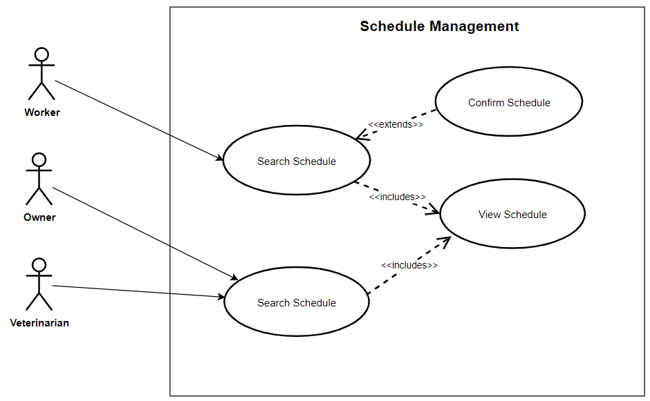

Figure 78: Use Case Diagram involving the Owner, Veterinarian, and Worker of Piggery Management System of Schedule Management Module

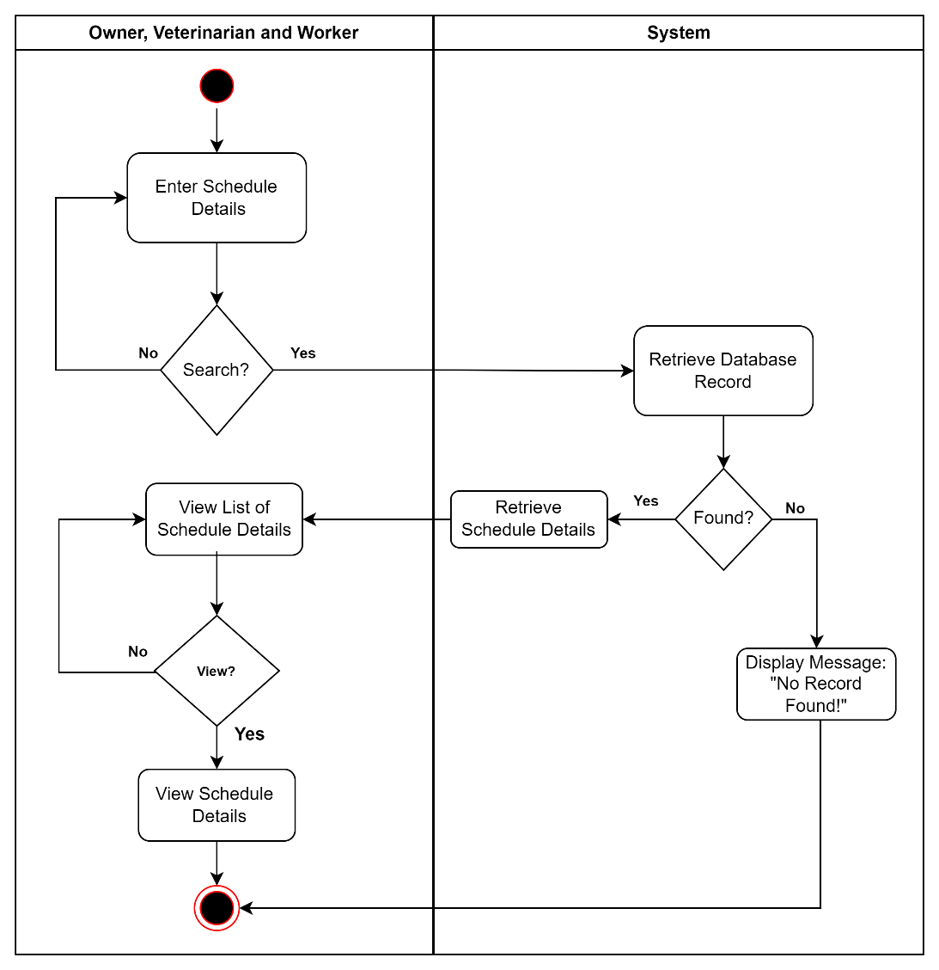

Figure 79: Activity Diagram of View Schedule of Scheduling Management Module Use Case

Report Module

|  |  |  |
| --- | --- | --- |
| Use Case | Description | User/Actor (Roles) |
| Search and View Report | The user/actor searches for specific report details and selects a report to view. | Owner |
| Search and Print Report | The user/actor searches for specific report details and selects a report to view. | Owner |

Table 19: Event Decomposition of Report Module

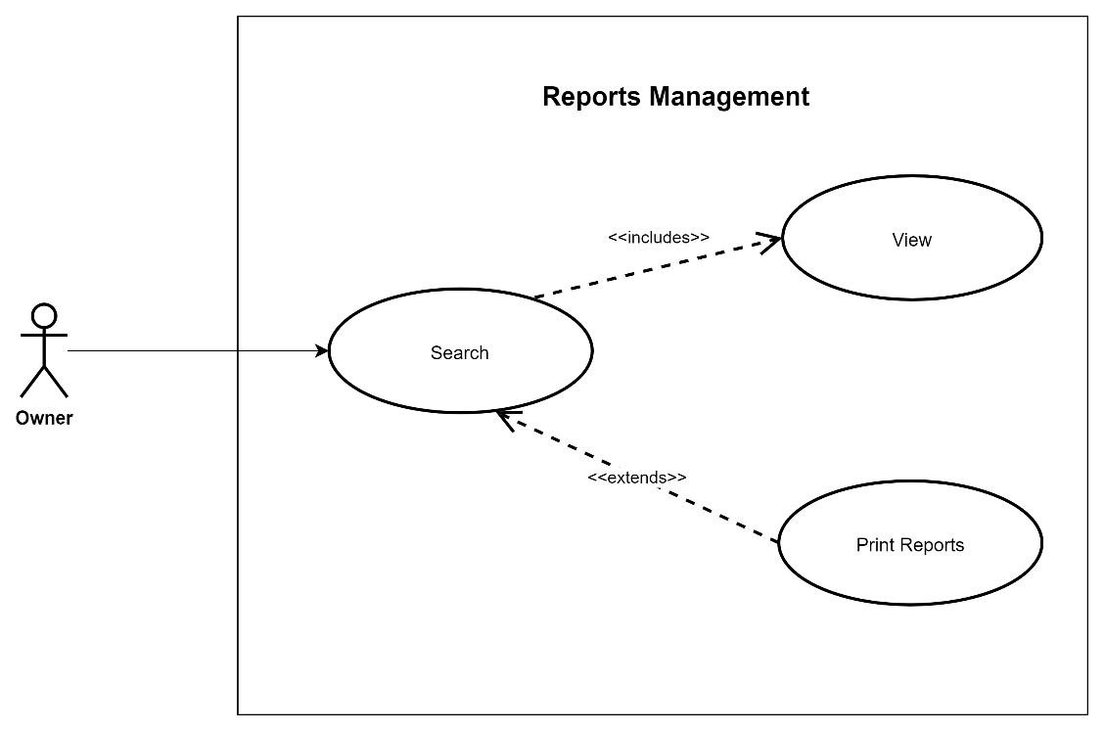

Figure 80: Use Case Diagram involving the Owner of Piggery Management System of Report Management Module

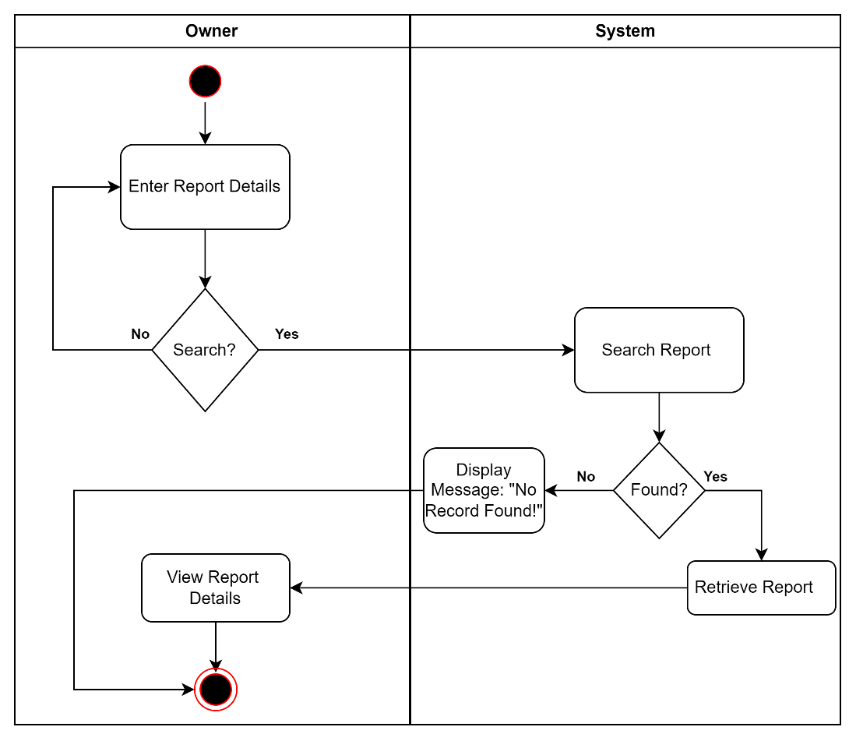

Figure 81: Activity Diagram of View Report of Report Module Use Case

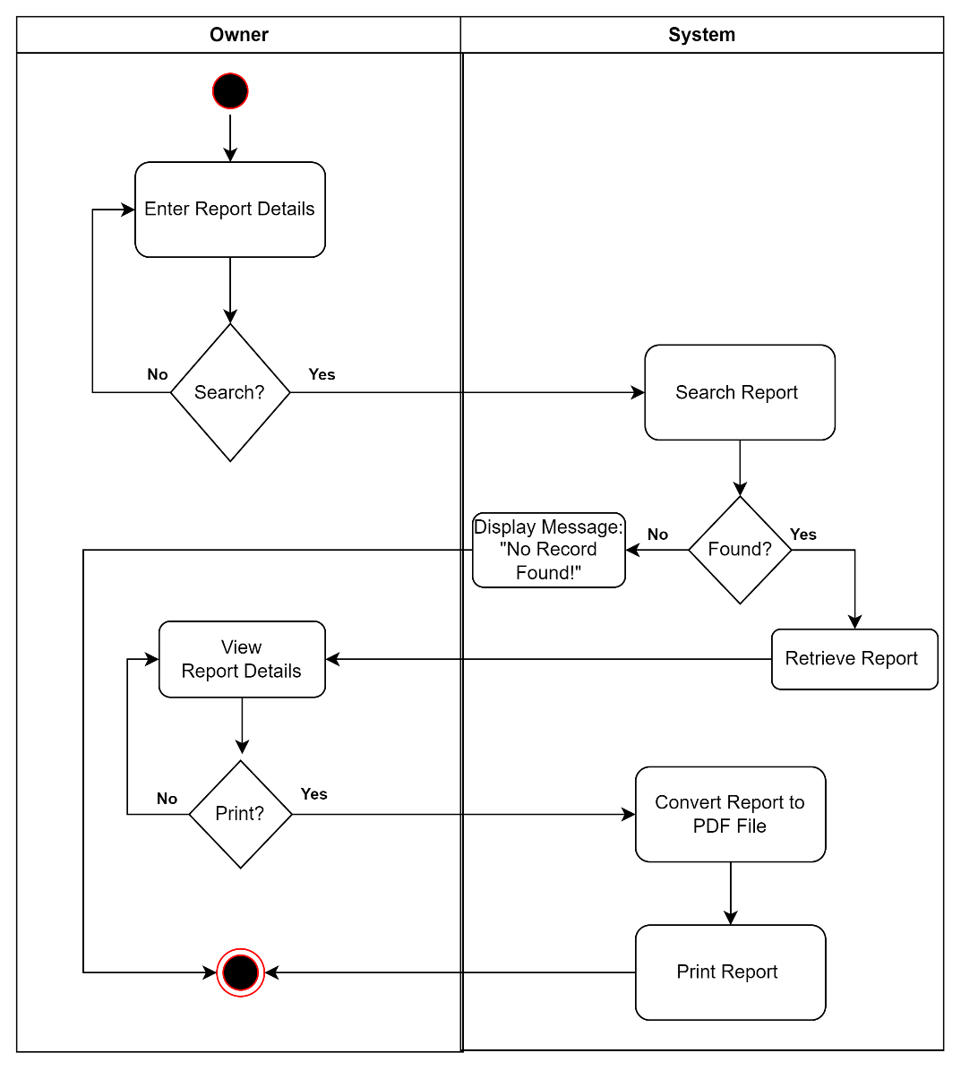

Figure 82: Activity Diagram of Search and Print Report of Report Module Use Case

QR Code Scan Module

|  |  |  |
| --- | --- | --- |
| Use Case | Description | User/Actor (Roles) |
| Scan QR Code and View Pig | The user/actor scans the pig QR Code details to view. | Worker |

Table 20: Event Decomposition of QR Code Scan Module

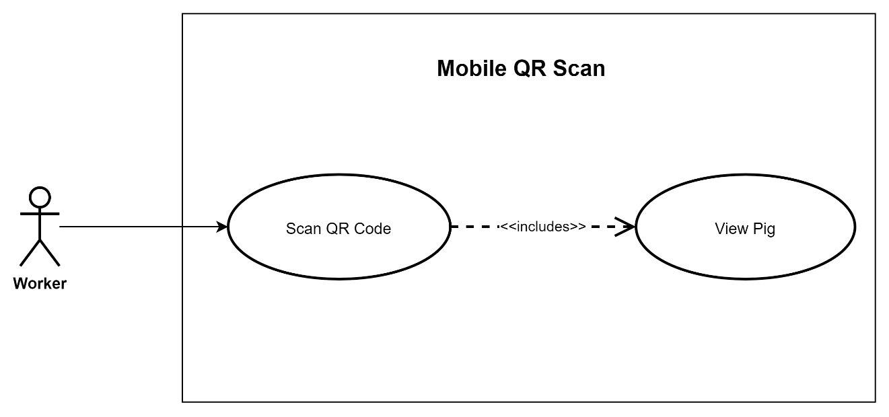

Figure 83: Use Case Diagram involving the Worker of Piggery Management System of Qr Code Scan Module

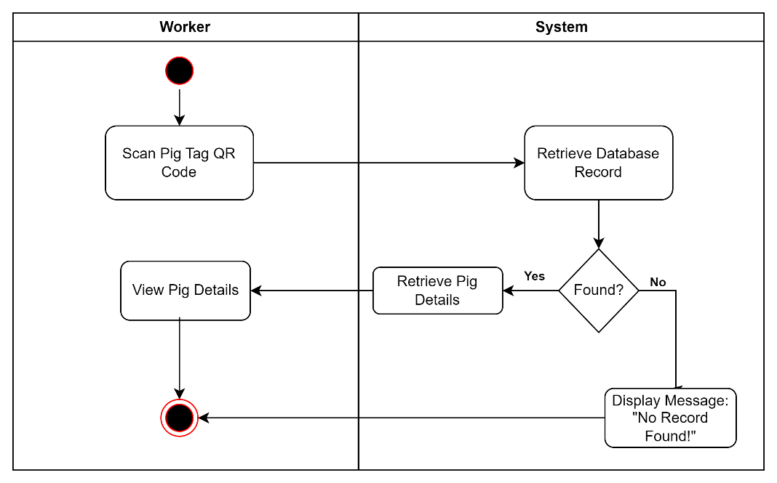

Figure 84: Activity Diagram of Scan QR Code and View Pig of QR Scan Module Use Case

Mobile Application Dashboard

|  |  |  |
| --- | --- | --- |
| Use Case | Description | User/Actor (Roles) |
| Enter and view dashboard interface | The user/actor enters the dashboard after logging in to the mobile application and views the dashboard interface. | Worker |

Table 21: Event Decomposition of Mobile Application Dashboard

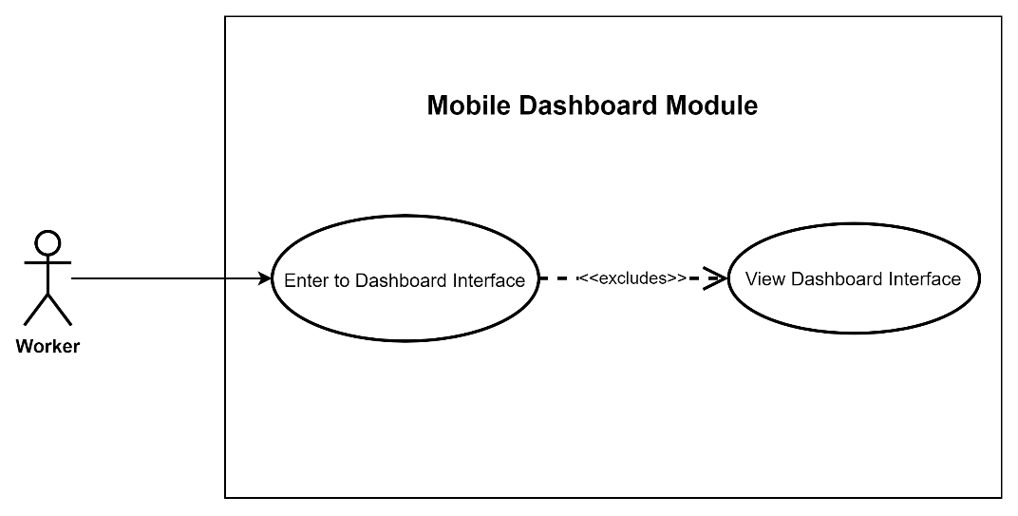

Figure 85: Use Case Diagram involving the Worker of Piggery Management System of Mobile Dashboard Module

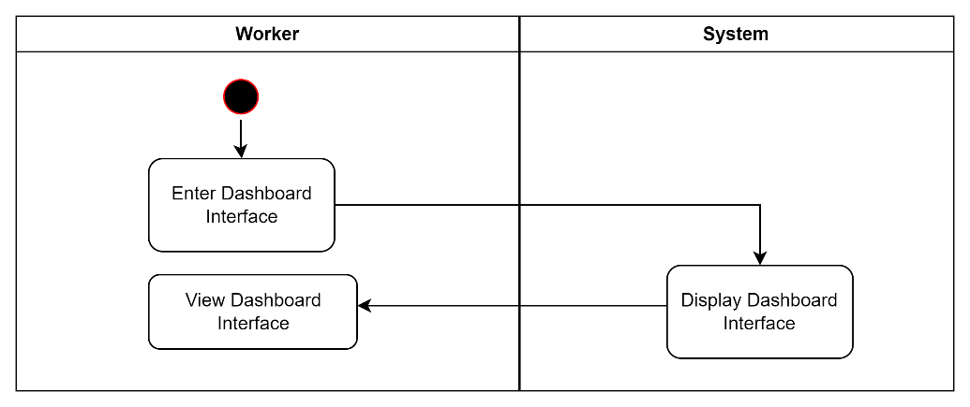

Figure 86: Activity Diagram of Search and Print Report of Report Module Use Case

Conceptual Database Model

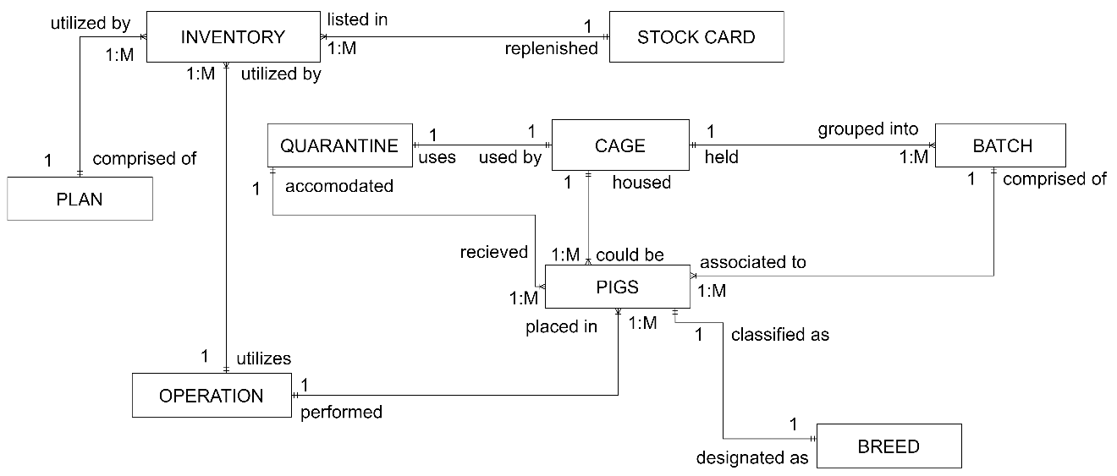

Figure 87: Conceptual Data Model of Web-Based Piggery Management System

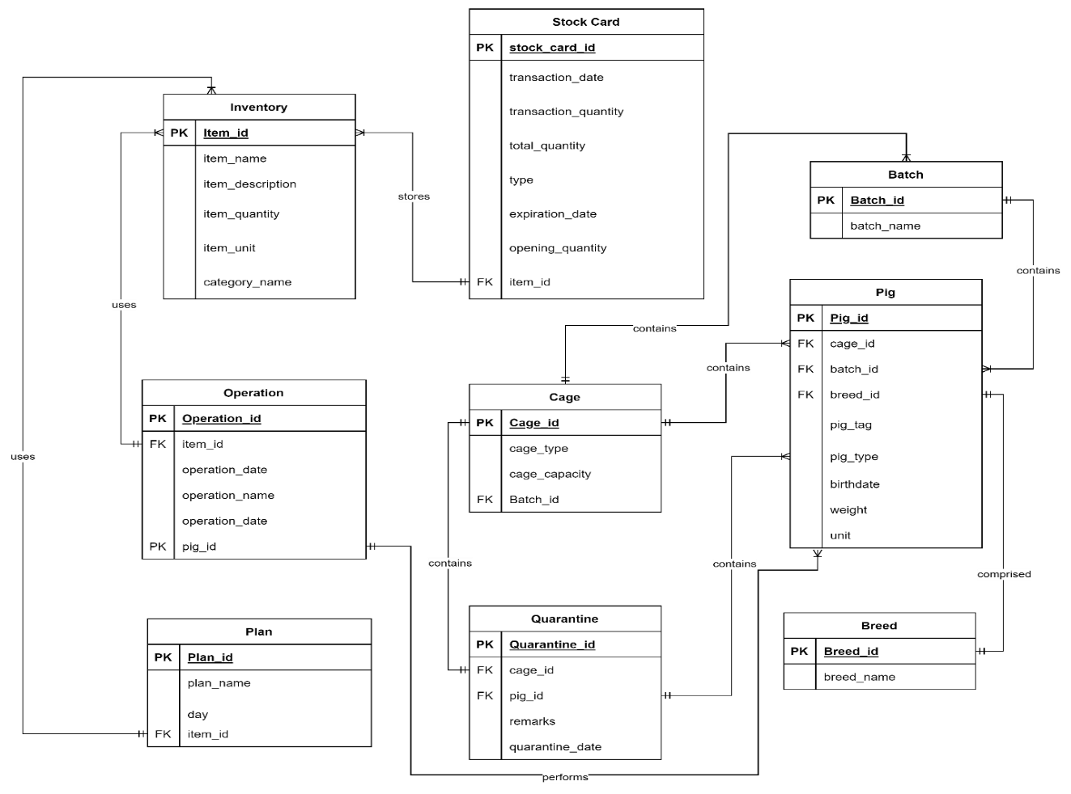

Figure 88: Logical Data Model of Web-Based Piggery Management System

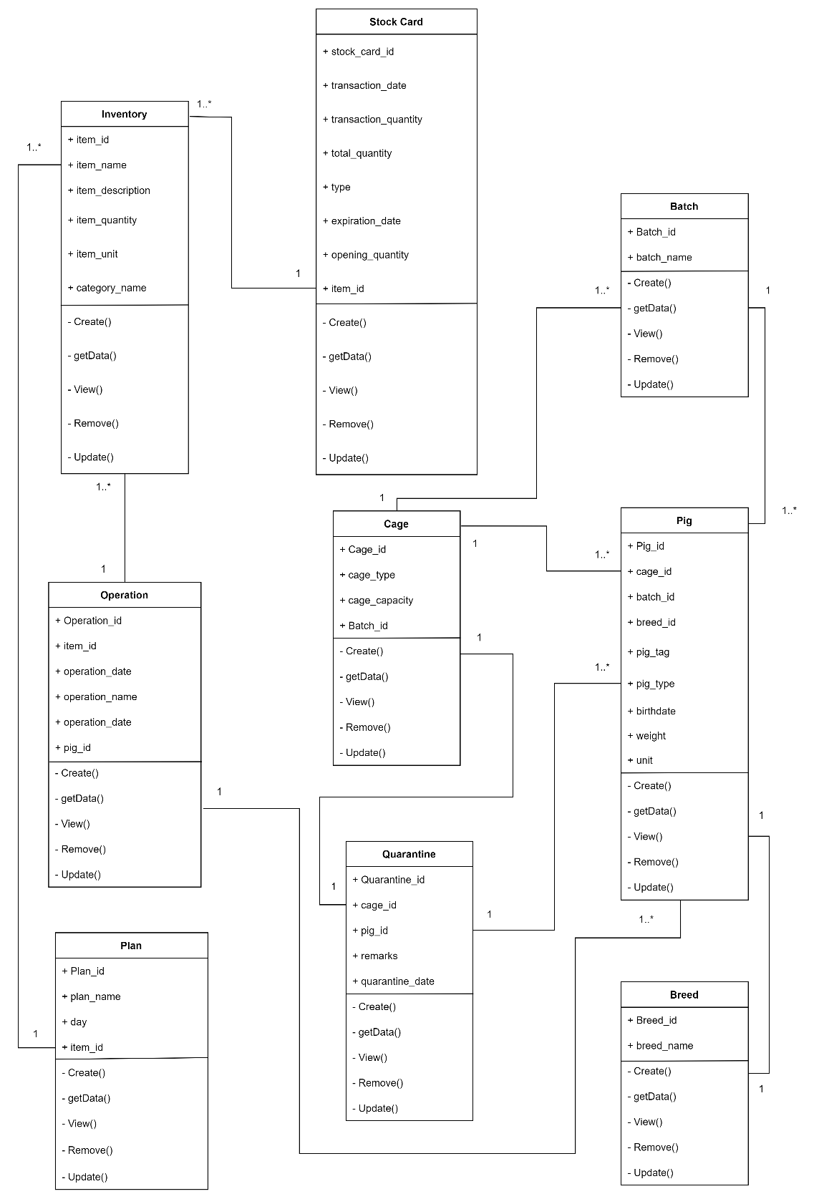

Figure 89: Logical Class Model of Web-Based Piggery Management System

Normalization

Cage – 0NF

Cage

|  |  |  |
| --- | --- | --- |
| Cage_no | cage_type | cage_capacity |
| Cage1 | Gestation cage | 1 |
| Cage2 | Gestation cage | 1 |
| Cage3 | Gestation cage | 1 |
| Cage4 | Fattening cage | 10 |
| Cage5 | Fattening cage | 10 |
| Cage6 | Quarantine cage | 10 |
| Cage7 | Quarantine cage | 10 |
| Cage8 | Quarantine cage | 10 |

Table 23. Cage Table - 0NF

Table 23 shows that the table Cage is not normalized because the row values in columns “cage_type” and “cage_capacity” are not unique.

Cage – 1NF

Cage

|  |  |  |
| --- | --- | --- |
| (PK)cage_id | cage_type | cage_capacity |
| 1 | Gestation cage | 1 |
| 2 | Gestation cage | 1 |
| 3 | Gestation cage | 1 |
| 4 | Fattening cage | 10 |
| 5 | Fattening cage | 10 |
| 6 | Quarantine cage | 10 |
| 7 | Quarantine cage | 10 |
| 8 | Quarantine cage | 10 |

Table 24. Cage Table - 1NF

Table 24 shows that the table Cage is in the first normal form by converting Table 23 by assigning “cage_id” as the Primary Key.

Cage – 2NF

Cage

|  |  |  |
| --- | --- | --- |
| (PK)cage_id | cage_type | cage_capacity |
| 1 | Gestation cage | 1 |
| 2 | Gestation cage | 1 |
| 3 | Gestation cage | 1 |
| 4 | Fattening cage | 10 |
| 5 | Fattening cage | 10 |
| 6 | Quarantine cage | 10 |
| 7 | Quarantine cage | 10 |
| 8 | Quarantine cage | 10 |

Table 25. Cage Table - 2NF

Table 25 shows the second normal form, which has no partial dependency because the table has only one assigned primary key “cage_id”, and all non-key attributes functionally depend on the primary key.

Cage – 3NF

Cage

|  |  |  |
| --- | --- | --- |
| (PK)cage_id | cage_type | cage_capacity |
| 1 | Gestation cage | 1 |
| 2 | Gestation cage | 1 |
| 3 | Gestation cage | 1 |
| 4 | Fattening cage | 10 |
| 5 | Fattening cage | 10 |
| 6 | Quarantine cage | 10 |
| 7 | Quarantine cage | 10 |
| 8 | Quarantine cage | 10 |

Table 26. Cage Table - 3NF

Table 26 has no transitive dependencies; hence this table shows the third normal form.

Batch – 0NF

Batch

|  |
| --- |
| batch_name |
| Batch1 |
| Batch2 |
| Batch3 |
| Batch4 |
| Batch5 |

Table 27. Batch Table - 0NF

Table 27 shows that the table Batch is not normalized because the row value in column “batch_name” is not unique.

Batch – 1NF

Batch

|  |  |
| --- | --- |
| (PK)batch_id | batch_name |
| 1 | Batch1 |
| 2 | Batch2 |
| 3 | Batch3 |
| 4 | Batch4 |
| 5 | Batch5 |

Table 28. Batch Table - 1NF

Table 28 shows that the table Batch is in the first normal form by converting Table 27 by assigning “batch_id” as the Primary Key.

Batch – 2NF

Batch

|  |  |
| --- | --- |
| (PK)batch_id | batch_name |
| 1 | Batch1 |
| 2 | Batch2 |
| 3 | Batch3 |
| 4 | Batch4 |
| 5 | Batch5 |

Table 29. Batch Table - 2NF

Table 29 shows the second normal form, which has no partial dependency because the table has only one assigned primary key “batch_id”, and a non-key attribute functionally depend on the primary key.

Batch – 3NF

Batch

|  |  |
| --- | --- |
| (PK)batch_id | batch_name |
| 1 | Batch1 |
| 2 | Batch2 |
| 3 | Batch3 |
| 4 | Batch4 |
| 5 | Batch5 |

Table 30. Batch Table - 3NF

Table 30 has no transitive dependencies; hence this table shows the third normal form.

Breed – 0NF

Breed

|  |
| --- |
| breed_name |
| Duroc |
| Land Race |
| Hampshire |
| Berkshire |
| Large White |

Table 31. Breed Table - 0NF

Table 31 shows that the table Breed is not normalized because the row value in column “breed_name” is not unique.

Breed – 1NF

Breed

|  |  |
| --- | --- |
| (PK)breed_id | breed_name |
| 1 | Duroc |
| 2 | Land Race |
| 3 | Hampshire |
| 4 | Berkshire |
| 5 | Large White |

Table 32. Breed Table - 1NF

Table 32 shows that the table Breed is in the first normal form by converting Table 31 by assigning “breed_id” as the Primary Key.

Breed – 2NF

Breed

|  |  |
| --- | --- |
| (PK)breed_id | breed_name |
| 1 | Duroc |
| 2 | Land Race |
| 3 | Hampshire |
| 4 | Berkshire |
| 5 | Large White |

Table 33. Breed Table - 2NF

Table 33 shows the second normal form, which has no partial dependency because the table has only one assigned primary key “breed_id”, and all non-key attributes functionally depend on the primary key.

Breed – 3NF

Breed

|  |  |
| --- | --- |
| (PK)breed_id | breed_name |
| 1 | Duroc |
| 2 | Land Race |
| 3 | Hampshire |
| 4 | Berkshire |
| 5 | Large White |

Table 34. Breed Table - 3NF

Table 34 has no transitive dependencies; hence this table shows the third normal form.

Pig – 0NF

Pig

|  |  |  |  |  |
| --- | --- | --- | --- | --- |
| pig_tag | pig_type | birthdate | weight | status |
| 11 | Sow | 08/05/2021 | 40KG | alive |
| 12 | Sow | 01/02/2021 | 40KG | alive |
| 13 | Piglet | 13/11/2022 | 40KG | alive |
| 14 | Piglet | 13/11/2022 | 40KG | alive |
| 15 | Boar | 03/04/2021 | 40KG | alive |

Table 35. Pig Table - 0NF

Table 35 shows that the table Pig is not normalized because the row value in column “weight” is not unique.

Pig – 1NF

Pig

|  |  |  |  |  |  |  |
| --- | --- | --- | --- | --- | --- | --- |
| (PK)pig_id | pig_tag | pig_type | birthdate | weight | unit | status |
| 1 | 11 | Sow | 08/05/2021 | 40 | Kilogram | alive |
| 2 | 12 | Sow | 01/02/2021 | 40 | Kilogram | alive |
| 3 | 13 | Piglet | 13/11/2022 | 40 | Kilogram | alive |
| 4 | 14 | Piglet | 13/11/2022 | 40 | Kilogram | alive |
| 5 | 15 | Boar | 03/04/2021 | 40 | Kilogram | alive |

Table 36. Pig Table - 1NF

Table 36 shows that the table Pig is in the first normal form by converting Table 35 by assigning “cage_id” as the Primary Key. The multivalued attribute “weight” is removed.

Pig – 2NF

Pig

|  |  |  |  |  |  |  |  |  |  |
| --- | --- | --- | --- | --- | --- | --- | --- | --- | --- |
| (PK)pig_id | pig_tag | pig_type | birthdate | weight | unit | status | (FK)cage_id | (FK)batch_id | (FK)breed_id |
| 1 | 11 | Sow | 08/05/2021 | 40 | Kilogram | alive | 1 | 1 | 1 |
| 2 | 12 | Sow | 01/02/2021 | 40 | Kilogram | alive | 2 | 2 | 1 |
| 3 | 13 | Piglet | 13/11/2022 | 40 | Kilogram | alive | 3 | 4 | 1 |
| 4 | 14 | Piglet | 13/11/2022 | 40 | Kilogram | alive | 4 | 4 | 2 |
| 5 | 15 | Boar | 03/04/2021 | 40 | Kilogram | alive | 5 | 5 | 2 |

Table 37. Pig Table - 2NF

Table 37 shows the second normal form, which has no partial dependency because the table has only one assigned primary key “pig_id”, and all non-key attributes functionally depend on the primary key.

Pig – 3NF

Pig

|  |  |  |  |  |  |  |  |  |  |
| --- | --- | --- | --- | --- | --- | --- | --- | --- | --- |
| (PK)pig_id | pig_tag | pig_type | birthdate | weight | unit | status | (FK)cage_id | (FK)batch_id | (FK)breed_id |
| 1 | 11 | Sow | 08/05/2021 | 40 | Kilogram | alive | 1 | 1 | 1 |
| 2 | 12 | Sow | 01/02/2021 | 40 | Kilogram | alive | 2 | 2 | 1 |
| 3 | 13 | Piglet | 13/11/2022 | 40 | Kilogram | alive | 3 | 4 | 1 |
| 4 | 14 | Piglet | 13/11/2022 | 40 | Kilogram | alive | 4 | 4 | 2 |
| 5 | 15 | Boar | 03/04/2021 | 40 | Kilogram | alive | 5 | 5 | 2 |

Table 38. Pig Table - 3NF

Table 38 has no transitive dependencies; hence this table shows the third normal form.

Inventory – 0NF

Inventory

|  |  |  |  |
| --- | --- | --- | --- |
| item_name | category | item_description | quantity |
| IverMictin | Deworming | Deworming | 50 ml |
| B-MEG Premium Starter | Feeds | Feeds for piglet | 50 kg |
| B-MEG Premium Grower | Feeds | Feeds for fattening | 50 kg |
| Iron | Medicine | Vaccine | 50 ml |
| Vitamins B complex | Medicine | Vitamins for pigs | 50 ml |

Table 39. Inventory Table - 0NF

Table 39 shows that the table Inventory is not normalized because the row value in column “quantity” is not unique.

Inventory – 1NF

Inventory

|  |  |  |  |  |  |
| --- | --- | --- | --- | --- | --- |
| (PK)item_id | item_name | category | item_description | item_quantity | item_unit |
| 1 | IverMictin | Deworming | Deworming | 50 | milligram |
| 2 | B-MEG Premium Starter | Feeds | Feeds for piglet | 50 | kilogram |
| 3 | B-MEG Premium Grower | Feeds | Feeds for fattening | 50 | kilogram |
| 4 | Iron | Medicine | Vaccine | 50 | milligram |
| 5 | Vitamins B complex | Medicine | Vitamins for pigs | 50 | milligram |

Table 40. Inventory Table - 1NF

Table 40 shows that the table Inventory is in the first normal form by converting Table 39 by assigning “item _id” as the Primary Key.

Inventory – 2NF

Inventory

|  |  |  |  |  |  |
| --- | --- | --- | --- | --- | --- |
| (PK)item_id | item_name | item_description | item_quantity | item_unit | (FK)category_id |
| 1 | IverMictin | Deworming | 50 | milligram | 3 |
| 2 | B-MEG Premium Starter | Feeds for piglet | 50 | kilogram | 1 |
| 3 | B-MEG Premium Grower | Feeds for fattening | 50 | kilogram | 1 |
| 4 | Iron | Vaccine | 50 | milligram | 2 |
| 5 | Vitamins B complex | Vitamins for pigs | 50 | milligram | 2 |

Table 41. Inventory Table - 2NF

Table 41 shows the second normal form, which has no partial dependency because the table has only one assigned primary key "item_id ", and all non-key attributes functionally depend on the primary key.

Category

|  |  |
| --- | --- |
| (PK)category_id | category_name |
| 1 | Feeds |
| 2 | Medicine |
| 3 | Deworming |

Table 42. Category Table - 2NF

Table 42 shows the second normal form, which has no partial dependency because the table has only one assigned primary key " category_id ", and all non-key attributes functionally depend on the primary key.

Inventory – 3NF

Inventory

|  |  |  |  |
| --- | --- | --- | --- |
| (PK)item_id | item_name | item_description | (FK)category_id |
| 1 | IverMictin | Deworming | 3 |
| 2 | B-MEG Premium Starter | Feeds for piglet | 1 |
| 3 | B-MEG Premium Grower | Feeds for fattening | 1 |
| 4 | Iron | Vaccine | 2 |
| 5 | Vitamins B complex | Vitamins for pigs | 2 |

Table 43. Inventory Table - 3NF

Category

|  |  |
| --- | --- |
| (PK)category_id | category_name |
| 1 | Feeds |
| 2 | Medicine |
| 3 | Deworming |

Table 44. Category Table - 3NF

Stock

|  |  |  |  |
| --- | --- | --- | --- |
| (PK)stock_id | item_quantity | item_unit | (FK)item_id |
| 1 | 50 | milligram | 1 |
| 2 | 50 | kilogram | 2 |
| 3 | 50 | kilogram | 3 |
| 4 | 50 | milligram | 4 |
| 5 | 50 | milligram | 5 |

Table 45. Category Table - 3NF

Table 41 has transitive dependency. To convert the table into the third normal form, the Inventory table is divided into three (3) resulting tables: Inventory (Table 43), Category (Table 44), and Stock (Table 45).

Stock Card – 0NF

Stock Card

|  |  |  |  |  |  |  |
| --- | --- | --- | --- | --- | --- | --- |
| transaction_date | transaction_quantity | total_quantity | type | expiration_date | opening_quantity | closing_quantity |
| 01/03/2022 | 50 | 50 | In | 01/03/2024 | 50 | 100 |
| 05/03/2022 | 10 | 10 | Out | N/A | 50 | 40 |
| 08/03/2022 | 2 | 2 | In | 02/03/2023 | 50 | 52 |
| 10/03/2022 | 15 | 15 | In | 05/15/203 | 50 | 65 |
| 09/03/2023 | 10, 10 | 20 | Out | N/A | 50 | 30 |

Table 46. Stock Card Table - 0NF

Table 46 shows that the table Stock Card is not normalized because the row value in column “transaction_quantity” is multivalued.

Stock Card – 1NF

Stock Card

|  |  |  |  |  |  |  |  |
| --- | --- | --- | --- | --- | --- | --- | --- |
| (PK)transaction_id | transaction_date | transaction_quantity | total_quantity | type | expiration_date | opening_quantity | closing_quantity |
| 1 | 01/03/2022 | 50 | 50 | In | 01/03/2024 | 50 | 100 |
| 2 | 05/03/2022 | 10 | 10 | Out | N/A | 50 | 40 |
| 3 | 08/03/2022 | 2 | 2 | In | 02/03/2023 | 50 | 52 |
| 4 | 10/03/2022 | 15 | 15 | In | 05/15/203 | 50 | 65 |
| 5 | 09/03/2023 | 10 | 40 | Out | N/A | 50 | 40 |
| 6 | 09/03/2023 | 10 | 30 | Out | N/A | 50 | 30 |

Table 47. Stock Card Table - 1NF

Table 47 shows that the table Stock Card is in the first normal form by converting Table 46 by assigning “transaction_id” as the Primary Key. Thus, removing the multivalued on column “transaction_quantity”.

Stock Card – 2NF

Stock Card

|  |  |  |  |  |
| --- | --- | --- | --- | --- |
| (PK)transaction_id | transaction_date | transaction_quantity | total_quantity | type |
| 1 | 01/03/2022 | 50 | 50 | In |
| 2 | 05/03/2022 | 10 | 10 | Out |
| 3 | 08/03/2022 | 2 | 2 | In |
| 4 | 10/03/2022 | 15 | 15 | In |
| 5 | 09/03/2023 | 10 | 40 | Out |
| 6 | 09/03/2023 | 10 | 30 | Out |

|  |  |  |  |
| --- | --- | --- | --- |
| expiration_date | opening_quantity | closing_quantity | (FK)Stock_id |
| 01/03/2024 | 50 | 100 | 1 |
| N/A | 50 | 40 | 2 |
| 02/03/2023 | 50 | 52 | 3 |
| 05/15/203 | 50 | 65 | 4 |
| N/A | 50 | 40 | 5 |
| N/A | 50 | 30 | 5 |

Table 48. Stock Card Table - 2NF

Table 48 shows the second normal form, which has no partial dependency because the table has only one assigned primary key "transaction_id", and all non-key attributes functionally depend on the primary key.

Stock Card – 3NF

Stock Card

|  |  |  |  |  |
| --- | --- | --- | --- | --- |
| (PK)stock_card_id | transaction_date | opening_quantity | closing_quantity | (FK)stock_id |
| 1 | 01/03/2022 | 50 | 100 | 1 |
| 2 | 05/03/2022 | 50 | 40 | 2 |
| 3 | 08/03/2022 | 50 | 52 | 3 |
| 4 | 10/03/2022 | 50 | 65 | 4 |
| 5 | 09/03/2023 | 50 | 30 | 5 |

Table 49. Stock Card Table - 3NF

Stock Card Details

|  |  |  |  |  |  |
| --- | --- | --- | --- | --- | --- |
| (PK)transaction_details_id | transaction_quantity | total_quantity | type | expiration_date | (FK)stock_card_id |
| 1 | 50 | 50 | In | 01/03/2024 | 1 |
| 2 | 10 | 10 | Out | N/A | 2 |
| 3 | 2 | 2 | In | 02/03/2023 | 3 |
| 4 | 15 | 15 | In | 05/15/203 | 4 |
| 5 | 10 | 40 | Out | N/A | 5 |
| 6 | 10 | 30 | Out | N/A | 5 |

Table 50. Stock Card Details Table - 3NF

Table 48 has transitive dependency. To convert the table into the third normal form, the Inventory table is divided into two (2) resulting tables: Stock Card (Table 49) and Stock Card Details (Table 50).

Operation – 0NF

Operation

|  |  |
| --- | --- |
| operation | operation_date |
| Deworming | 10/20/2022 |
| Deworming | 10/25/2022 |
| Vaccination | 12/20/2022 |
| Vaccination | 01/21/2023 |
| Medicine Administration | 01/20/2023 |

Table 51. Operation Table - 0NF

Table 51 shows that the table Operation is not normalized because the row values in columns “operation” and “operation_date” are not unique.

Operation – 1NF

Operation

|  |  |  |
| --- | --- | --- |
| (PK)operation_id | operation_type | operation_date |
| 1 | Deworming | 10/20/2022 |
| 2 | Deworming | 10/25/2022 |
| 3 | Vaccination | 12/20/2022 |
| 4 | Vaccination | 01/21/2023 |
| 5 | Medicine Administration | 01/20/2023 |

Table 52. Operation Table - 1NF

Table 52 shows that the table Operation is in the first normal form by converting Table 51 by assigning “operation_id” as the Primary Key.

Operation – 2NF

Operation

|  |  |  |  |  |
| --- | --- | --- | --- | --- |
| (PK)operation_id | operation_type | operation_date | (FK)item_id | (FK)pig_id |
| 1 | Deworming | 10/20/2022 | 1 | 1 |
| 2 | Deworming | 10/25/2022 | 1 | 2 |
| 3 | Vaccination | 12/20/2022 | 4 | 3 |
| 4 | Vaccination | 01/21/2023 | 4 | 4 |
| 5 | Medicine Administration | 01/20/2023 | 5 | 5 |

Table 53. Operation Table - 2NF

Table 53 shows the second normal form, which has no partial dependency because the table has only one assigned primary key "operation_id ", and all non-key attributes functionally depend on the primary key.

Operation – 3NF

Operation

|  |  |  |
| --- | --- | --- |
| (PK)operation_id | operation_date | (FK)operation_type_id |
| 1 | 10/20/2022 | 1 |
| 2 | 10/25/2022 | 1 |
| 3 | 12/20/2022 | 2 |
| 4 | 01/21/2023 | 2 |
| 5 | 01/20/2023 | 3 |

Table 54. Operation Table - 3NF

Operation Type

|  |  |
| --- | --- |
| (PK)operation_type_id | operation_name |
| 1 | Deworming |
| 2 | Vaccination |
| 3 | Medicine Administration |
| 4 | Feeding |

Table 55. Operation Type Table - 3NF

Operation Pig Details

|  |  |  |
| --- | --- | --- |
| (PK)operation_details_id | (FK)operation_id | (FK)pig_id |
| 1 | 1 | 1 |
| 2 | 2 | 2 |
| 3 | 3 | 3 |
| 4 | 4 | 4 |
| 5 | 5 | 5 |

Table 56. Operation Pig Details Table - 3NF

Operation Item Details

|  |  |  |
| --- | --- | --- |
| (PK)operation_item_details_id | (FK)operation_id | (FK)item_id |
| 1 | 1 | 1 |
| 2 | 1 | 1 |
| 3 | 1 | 4 |
| 4 | 1 | 4 |
| 5 | 1 | 5 |

Table 57. Operation Item Details Table - 3NF

Table 53 has transitive dependency. To convert the table into the third normal form, the operation table is divided into four (4) resulting tables: Operation (Table 54), Operation Type (Table 55), Operation Pig Details (Table 56) and Operation Item Details (Table 57).

Quarantine – 0NF

Quarantine

|  |  |  |  |
| --- | --- | --- | --- |
| quarantine_date | quarantine_cage_no | quarantine_cage_capacity | remarks |
| 09/08/2021 | cage6 | 10 | Mild Cough |
| 09/08/2021 | cage6 | 10 | Mild Cough |
| 01/01/2023 | cage7 | 10 | Ring Worm Infection |
| 01/01/2023 | cage7 | 10 | Ring Worm Infection |
| 03/07/2021 | cage8 | 10 | High Fever |

Table 58. Quarantine Table - 0NF

Table 58 shows that the table Quarantine is not normalized because the row value in column “quarantine_cage_no” is not unique.

Quarantine – 1NF

Quarantine

|  |  |  |  |  |
| --- | --- | --- | --- | --- |
| (PK)quarantine_id | quarantine_date | quarantine_cage_no | quarantine_cage_capacity | remarks |
| 1 | 09/08/2021 | cage6 | 10 | Mild Cough |
| 2 | 09/08/2021 | cage6 | 10 | Mild Cough |
| 3 | 01/01/2023 | cage7 | 10 | Ring Worm Infection |
| 4 | 01/01/2023 | cage7 | 10 | Ring Worm Infection |
| 5 | 03/07/2021 | cage8 | 10 | High Fever |

Table 59 Quarantine Table - 1NF

Table 59 shows that the table Quarantine is in the first normal form by converting Table 58 by assigning “quarantine_id” as the Primary Key.

Quarantine – 2NF

Quarantine

|  |  |  |  |  |
| --- | --- | --- | --- | --- |
| (PK)quarantine_id | remarks | quarantine_date | (FK)cage_id | (FK)pig_id |
| 1 | Mild Cough | 09/08/2021 | 6 | 1 |
| 2 | Mild Cough | 09/08/2021 | 6 | 2 |
| 3 | Ring Worm Infection | 01/01/2023 | 7 | 3 |
| 4 | Ring Worm Infection | 01/01/2023 | 7 | 4 |
| 5 | High Fever | 03/07/2021 | 8 | 5 |

Table 60. Quarantine Table - 2NF

Table 60 shows the second normal form, which has no partial dependency because the table has only one assigned primary key "quarantine_id", and all non-key attributes functionally depend on the primary key.

Quarantine – 3NF

Quarantine

|  |  |  |
| --- | --- | --- |
| (PK)quarantine_id | remarks | quarantine_date |
| 1 | Mild Cough | 09/08/2021 |
| 2 | Ring Worm Infection | 01/01/2023 |
| 3 | High Fever | 03/07/2021 |

Table 61. Quarantine Table - 3NF

Quarantine Details

|  |  |  |  |
| --- | --- | --- | --- |
| (PK)qurantine_details_id | (FK)quarantine_id | cage_id(FK) | pig_id(FK) |
| 1 | 1 | 6 | 1 |
| 2 | 1 | 6 | 2 |
| 3 | 2 | 7 | 3 |
| 4 | 2 | 7 | 4 |
| 5 | 3 | 8 | 5 |

Table 62. Quarantine Details Table - 3NF

Table 60 has transitive dependency. To convert the table into the third normal form, the Quarantine table is divided into two (2) resulting tables: Quarantine (Table 61) and Quarantine Details (Table 62).

Plan – 0NF

Plan

|  |  |  |
| --- | --- | --- |
| plan_name | day | objectives |
| Farrowing Period | 4 | Inject Iron 1st Dose :(Iron) 1ml |
| Farrowing Period | 10 | Inject Iron 2nd Dose: (Iron) 1ml |
| Fattening Period | 40 | Deworm Weaned piglets: (IverMictin) 1ml |
| Gestating Period | 90 | Inject Iron (Iron): 3-5ml |
| Gestating Period | 110 | Inject Vitamins B-complex (10ml) |

Table 63. Plan Table - 0NF

Table 63 shows that the table Plan is not normalized because the row values in column “objective” is multivalued.

Plan – 1NF

Plan

|  |  |  |  |  |  |
| --- | --- | --- | --- | --- | --- |
| (PK) plan_id | plan_name | day | item_objective | quantity_objective | unit |
| 1 | Farrowing Period | 4 | Iron | 1 | milligram |
| 2 | Farrowing Period | 10 | Iron | 1 | milligram |
| 3 | Fattening Period | 40 | IverMictin | 1 | milligram |
| 4 | Gestating Period | 90 | Iron | 5 | milligram |
| 5 | Gestating Period | 110 | Vitamins B complex | 10 | milligram |

Table 64 Plan Table - 1NF

Table 64 shows that the table Plan is in the first normal form by converting Table 63 by assigning “plan_id” as the Primary Key.

Plan – 2NF

Plan

|  |  |  |  |
| --- | --- | --- | --- |
| (PK) plan_id | plan_name | day | (FK)item_id |
| 1 | Farrowing Period | 4 | 4 |
| 2 | Farrowing Period | 10 | 4 |
| 3 | Fattening Period | 40 | 3 |
| 4 | Gestating Period | 90 | 4 |
| 5 | Gestating Period | 110 | 5 |

Table 65. Plan Table - 2NF

Table 65 shows the second normal form, which has no partial dependency because the table has only one assigned primary key "plan_id", and all non-key attributes functionally depend on the primary key.

Plan – 3NF

Plan

|  |  |  |  |
| --- | --- | --- | --- |
| (PK) plan_id | plan_name | day | (FK)item_id |
| 1 | Farrowing Period | 4 | 4 |
| 2 | Farrowing Period | 10 | 4 |
| 3 | Fattening Period | 40 | 3 |
| 4 | Gestating Period | 90 | 4 |
| 5 | Gestating Period | 110 | 5 |

Table 66. Plan Table - 3NF

Table 66 has no transitive dependencies; hence this table shows the third normal form.

Physical Database Design

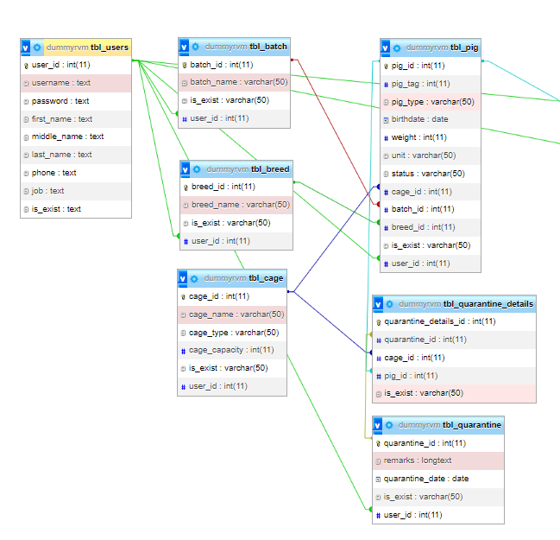

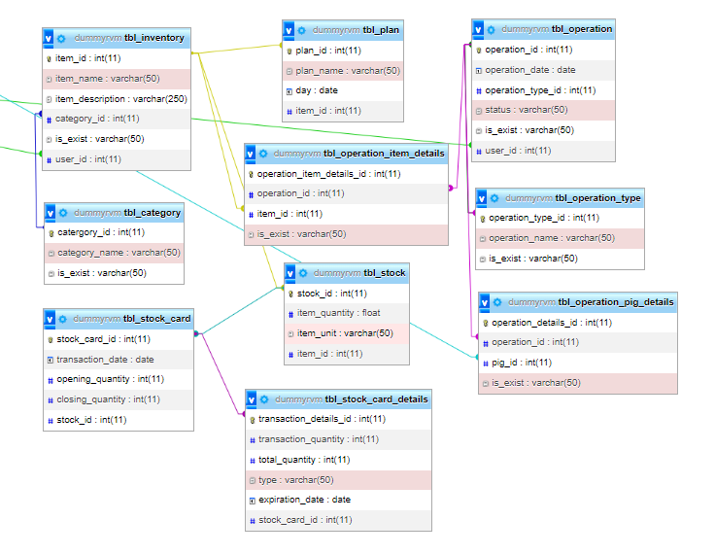

Figure 89: Physical Database Model of Web-Based Piggery Management System

Final Relations

This section contains list of tables with their attributes. The table below represent the final relations of Web-Based Piggery Management System with Mobile-Based QR Code Scanner.

|  |  |
| --- | --- |
| TABLE NAME | ATTRIBUTES |
| tbl_user | user_id, username, password, first_name, middle_name, last_name, phone, job, is_exist |
| tbl_batch | batch_id, batch_name, is_exist, user_id |
| tbl_breed | breed_id, breed_name, user_id |
| tbl_cage | cade_id, cage_name, cage_type, cage_capacity, is_exist, user_id |
| tbl_pig | pig_id, pig_tag, pig_type, birthdate, weight, unit, status, cage_id, batch_id, breed_id, is_exist, user_id |
| tbl_quarantine_details | quarantine_details_id, quarantine_id, cage_id, pig_id, is_exist |
| tbl_quarantine | quarantine_id, remarks, quarantine_date, is_exist, user_id |
| tbl_inventory | item_id, item_name, item_description, category_id, is_exist, user_id |
| tbl_category | category_id, category_name, is_exist |
| tbl_stock_card | stock_card_id, transaction_id, opening_quantity, closing_quantity, stock_id |
| tbl_stock | stock_id, item_quantity, item_unit, item_id |
| tbl_stock_card_details | transaction_details_id, transaction_quantity, total_quantity, type, expiration_date, stock_card_id |
| tbl_plan | plan_id, plan_name, day, item_id |
| tbl_operation_item_details | operation_item_details_id, operation_id, item_id, is_exist |
| tbl_operation | operation_id, operation_date, operation_type, status, is_exist, user_id |
| tbl_operation_type | operation_type_id, operation_name, is_exist |
| tbl_operation_pig_details | operation_details_id, operation_id, pig_id, is_exist |

Table 63. Final Relations Web-Based Piggery Management System with Mobile-Based QR Code Scanner.

Data Dictionary

|  |  |  |  |  |  |  |  |  |
| --- | --- | --- | --- | --- | --- | --- | --- | --- |
| Table Name | tbl_users | | | | | | | |
| Description | This table records the user information. | | | | | | | |
| Alias | None | | | | | | | |
| Attribute Name | Description | Data Type | Default Value | Primary Key | Example | Null Allowed? (Y/N) | Length | Validation Rules |
| user_id | Unique Identified ID for user | int | None | true | 1 | N | 11 | [0-9] |
| username | Unique Identified username for user | text | None | false | admin | Y | 255 | [A-Z, a-z,0-9,@]] |
| password | Unique password for user | text | None | false | Admin123 | Y | 255 | [A-Z, a-z,0-9,@] |
| first_name | User’s first name | text | None | false | April | Y | 255 | [A-Z, a-z,0-9,@] |
| middle_name | User’s middle name | text | None | false | Dapulang | Y | 255 | [A-Z, a-z,0-9,@] |
| last_name | User’s last name | text | None | false | Provido | Y | 255 | [A-Z, a-z,0-9,@] |
| phone | User’s phone number | text | None | false | 09123456789 | Y | 255 | [A-Z, a-z,0-9,@] |
| job | User’s job desription | text | None | false | worker | Y | 255 | [A-Z, a-z,0-9,@] |
| is_exist | Determines user existing record | text | None | false | true | Y | 255 | [A-Z, a-z,0-9, @] |

Figure 64. Data Dictionary of User Table

|  |  |  |  |  |  |  |  |  |
| --- | --- | --- | --- | --- | --- | --- | --- | --- |
| Table Name | tbl_batch | | | | | | | |
| Description | This table records the batch information of the pig. | | | | | | | |
| Alias | None | | | | | | | |
| Attribute Name | Description | Data Type | Default Value | Primary Key | Example | Null Allowed? (Y/N) | Length | Validation Rules |
| batch_id | Unique Identified ID for batch | int | None | true | 1 | N | 11 | [0-9] |
| batch_name | id of the sow pig | varchar | None | false | Batch1 | Y | 50 | [A-Z, a-z,0-9, @] |
| is_exist | Determines batch existing record | varchar | None | false | true | Y | 50 | [A-Z, a-z,0-9, @] |
| user_id | Unique Identified ID for user | int | None | false | 1 | Y | 11 | [0-9] |

Figure 65. Data Dictionary of Batch Table

|  |  |  |  |  |  |  |  |  |
| --- | --- | --- | --- | --- | --- | --- | --- | --- |
| Table Name | tbl_cage | | | | | | | |
| Description | This table records the cage information. | | | | | | | |
| Alias | None | | | | | | | |
| Attribute Name | Description | Data Type | Default Value | Primary Key | Example | Null Allowed? (Y/N) | Length | Validation Rules |
| cage_id | Unique Identified ID for cage | int | None | true | 1 | N | 11 | [0-9] |
| cage_name | Name of Cage | varchar | None | false | Cage1 | Y | 50 | [A-Z, a-z,0-9, @] |
| cage_type | Classification of Cage | varchar | None | false | Fattening | Y | 50 | [A-Z, a-z,0-9, @] |
| cage_capacity | Capacity of Cage | int | None | false | 10 | Y | 11 | [0-9] |
| is_exist | Determines cage existing record | varchar | None | false | true | Y | 50 | [A-Z, a-z,0-9, @] |
| user_id | Unique Identified ID for user | int | None | false | 1 | Y | 11 | [0-9] |

Figure 66. Data Dictionary of Cage Table

|  |  |  |  |  |  |  |  |  |
| --- | --- | --- | --- | --- | --- | --- | --- | --- |
| Table Name | tbl_breed | | | | | | | |
| Description | This table records the breeds information in the hog farm. | | | | | | | |
| Alias | None | | | | | | | |
| Attribute Name | Description | Data Type | Default Value | Primary Key | Example | Null Allowed? (Y/N) | Length | Validation Rules |
| breed_id | Unique Identified ID for batch | int | None | true | 1 | N | 11 | [0-9] |
| breed_name | Breed Description | varchar | None | false | Large White | Y | 50 | [A-Z, a-z,0-9, @] |
| is_exist | Determines breed existing record | varchar | None | false | true | Y | 50 | [A-Z, a-z,0-9, @] |
| user_id | Unique Identified ID for user | int | None | false | 1 | Y | 11 | [0-9] |

Figure 67. Data Dictionary of Breed Table

|  |  |  |  |  |  |  |  |  |
| --- | --- | --- | --- | --- | --- | --- | --- | --- |
| Table Name | tbl_pig | | | | | | | |
| Description | This table records the inventory information in the hog farm | | | | | | | |
| Alias | None | | | | | | | |
| Attribute Name | Description | Data Type | Default Value | Primary Key | Example | Not Allowed? (Y/N) | Length | Validation Rules |
| pig_id | Unique Identified ID for pig | int | None | true | 1 | N | 11 | [0-9] |
| pig_tag | Identifier of pig in the farm | int | None | false | 1 | Y | 50 | [0-9] |
| pig_type | Types of pig in the farm | varchar | None | false | Sow | Y | 50 | [A-Z, a-z,0-9, @] |
| birthdate | Day that the pig is born | double | None | false | 25 | Y | 9999-12-31 | YYYY-MM-DD |
| weight | Weight of the pig | int | None | false | 40 | Y | 11 | [0-9] |
| status | Status of the pig | varchar | None | false | sold | Y | 50 | [A-Z, a-z,0-9, @] |
| cage_id | Cage identifier | int | true | false | 1 | Y | 11 | [0-9] |
| batch_id | Batch identifier | int | None | false | 1 | Y | 11 | [0-9] |
| breed_id | Breed identifier | int | None | false | 1 | Y | 11 | [0-9] |
| is_exist | Determines pig existing record | varchar | None | false | true | Y | 50 | [A-Z, a-z,0-9, @] |
| user_id | Unique Identified ID for user | int | None | false | 1 | Y | 11 | [0-9] |

Figure 68. Data Dictionary of Pig Table

|  |  |  |  |  |  |  |  |  |
| --- | --- | --- | --- | --- | --- | --- | --- | --- |
| Table Name | tbl_quarantine_details | | | | | | | |
| Description | This table records the quarantine details. | | | | | | | |
| Alias | None | | | | | | | |
| Attribute Name | Description | Data Type | Default Value | Primary Key | Example | Not Allowed? (Y/N) | Length | Validation Rules |
| quarantine_details_id | Unique Identified ID for quarantine details | int | None | true | 1 | N | 11 | [0-9] |
| quarantine_id | Unique Identified ID for quarantine | int | None | false | 2 | N | 11 | [0-9] |
| cage_id | Cage identifier | int | true | false | Cage1 | Y | 11 | [a-z, A-Z,0-9] |
| pig_id | Unique Identified ID for pig | int | None | true | 1 | N | 50 | [0-9] |
| is_exist | Determines quarantine details existing record | varchar | None | false | true | Y | 50 | [A-Z, a-z,0-9, @] |

Figure 69. Data Dictionary of Quarantine Details Table

|  |  |  |  |  |  |  |  |  |
| --- | --- | --- | --- | --- | --- | --- | --- | --- |
| Table Name | tbl_quarantine | | | | | | | |
| Description | This table records the quarantine details. | | | | | | | |
| Alias | None | | | | | | | |
| Attribute Name | Description | Data Type | Default Value | Primary Key | Example | Not Allowed? (Y/N) | Length | Validation Rules |
| quarantine_id | Unique Identified ID for quarantine | int | None | true | 1 | N | 11 | [0-9] |
| remarks | The date the request is added | Varchar | None | false | Sick | Y | 50 | [A-Z, a-z,0-9, @] |
| quarantine_date | Identify if the data should be shown to users | Date | true | false | true | Y | 9999-12-31 | YYYY-MM-DD |
| is_exist | Determines quarantine existing record | varchar | None | false | true | Y | 50 | [A-Z, a-z,0-9, @] |
| user_id | Unique Identified ID for user | int | None | false | 1 | Y | 11 | [0-9] |

Figure 70. Data Dictionary of Quarantine Table

|  |  |  |  |  |  |  |  |  |
| --- | --- | --- | --- | --- | --- | --- | --- | --- |
| Table Name | tbl_inventory | | | | | | | |
| Description | This table records the scheduled operation in the hog farm | | | | | | | |
| Alias | None | | | | | | | |
| Attribute Name | Description | Data Type | Default Value | Primary Key | Example | Not Allowed? (Y/N) | Length | Validation Rules |
| item_id | Unique Identified ID for item | int | None | true | 1 | N | 11 | [0-9] |
| item_name | Name of the item | Varchar | None | false | Ivermectin | N | 50 | [A-Z, a-z,0-9, @] |
| item_description | Description for the item | Varchar | None | false | Deworming | Y | 50 | [A-Z, a-z,0-9, @] |
| category_id | Identifier of the item category | int | None | false | 1 | Y | 11 | [0-9] |
| is_exist | Determines item existing record | varchar | None | false | true | Y | 50 | [A-Z, a-z,0-9, @] |
| user_id | Unique Identified ID for user | int | None | false | 1 | Y | 11 | [0-9] |

Figure 71. Data Dictionary of Inventory Table

|  |  |  |  |  |  |  |  |  |
| --- | --- | --- | --- | --- | --- | --- | --- | --- |
| Table Name | tbl_category | | | | | | | |
| Description | This table record the category of item stored in the inventory. | | | | | | | |
| Alias | None | | | | | | | |
| Attribute Name | Description | Data Type | Default Value | Primary Key | Example | Not Allowed? (Y/N) | Length | Validation Rules |
| category_id | Unique Identified ID for category | int | None | true | 1 | N | 11 | [0-9] |
| category_name | Name of the category | Varchar | None | false | Feeds | Y | 50 | [A-Z, a-z,0-9, @] |
| is_exist | Determines category existing record | varchar | None | false | true | Y | 50 | [A-Z, a-z,0-9, @] |

Figure 72. Data Dictionary of Category Table

|  |  |  |  |  |  |  |  |  |
| --- | --- | --- | --- | --- | --- | --- | --- | --- |
| Table Name | tbl_stock_card | | | | | | | |
| Description | This operation records the feeding operation details of the piggery. | | | | | | | |
| Alias | None | | | | | | | |
| Attribute Name | Description | Data Type | Default Value | Primary Key | Example | Not Allowed? (Y/N) | Length | Validation Rules |
| stock_card_id | Unique Identified ID for stock card | int | None | true | 1 | N | 11 | [0-9] |
| transaction_date | Date of transaction | date | None | false | 2 | Y | 9999-12-31 | YYYY-MM-DD |
| opening_quantity | Quantity for opening | int | None | false | 2 | Y | 11 | [0-9] |
| closing_quantity | Quantity for closing | int | None | false | 2 | Y | 11 | [0-9] |
| stock_id | Unique Identifier for stock | int | None | false | 2 | Y | 11 | [0-9] |

Figure 73. Data Dictionary of Stock Card Table

|  |  |  |  |  |  |  |  |  |
| --- | --- | --- | --- | --- | --- | --- | --- | --- |
| Table Name | tbl_stock | | | | | | | |
| Description | This table record the stock items. | | | | | | | |
| Alias | None | | | | | | | |
| Attribute Name | Description | Data Type | Default Value | Primary Key | Example | Not Allowed? (Y/N) | Length | Validation Rules |
| stock_id | Unique Identifier for stock | int | None | true | 2 | Y | 11 | [0-9] |
| item_quantity | Number of items | float | None | true | 10 | Y | 11 | [0-9] |
| item_unit | Measurement of the item | Varchar | None | true | kilogram | Y | 50 | [A-Z, a-z,0-9, @] |
| item_id | Unique Identified ID for item | int | None | true | 1 | N | 11 | [0-9] |

Figure 74. Data Dictionary of Stock Table

|  |  |  |  |  |  |  |  |  |
| --- | --- | --- | --- | --- | --- | --- | --- | --- |
| Table Name | tbl_stock_card_details | | | | | | | |
| Description | This table record the stock card item details. | | | | | | | |
| Alias | None | | | | | | | |
| Attribute Name | Description | Data Type | Default Value | Primary Key | Example | Not Allowed? (Y/N) | Length | Validation Rules |
| transaction_details_id | Unique Identifier for transaction | int | None | true | 1 | N | 11 | [0-9] |
| transaction_quantity | Quantity for transaction | int | None | False | 10 | N | 11 | [0-9] |
| total_quantity | The total quantity of the item | int | None | False | 100 | N | 11 | [0-9] |
| type | Type of transaction | Varchar | None | False | Opening | N | 11 | [A-Z, a-z,0-9, @] |
| expiration_date | Expiration date of the item | Date | None | False | 01/02/2023 | N | 9999-12-31 | YYYY-MM-DD |
| stock_card_id | Unique Identifier for stock card | int | None | true | 1 | N | 11 | [0-9] |

Figure 75. Data Dictionary of Stock Card Details Table

|  |  |  |  |  |  |  |  |  |
| --- | --- | --- | --- | --- | --- | --- | --- | --- |
| Table Name | tbl_plan | | | | | | | |
| Description | This table records plan details of pig. | | | | | | | |
| Alias | None | | | | | | | |
| Attribute Name | Description | Data Type | Default Value | Primary Key | Example | Not Allowed? (Y/N) | Length | Validation Rules |
| plan_id | Unique Identified ID for plan | int | None | true | 1 | N | 11 | [0-9] |
| plan_name | The name of the plan | Varchar | None | False | Piglet plan | Y | 50 | [A-Z, a-z,0-9, @] |
| day | Plan Timeline | Date | None | False | 01/02/2023 | N | 9999-12-31 | YYYY-MM-DD |
| item_id | Unique Identified ID for item | int | None | true | 1 | N | 11 | [0-9] |

Figure 76. Data Dictionary of Plan Table

|  |  |  |  |  |  |  |  |  |
| --- | --- | --- | --- | --- | --- | --- | --- | --- |
| Table Name | tbl_operation_item_details | | | | | | | |
| Description | This table records the item details used in operations. | | | | | | | |
| Alias | None | | | | | | | |
| Attribute Name | Description | Data Type | Default Value | Primary Key | Example | Not Allowed? (Y/N) | Length | Validation Rules |
| operation_item_details_id | Unique Identified ID for operation item | int | None | true | 1 | N | 11 | [0-9] |
| operation_id | Unique Identified ID for operation | int | None | false | 1 | N | 11 | [0-9] |
| item_id | Unique Identified ID for item | int | None | false | 1 | N | 50 | [0-9] |
| is_exist | Determines operation item existing record | varchar | None | false | true | Y | 50 | [A-Z, a-z,0-9, @] |

Figure 77. Data Dictionary of Operation Item Details Table

|  |  |  |  |  |  |  |  |  |
| --- | --- | --- | --- | --- | --- | --- | --- | --- |
| Table Name | tbl_operation | | | | | | | |
| Description | This table records operation details. | | | | | | | |
| Alias | None | | | | | | | |
| Attribute Name | Description | Data Type | Default Value | Primary Key | Example | Not Allowed? (Y/N) | Length | Validation Rules |
| operation_id | Unique Identified ID for operation | int | None | True | 1 | N | 11 | [0-9] |
| operation_date | Date of the operation | date | None | False | 01/02/2023 | N | 9999-12-31 | YYYY-MM-DD |
| operation_type_id | Unique Identified ID for operation type | int | None | true | 1 | N | 11 | [0-9] |
| status | Status of the operation | varchar | None | false | pending | Y | 11 | [a-z, A-Z] |
| is_exist | Determines operation existing record | varchar | None | false | true | Y | 50 | [A-Z, a-z,0-9, @] |
| user_id | Unique Identified ID for user | int | None | false | 1 | Y | 11 | [0-9] |

Figure 78. Data Dictionary of Operation Table

|  |  |  |  |  |  |  |  |  |
| --- | --- | --- | --- | --- | --- | --- | --- | --- |
| Table Name | tbl_operation_type | | | | | | | |
| Description | This table record the operation type. | | | | | | | |
| Alias | None | | | | | | | |
| Attribute Name | Description | Data Type | Default Value | Primary Key | Example | Not Allowed? (Y/N) | Length | Validation Rules |
| operation_type_id | Unique Identified ID for operation type | int | None | true | 1 | N | 11 | [0-9] |
| operation_name | Name of the operation | varchar | None | false | Feeding | Y | 50 | [A-Z, a-z,0-9, @] |
| is_exist | Determines operation type existing record | varchar | None | false | true | Y | 50 | [A-Z, a-z,0-9, @] |

Figure 79. Data Dictionary of Operation Type Table

|  |  |  |  |  |  |  |  |  |
| --- | --- | --- | --- | --- | --- | --- | --- | --- |
| Table Name | tbl_operation_pig_details | | | | | | | |
| Description | This table record the medicine administration operation of the piggery. | | | | | | | |
| Alias | None | | | | | | | |
| Attribute Name | Description | Data Type | Default Value | Primary Key | Example | Not Allowed? (Y/N) | Length | Validation Rules |
| operation_details_id | Unique Identifier for operation details | int | None | true | 1 | N | 11 | [0-9] |
| operation_id | Unique Identifier for operation | int | None | true | 1 | N | 11 | [0-9] |
| pig_id | ID of pig where the operation is done | int | None | false | pig_hkl525 | Y | 50 | [A-Z, a-z,0-9, @] |
| is_exist | Determines operation details existing record | varchar | None | false | true | Y | 50 | [A-Z, a-z,0-9, @] |

Figure 80. Data Dictionary of Operation Pig Details Table

## Appendix

Resource Persons

Reyan Fernandez Antiquin

Owner of RVM Hog Farm

Lamba, Banga, South Cotabato

Rodrilito Gluma

Worker of RVM Hog Farm

Lamba, Banga, South Cotabato

Christian Fernandez

Worker of RVM Hog Farm

Lamba, Banga, South Cotabato

# References

Related Literature

Reginio, R., & Robles, J. (2021). Development and Implementation of

Marinduke Native Pig Breed Information System. Southeast Asian Journal of Science and Technology, 6 (2(SI). 23-26. Retrieved April 10, 2022, from <http://sajst.org/online/index.php/sajst/article/view/154>

Jung, S., Lee, T., Gasic, K., Campbell, T., Yu, J., Humann, J., Ru, S., Garza,

D., Hough, H., & Main, D. (2021). The Breeding Information

Management System (BIMS): an online resource for crop breeding. *Database*, Volume 2021, 2021, baab054. Retrieved June 15, 2022, from <https://doi.org/10.1093/database/baab054>

Hady, A. A., & Lammers, P. (2015). Pig Breeding Systems for Small and

Beginning Pig Farmers.Pork Information Gateway. Retrieved May 17, 2022, from <https://porkgateway.org/resource/pig-breeding-systems-for-small-and-beginning-pig-farmers/>

Knox, R. V. (2021). Breeding Management of Pigs*.* MSD Manual Veterinary

Manual. Retrieved May 19, 2022, from <https://www.msdvetmanual.com/management-and-nutrition/management-of-reproduction-pigs/breeding-management-of-pigs>

Hillyer, M. (2015). An introduction to database normalization - uchile.cl. An

Introduction to Database Normalization. Retrieved June 15, 2022, from <https://users.dcc.uchile.cl/~mnmonsal/cc42a/guias/intronorm.pdf>

Dar, A. R., & Ravindran, D. (2018). A Comprehensive Study on Cloud

Computing. ResearchGate. Retrieved June 14, 2022, from <https://www.researchgate.net/publication/324587212_A_COMPREHENSIVE_STUDY_ON_CLOUD_COMPUTING>

Hossain, M. S., Zhou, X., & Rahman, M. F. (2018). Examining the impact of

QR codes on purchase intention and customer satisfaction based on perceived flow. *Sage Journals*. Retrieved June 15, 2022, from <https://doi.org/10.1177/1847979018812323>

Odeh, A. H. (2019). Analytical and Comparison Study of Main Web

Programming Languages ‒ ASP and PHP. *TEM Journal*. Volume 8, Issue 4, Pages 1517-1522, ISSN 2217-8309. Retrieved June 15, 2022, from <https://www.temjournal.com/content/84/TEMJournalNovember2019_1517_1522.pdf>

Siame, A. & Kunda, D. (2017). Evolution of PHP Applications: A Systematic

Literature Review. ResearchGate. Retrieved June 14, 2022, from <https://www.researchgate.net/publication/315988466_Evolution_of_PHP_Applications_A_Systematic_Literature_Review>

Wheeler, R. (2021). 2021 Roadmap to Web Development. IEEE Computer

Society. Retrieved June 15, 2022, from <https://www.computer.org/publications/tech-news/build-your-career/2021-web-development-roadmap>

Evin, A., Dopney, K., & Cucchi, T. (2017). A history of pig domestication: New

ways of exploring a complex process. University of Aberdeen. Retrieved June 15, 2022, from <https://abdn.pure.elsevier.com/en/publications/a-history-of-pig-domestication-new-ways-of-exploring-a-complex-pr>

Maliappis, M. T., Yialouris, C. P., Deligeorgis, S. G., & Sideridis, A. B. (2014).

EMISP: An Expert Management Information System for Pigs. ResearchGate. Retrieved May 17, 2022, from <https://www.researchgate.net/publication/253700943_EMISP_AN_EXPERT_MANAGEMENT_INFORMATION_SYSTEM_FOR_PIGS>

Janani, A. K., (2021). Agile Methodology. Atatus. Retrieved June 9, 2022, from

<https://www.atatus.com/glossary/agile-methodology/>

**Sharma, L. (2021).** What is waterfall model in software development life cycle –

toolsqa. Retrieved May 20, 2022, from <https://www.toolsqa.com/software-testing/waterfall-model/>

Martin, M. (2022). Spiral model: When to use? advantages and

disadvantages.Guru99. Retrieved May 21, 2022, from <https://www.guru99.com/what-is-spiral-model-when-to-use-advantages-disadvantages.html?fbclid=IwAR1HONlunbCJsSed1n3aBM86yG3uPUQG0DYXtn___BzvrE2N6PRTadIuKcg>

Related Studies

Labuanan, F., Tapaoan, S. J., & Camungao, R. (2021). Class Scheduling

System. *ResearchGate.* Retrieved June 9, 2022, from <https://doi.org/10.35940/ijrte.B1026.078219>

Arpankumar, P., Ansel, J., Shubham, S., & Rohini, N. (2019). Smart Student

Attendance System Using QR Code. *SSRN.* Retrieved June 9, 2022, from <https://dx.doi.org/10.2139/ssrn.3370769>

Maharjan, A. (2016). Final Year Project on Inventory Management System

Submitted By. Academia. Retrieved May 21, 2022, from <https://www.academia.edu/26003928/Final_Year_Project_On_Inventory_Management_System_Submitted_By>

Curriculum Vitae of

ROYD P. CATALUNES

Lamba Banga, South Cotabato

catalunes.181138@koronadal.sti.edu.ph

09082294656

EDUCATIONAL BACKGROUND

|  |  |  |
| --- | --- | --- |
| Level | Inclusive Dates | Name of school/ Institution |
| Tertiary | 2019 - Present | STI College Koronadal |
| Vocational/Technical | 2017 - 2019 | Notre Dame of Lamba |
| High School | 2013 - 2017 | Notre Dame of Lamba |
| Elementary | 2007 - 2013 | Lamba Central Elementary School |

PROFESSIONAL OR VOLUNTEER EXPERIENCE

|  |  |  |
| --- | --- | --- |
| Inclusive Dates | Nature of Experience/  Job Title | Name and Address of Company or Organization |
| N/A | N/A | N/A |
|  |  |  |

AFFILIATIONS

|  |  |  |
| --- | --- | --- |
| Inclusive Dates | Name of Organization | Position |
| N/A |  |  |
|  |  |  |

SKILLS

|  |  |  |
| --- | --- | --- |
| SKILLS | Level of Competency | Date Acquired |
| N/A | N/A | N/A |
|  |  |  |

TRAININGS, SEMINARS, OR WORKSHOPS ATTENDED

|  |  |
| --- | --- |
| Inclusive Dates | Title of Training, Seminar, or Workshop |
| N/A | N/A |
|  |  |

Curriculum Vitae of

APRIL JUDE D. PROVIDO

Barangay Avanceña, Koronadal City, South Cotabato

provido.08635@koronadal.sti.edu.ph

09082294975

EDUCATIONAL BACKGROUND

|  |  |  |
| --- | --- | --- |
| Level | Inclusive Dates | Name of school/ Institution |
| Tertiary | 2019 - Present | STI College Koronadal |
| Senior High | 2017 - 2019 | STI College Koronadal |
| High School | 2013 - 2017 | Koronadal National Comprehensive Highschool |
| Elementary | 2007 - 2013 | Marbel 3 elementary School |

PROFESSIONAL OR VOLUNTEER EXPERIENCE

|  |  |  |
| --- | --- | --- |
| Inclusive Dates | Nature of Experience/  Job Title | Name and Address of Company or Organization |
| 2021-Current | Web Developer | Edge Digital Marketing Services |

AFFILIATIONS

|  |  |  |
| --- | --- | --- |
| Inclusive Dates | Name of Organization | Position |
| N/A | N/A | N/A |

SKILLS

|  |  |  |
| --- | --- | --- |
| SKILLS | Level of Competency | Date Acquired |
| N/A | N/A | N/A |

TRAININGS, SEMINARS, OR WORKSHOPS ATTENDED

|  |  |
| --- | --- |
| Inclusive Dates | Title of Training, Seminar, or Workshop |
|  |  |
| 2020 | Tagisan Nang Talino: Codefest Entry Level at STI College Tagum |
| 2020 | Tagisan Nang Talino: Codefest Entry Level at STI College Koronadal |
| 2020 | PSITS XII: Embracing Diversity & Transformation Breakthrough Innovation & Creativeness |

Curriculum Vitae of

PEA MARIE D. TUMILAP

Lower, Liwanay, Bo.1 Banga, South Cotabato

tumilap.183045@koronadal.sti.edu.ph

09551397508

EDUCATIONAL BACKGROUND

|  |  |  |
| --- | --- | --- |
| Level | Inclusive Dates | Name of school/ Institution |
| Tertiary | 2019 - Present | STI College Koronadal |
| Senior High | 2017 - 2019 | Notre Dame of Marbel University |
| High School | 2013 - 2017 | Libertad National Highschool |
| Elementary | 2007 - 2013 | Purok Sison Elementary School |

PROFESSIONAL OR VOLUNTEER EXPERIENCE

|  |  |  |
| --- | --- | --- |
| Inclusive Dates | Nature of Experience/  Job Title | Name and Address of Company or Organization |
| N/A | N/A | N/A |

AFFILIATIONS

|  |  |  |
| --- | --- | --- |
| Inclusive Dates | Name of Organization | Position |
| N/A | N/A | N/A |
|  |  |  |

SKILLS

|  |  |  |
| --- | --- | --- |
| SKILLS | Level of Competency | Date Acquired |
| N/A | N/A | N/A |
|  |  |  |
|  |  |  |

TRAININGS, SEMINARS, OR WORKSHOPS ATTENDED

|  |  |
| --- | --- |
| Inclusive Dates | Title of Training, Seminar, or Workshop |
|  |  |
| 2020 | PSITS XII: Embracing Diversity & Transformation Breakthrough Innovation & Creativeness |

TRANSCRIPT OF INTERVIEW

Respondent: REYAN FERNANDEZ ANTIQUIN - RVM Hog Farm owner

Q1: What are the feeds you use in your farm?

Answer: These are the list of feeds we use in our farm: gestating, lactating, booster, Starter, pre-starter, grower, and finisher.

Q2: How many times do you inject vitamins in your pigs?

Answer: We inject vitamins according to the growth of the pig.

Q3: How do you record your expenses in your farm? Is it daily, weekly, or monthly?

Answer: We record the income and expenses using logbook, and it is daily, weekly, monthly, and yearly.

Q4: For kinds of pigs (mother pig, piglet, boar, adult pig) do they have different deworming procedures? What are those?

Answer: They have the same deworming medicine.

Mother Pig (Gilts /Sow): Ivermectin

Piglet: Ivermectin

Boar: Ivermectin

Adult Pig: Ivermectin

Q5: What is the monthly budget for the feeds, vitamins, and deworming?

Answer: The budget for the feeds and other are different each time cause the product price are not stable it changes every time. But our budget is 400kl of feeds per 2 weeks. As for the vitamins and deworm they are pack.

Q6: How frequent do you sell the pigs?

Answer: It depends on the quantity and weight of the pig and at the same time it depends on the buyer.

Q7: What are the specific details that are being recorded in the sow or mother pig?

Answer: The specific information that are being recorded in sow is the heat period, pregnancy date, boar race, vitamins, deworm and feeding time.

Q8: What are the specific details that are being recorded in the piglet?

Answer: The information about the piglet that are being recorded is date of birth, breed of both sow and boar, the generation of the pig, vitamins and deworm.

Q9: What are the specific details that are being recorded in adult pig?

Answer: Like in the piglet, adult pig also has the same information that are being recorded.

Q10: What are the specific details that are being recorded in boar?

Answer: The race of the boar is important, the vitamins, deworm and the times it uses to breed.

Q11: How many times do you feed your pig in a day?

Answer: For sow, we feed it two times a day, for the adult pig we feed it until it is full.

Q12: How much time do you spend in monitoring the pigs?

Answer: In monitoring the pig we spent almost 8 hours just to ensure that the sow in not stress.

Q13: How many times do the veterinarian visit the farm in a month?

Answer: It depends about the hog farm; they visit at least twice or thrice a month.

Q14: How much your pig cost if you sell them in the marketplace?

Answer: It depends on the market price and the weight of the pig.

Q15: How much does a pig weigh when it goes to market?

Answer: The average kilo of the pig that should be sold is eighty kilos and above.

Q16: What do piglet weight when they are born?

Answer: There is no specific weight, but they have different weight when they are born.

Q17: What kind of treatment do you use in your pigs?

Answer: The treatment depends on the veterinarian on what he will suggest.

Q18: How much did the treatment cost?

Answer: It depends about the farm, but the personal items of the veterinarian that are use is being paid.

Q19: Where do you buy treatment for your pigs?

Answer: The veterinarian brings the treatment.

Q20: Does the veterinarian inspect your pigs in a month?

Answer: The veterinarian inspects the pig whenever he came to the farm.

Q21: How many times do you check your pigs?

Answer: We check them on daily basis.

Q22: Have you used a monitoring system for your pig farm?

Answer: We do not have that kind of system.

Q23: What is the problem that occur in your business or farm?

Answer: One of the common problems is the recording of information as far as the hog farm get older, the more the information we record. We use the information record to track the origin of the pig. I also want to monitor the pig even when I am far or away from my farm.

Q24: Can you give a scenario of this problems?

Answer: Tracking the origin of the pig is hard especially if you are only using a record book at the same time, we sometimes lost our record books. And for the monitoring I cannot monitor the information of the farm if I am away.

Q25: In what percentage thus this problem affects your business /farm?

Answer: Well, it is a small factor but once the problems is solved it is still beneficial to the farm.

Q26: How many are your worker in the farm?

Answer: Currently, we have five workers at the farm they take turn to maintain the farm.

Q27: Why do you need to track each piglet that are born of each mother pig?

Answer: We, use this method so that we can get another batch of sow in our own breeding in the farm, at the same time we can ensure that the next sow is well because it come from our farm. Also, using it we can avoid in breeding so that is why we use tracking.

